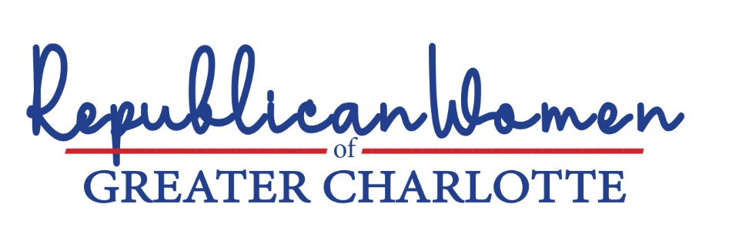

Children should not be exposed to drag shows, including
the “Drag Queen Story Hour.”
Founded in San Francisco in 2015, the Drag Queen Story Hour organization proudly advertises that it "started out as drag queens reading stories to children in libraries and grew into a global phenomenon." Defenders of drag shows and drag queen story hour say the programs are fun and harmless ways to introduce children to the gay and transgender movement.
North Carolina communities should reflect the values of their residents. Our values are more akin to those of Texas not California. When a drag show in Dallas went viral, a Texas congressman moved quickly to introduce a bill banning the practice, wisely noting, " … we do not allow drag shows in front of children in the same way we do not allow strip shows in front of children … it’s the same idea of decency and morals that we don't let children have women dance around in their underwear and put money in their underwear. In the same way, we should not allow that with a man dressed in women's clothes."
    - Drag shows (including so-called Drag Show Story Hour performances) should be limited to participants and audiences that are 18 years or older and should not be held on public property or parks.

Charlotte has a chapter of this organization. The group’s application to perform in local public libraries was denied. The group performed in front of children at other venues in 2022, including the Charlotte International Arts Festival in Romare Bearden Park. Men dressed in sexually provocative women’s clothing “read books to children to show them that there is always a way to love who they are.”
“Why drag queen shows are not appropriate for children,” Dr. Debra Soh, Washington Examiner, June 27, 2022.

