In Class Saver – Screenshot
By Haylie Hawxhurst
Using Keyboard

Using Word Screenshot
- 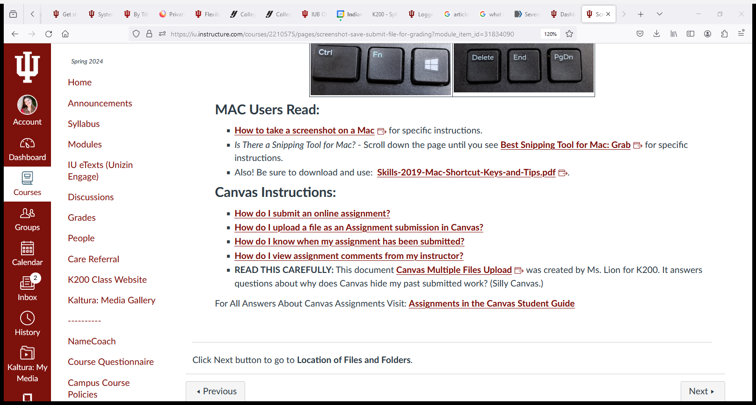

Snipping tool

