DISCORD MANUAL
INAAQC’s server

April 04 2022
inaaqc

DISCORD MANUAL
(ENGLISH VERSION)

DISCORD MANUAL

WHAT IS DISCORD? 3
WHY DISCORD? 3
HOW CAN I USE DISCORD? 4
DISCORD IN A BROWSER 4
DISCORD AS AN APPLICATION 4
INAAQC’S SERVER 5
SERVER’S CHANNELS 7
ALTITUDE 8
EFAC 9
DESIGN 10
PC ONLINE 10
PXS 11
SOCIAL MEDIA 11
HOW TO USE VOICE CHANNELS 13
HOW TO MAKE A VIDEO CALL 13
HOW TO SHARE THE SCREEN 15
HOW TO JOIN AND WATCH A STREAM OR SCREEN SHARING 16
SERVER’S RULES 17
GENERAL SERVER RULES 17
TEXT CHAT RULES 17
VOICE CHAT RULES 18
TEXT FORMATTING 18
KEYBOARD SHORTCUTS 19

WHAT IS DISCORD?

Discord is a VoIP (Voice over Internet Protocol), instant messaging and digital distribution platform. With discord, users communicate with voice calls, video calls, text messaging, media and files in private chats or as part of communities called "servers".

WHY DISCORD?

Discord platform may bring a considerable number of benefits to our current means of communication such as:
- Agglomeration of all means of communication in one single server.
- Reduction of the number of message notifications members receive.
- A cleaner and condensed organization of all means of communication.
- Different channels for every existing topic.
- Addition of bots for tasks remembrance.
- Creation of both message and voice chats for every channel.
- Better view of existing members in each channel.
- Simple creation and manipulation of different channels in a single server.
- Voice channels that allow video calls and screen sharing with minimum internet usage.
- The capacity to share personalized messages like images and file messages in chat channels. Allows messages edition and removal.
- The possibility to create bots and threads, or even pin messages, allow INAAQC members to easily reach important messages and implement an automatic mean of sending messages to the channel, such as deadlines and other important information.
- Application of roles with permissions more complex than the ones used in WhatsApp.
- A better mentioning and notification system for directly addressing users in chat.

HOW CAN I USE DISCORD?

Discord can be used in a normal browser, such as Mozilla Firefox and Google Chrome, or as an application.

DISCORD IN A BROWSER
- Go to https://discord.com/app.
- Create and login on your private account.

DISCORD AS AN APPLICATION

- Go to https://discord.com/download.
- Download the application on your computer or mobile phone.
- Create and login on your private account.

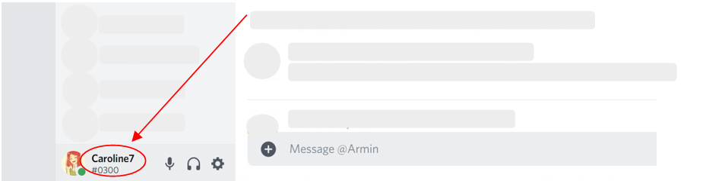
After you’ve successfully registered on Discord, ask the moderators to add you to INAAQC’s server. For that purpose, ask any of the members to send you the link of the server. Make sure you use a username that easily identifies you (check Figure 1).
Figure 1: Discord username

INAAQC’S SERVER

Once you are invited to the server, you will receive a message to enter the server (Figure 2).

Figure 2: INAAQC Server invite

You will now be part of INAAQC’s server, which will appear as shown in Figure 3.
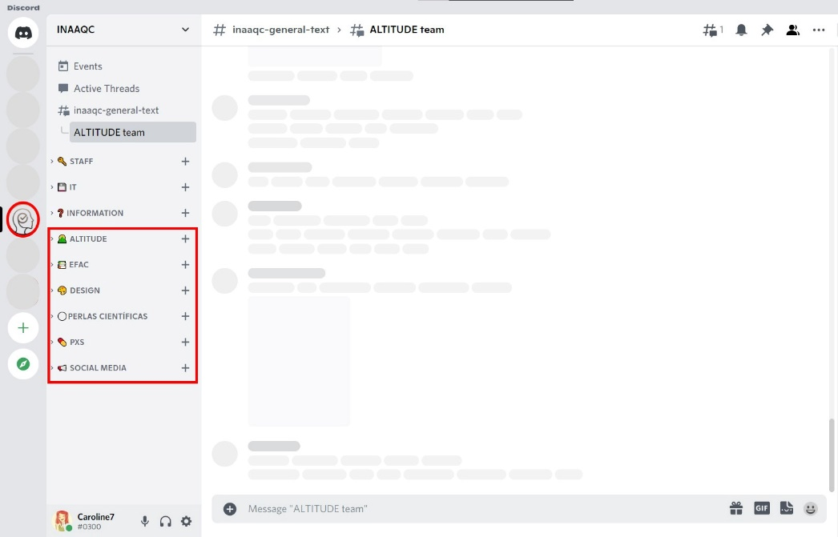
Depending on the roles assigned to each member, their channels will be visible on the left side. In these channels, members can communicate via text messages ([channel_name]-text) or voice messages ([channel_name]-voice).
Figure 3: INAAQC's server
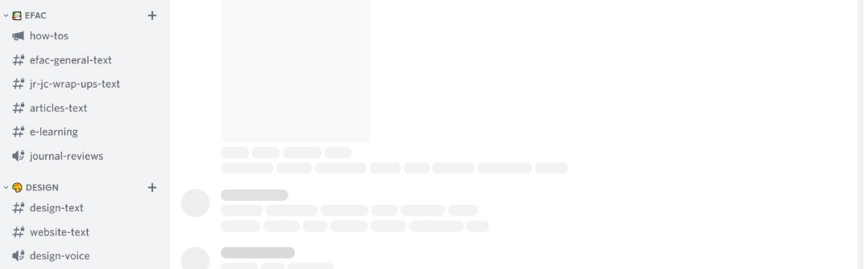

SERVER’S CHANNELS

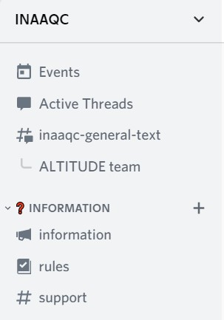
INAAQC’s server is divided according to the current categories and projects. This server has four common channels: #inaaqc-general-text, #information, #rules and #support (Figure 4).
Figure 4: Server's channels

The inaaqc-general-text channel is the main desktop of proactive communication among the members of INAAQC. We attain to get efficiently connected with each other, you therefore undoubtedly want to share, discuss, comment, raise questions, and more questions to raise clarity, start proposals, seek understanding, practice synergism, and apply our team principles (respect, efficiency, and discipline). Let us all get motivated, inspired and be able to keep learning.
In the information channel, various information related to INAAQC matters will be shared. This may include any updates and issues in the server. This channel must not be used to carry any type of conversation.
The rules (see section SERVER’S RULES) channel is solely to inform and remind you of the rules and good practices to be used on our server. This channel must not be used to carry any type of conversation.
Lastly, the support channel may be used whenever support for any problems or doubts is needed. To ease support for any problems encountered, please use the following encoding:
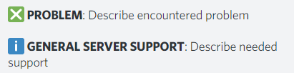
Figure 5: Support codification

ALTITUDE

Altitude is one of the four branches of 𝙄𝙉𝘼𝘼𝙌𝘾. In this category, we seek to manage tasks, pendings and ideas. We have many scientific projects ongoing, and their completion will depend on the teamwork we generate. Altitude is an opportunity for Bolivia to do scientific medicine at the best possible level. This category consists of two channels, altitude-text, for text messages and information sharing, and altitude-voice, for voice and video calls.
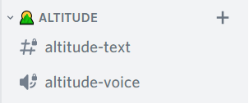
Figure 6: Altitude channels

EFAC

The equipo de formación académica - científica (EFAC) is a high-performance group, that is, a group of people with specific, complementary, and multifunctional roles who cooperate, with great commitment and identification, in achieving a common goal for which they are responsible and for whose achievement they have sufficient resources and autonomy. EFAC category consists of four different channels. Efac-general-text has a similar purpose to the one mentioned in ALTITUDE. Jr-jc-wrap-ups-text is a channel meant to assist the website team on entering the information related to the Journal Reviews. For this reason, JR/JC wrap ups must be inserted in this channel. Lastly, the journal-reviews voice channel will be used for the daily Journal Reviews meetings that usually were done by Zoom. Please be aware of the how-tos channel, whose purpose is to inform the codification and rules for the EFAC material.
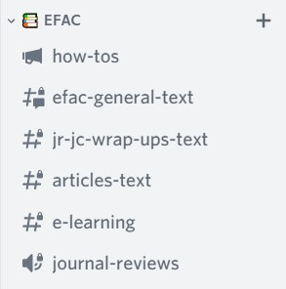
Figure 7: EFAC channels

DESIGN

This is a prodigious place because aesthetics, shapes, colors, images... 'design' in a word are born here. It is the place where the creativity of the team stands out and captivates. The brain thinks in images and this section creates those images. The purpose is to improve the presentation and facilitate the understanding of our material through an appropriate design.
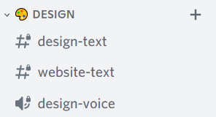
Figure 8: Design channels

PC ONLINE

Perlas Científicas (PC) online is the site to administer and manage the necessary tasks to optimize this section on the website. We define colors, images, exchange documents, etc. The purpose is to keep our available online PCs impeccable. Please be aware of the how-to-write channel, whose purpose is to inform the structure and rules to create our PCs.
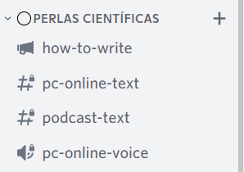
Figure 9: PC online channels

PXS

In this section we design strategies to interact with the group of patients (PXS) organizing ourselves as a team to maintain consistency in the transmission of information to patients. These strategies can be discussed via text message (pxs-online-text) or by voice/video conference (pxs-voice). Please be aware of the how-to-post channel, whose purpose is to inform the structure and rules to interact with the group of PXS.
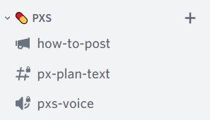
Figure 10: PXS channels

SOCIAL MEDIA (SoMe)

The purpose of our social media channels is to disseminate in a mechanized, systematized, and simplified way the information that we wish to transmit using our social networks. Among all we can assign complementary roles to achieve it.
To achieve the intended objectives, three different channels were created. All publications to be placed on our social media MUST be placed on the some-text channel. Each publication’s translation MUST, in turn, be placed in the translation-text channel. The some-voice channel will be used as needed. It is crucial to follow these instructions to guarantee the correct functioning and organization of our means of communication.
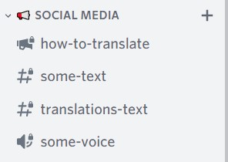
Figure 11: Social media channel

Please be aware of the how-to-translate channel, whose purpose is to inform the structure and rules for our social media posts.
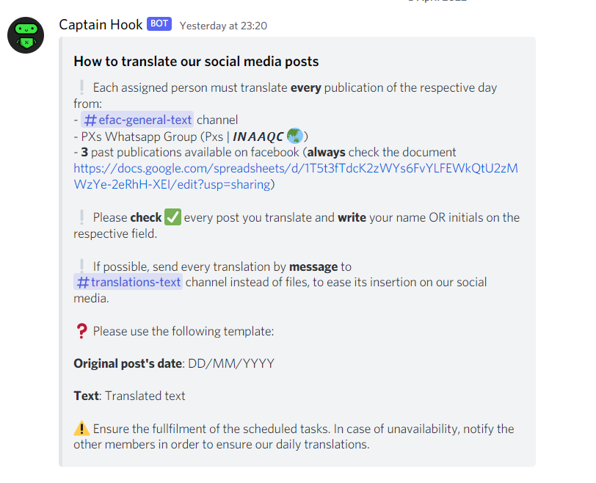
Figure 12: how-to-translate

HOW TO USE VOICE CHANNELS

- Click a voice 🔊 channel in the server
- Start talking!
You should see a green outline around your avatar when speaking.

If you need to adjust your voice settings, click the gear ⚙️ icon to open User Settings. On desktop, you'll find it in the lower left corner of your server. Under User Settings, go to Voice and Video settings to adjust your audio input, microphone sensitivity, and more.
You can adjust the volume of other people on the voice channel by right clicking their avatars on desktop or pressing their names on mobile.

HOW TO MAKE A VIDEO CALL

- Enter a voice 🔊 channel in the server.
- Press the Video button in the lower left corner and your video will be added to the voice channel. If you navigate away from the channel, just click again to open.

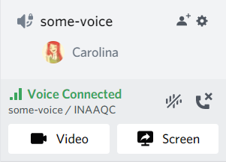
Figure 13: How to make a video call

To change the input device, click the ⚙️ icon to open User Settings. On desktop, you'll find it in the lower left corner of your server. Under User Settings, access voice and video settings to update your video input device.

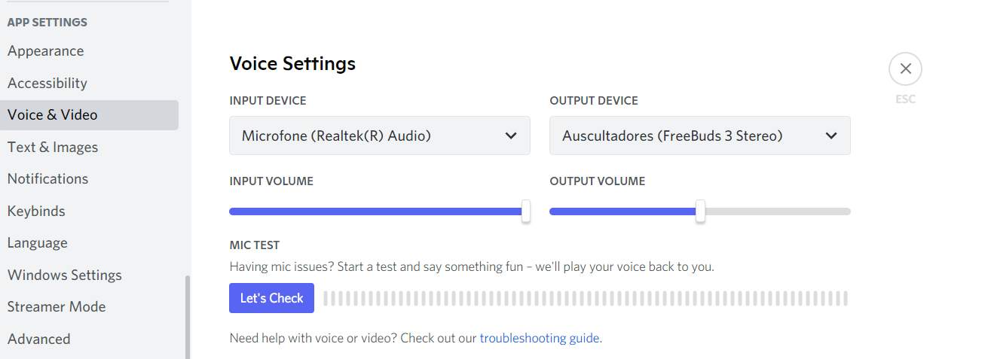
Figure 14: Change input device

HOW TO SHARE THE SCREEN

- Enter a voice 🔊 channel.
- Active the screen sharing. Press the Screen icon on the voice status panel near the lower left corner and a new window will appear.
- Choose an application or screen to share.
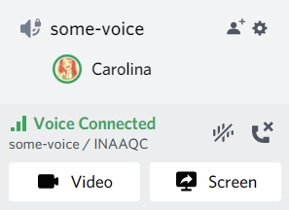
Figure 15: How to share the screen

- Press the "Live" button at the bottom of the window when you are ready to share your stream
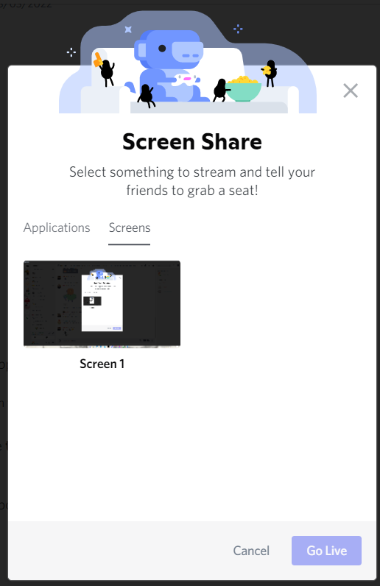
Figure 16: How to share the screen: Go Live

HOW TO JOIN AND WATCH A STREAM OR SCREEN SHARING

- Search for anyone with the Live icon within a voice 🔊 channel.
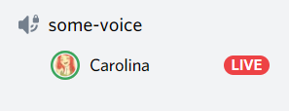
Figure 17: Join a stream or screen sharing

- Click on the username that is broadcasting with the Live icon to automatically join the stream.

After entering the stream, you can change the size and location of the preview window. You can also control the stream's audio from the volume icon while hovering over the stream.

SERVER’S RULES

Rules are extremely important to maintain a respectful and friendly environment between INAAQC members. For this reason, we ask that you strictly follow the rules presented below.

GENERAL SERVER RULES
- No asking to be granted roles/moderator roles.
- Contact the moderators under #channel for support
- Use the appropriate channels.
- No inviting unofficial bots.
- The primary languages of this server are English and Spanish.

TEXT CHAT RULES
- @mention the moderators for support.
- No sexually explicit content.
- No NSFW content.
- No illegal content.
- No sexism.
- No racism.
- No hate speech.
- Moderators reserve the right to delete any post.
- Moderators reserve the right to edit any post.
- No advertisement without permission.
- No Discord server invite links or codes.
- Do not send any malicious and harmful links or files, or anything that jeopardizes the security of others.

VOICE CHAT RULES
- Reduce the amount of background noise, if possible.
- Push to talk only.
- Do not record voice channel conversations.
- Moderators reserve the right to disconnect you from a voice channel if your sound quality is poor.
- Moderators reserve the right to disconnect, mute, deafen or move members to and from voice channels.

TEXT FORMATTING (it may be useful to consult the Spanish version)

Code | Result
*italics* | italic
__underline__ | underline
**bold** | bold
***bold italics*** | bold italics
~~strikeout~~ | strikeout
__*underline italics*__ | underline italics
__**underline bold**__ | underline bold
__***underline bold italics***__ | underline bold italics
`code` | inline code
```code``` | multiple line code
|| spoiler || | message as spoiler

KEYBOARD SHORTCUTS

Shortcut | Result
ALT + arrow key up | Navigate upwards between channels
ALT + arrow key down | Navigate downwards between channels
Esc | Mark channel as read
Shift + Esc | Mark server as read
Ctrl + B | Return to previous text channel
Ctrl + ALT + A | Return to active audio channel
Page up | Scroll page upwards
Page down | Scroll page downwards
Shift + Page up | Jump to oldest unread message
Ctrl + Enter | Answer incoming call
Ctrl + K | Find or start a direct message
Esc | Decline incoming call
Ctrl + Shift + H | Check discord’s support page
Ctrl + arrow key left | Return to the text channel you were previously at
Ctrl + Shift + U | Upload a file

There is the Mac hotkey version available in the app.

For more information on how to use Discord, check the following available manuals:
- Discord Manual
- Discord Chat for Communities and Friends
- How to use Discord – Begginer’s Guide [video]

Available in iOS, Android, Linux and Windows devices.
Carolina Cunha or José Carvalho

