Learning YHVH’s Calendar

The New Moons
Susan Huddleston
Jan. 23, 2023
Covenantcelebration.org

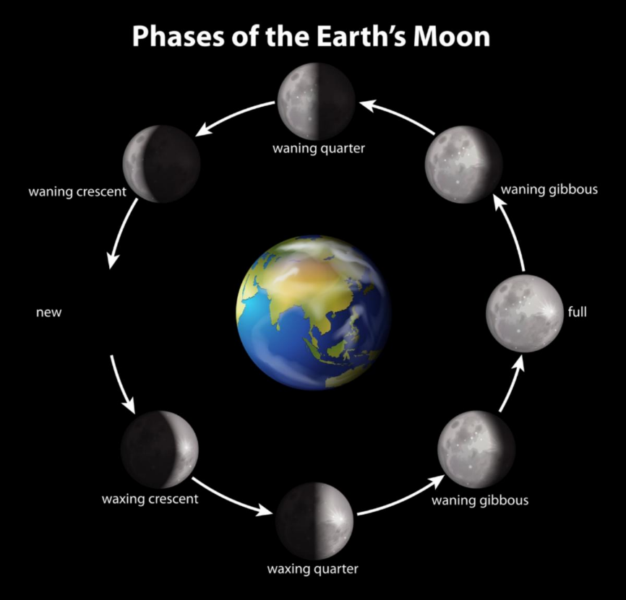

Recently someone asked if we would teach on observing YHVH’S Scriptural calendar as we are currently led to observe it at Covenant Celebration. For those of us who did not grow up in homes that taught us how to keep the times and seasons of Elohim we are all familiar with the many challenges and issues one must grapple with when trying to put the pieces of the Scriptural calendar back together again. For those who are desiring to be restorers of the old waste places (Isa. 59:12), this is a necessary process all have to sort through.
Congregationally, having the same understanding of why we do what we do helps us to stay in unity. I believe the festivals, or appointed times of YHVH, were designed to be one of the most unifying experiences for the body of Messiah. I know as our congregation has been adapting to making YHVH’S appointed times a priority in our congregational and personal lives by coming together to learn, celebrate and be a witness, our congregational unity has increased greatly.

These times of being in agreement with our Father’s commands were designed to bring encouragement and strength to the heart. The level of participation and unity we experienced this past season was especially amazing. I am not saying there were not obstacles to overcome in coming together, but for those who were able to press in and did, the testimonies of healing and deliverance were beautiful! Praises to YHVH!

With these appointed times being designed to be so central to our congregational health, is it any wonder that the enemy has worked overtime to “babbelize” YaH’s calendar by bringing in a smorgasbord of opinions and viewpoints that can leave one in a stagnant puddle of confusion. As a congregation we are still growing, and I pray will always be growing, in more and more understanding of our Father’s ways and must remember it is important to be long suffering towards each other as we learn to guard His commands. Being a restorer of the ancient paths has never been an easy task but it is an honor to be called to be a part of this call in our generation for YaH’s esteem… just like Nehemiah, Josiah or Ezra, etc.

There are too many aspects of the Scriptural calendar to cover in this one article so my focus here will be on how we determine the time of the Renewed or New Moons. Being able to recognize when the New Moon begins is paramount to being able to guard the appointed times of YHVH. All of the appointed times are observed on certain days within certain months and the moon cycle is how we determine when each month begins so we can count the days and know when an appointed time occurs. So again, in the Scriptural Calendar, understanding the moon cycle is how we know when to keep the appointed times so this is a good place to start.

Father has led Marc and I to use the Scriptures themselves to help us restore the ways of our Father so let us begin there. In Genesis chapter one on day four of this creation we find these verses:

“And Elohim said, “Let lights come to be in the expanse of the heavens to separate the day from the night, and let them be for signs and appointed times, and for days and years, and let them be for lights in the expanse of the heavens to give light on the earth.” And it came to be so. And Elohim made two great lights: the greater light to rule the day, and the lesser light to rule the night, and the stars. And Elohim set them in the expanse of the heavens to give light on the earth, and to rule over the day and over the night, and to separate the light from the darkness. And Elohim saw that it was good. And there came to be evening and there came to be morning, the fourth day.”
Berĕshith (Genesis) 1:14-19 TS2009

Here we discover that YHVH had purposes for creating the “greater light” - the sun and “the lesser light” - the moon. The first purpose is to rule over the day and the night and to separate the light from the darkness. Secondly, the sun and moon are to be used to identify, “signs, appointed times, days and years.” The first purpose is obvious, day and night, so let us move on to the second.

First notice the phrase, “and let them be for”, this small phrase is important because some teach that there should only be a lunar based, or only a solar based calendar. Others teach that we should ignore the observed sun and moon cycles altogether and just “calculate” the calendar without their witness. If we simply stick to what YaH established at the beginning in Genesis the text plainly tells us that the sun and moon work together to help us keep track of time therefore, both sun and moon have their function in understanding the Scriptural calendar. The Creator established this principal from the beginning and does not change it.

In Genesis we find there are four categories given to us in designing this calendar: signs, appointed times, days and years. The word “signs” in Hebrew (owth) means a signal, a miraculous sign or a warning. Joel 2:10 speaks of these, “And I shall give signs in the heavens…” Also Mt. 24:29, Rev. 6:12 and Rev. 12 speaks of signs given by the sun and moon, and other celestial bodies, to those on the earth. When returning to the Everlasting Covenant one begins to be more observant of events that are happening in the heavens that includes eclipses and other events. These events are often ways our Father is communicating with us. Of course, we are not speaking of astrology or divining our future through the horoscope which is forbidden in Scripture. Sadly, the enemy always hi-jacks the truth and perverts it. YaH made it clear from the creation account that He intended for us to recognize certain seasons by “signs” given by His heavenly time pieces.

The next three categories YHVH uses the sun and moon for are, “appointed times, days and years.” As stated, YaH designed both the sun and the moon to work together to help those on the earth keep track of these things. The sun by its rising and setting helps us keep track of days - for a day is made up of a night and day period, established in Gen. 1:5. (See my article on Why the Hebrew Day begins in the Evening on our websites resource page if you have questions on this)

The moon by completing one cycle of waxing (appearing larger) and waning (appearing smaller) takes just under 30 days, or about a month. This moon cycle was designed to help us be able to determine when a month begins and ends by watching it's cycle. The month determined by the moon is made up of days determined by the sun - so we need both the sun and the moon to determine the Scriptural calendar. I am repeating this point because many get off by not following the Scriptural given pattern here.

So how do we use the moon cycles to determine the start of a new month?

There are two common ways in most communities desiring to follow the Scriptural calendar. One is by starting the new month on the dark moon, that is when the moon has finished waning and cannot be seen from the earth because it is completely darkened. The second is by the first sighting of the crescent moon, the small slither that you can see when the moon starts to wax larger in appearance again. For the remaining of this article, I would like to share why we have been led to go by the sighting of the crescent moon and not the dark moon.

Now in case it has been a while since you had a good science class about the cycles of the moon, or you have just gotten used to operating off of the Gregorian calendar given to us by the Roman Pope Gregory XIII in 1582, who, according to history, had used the calendar reforms promoted by the Jesuit Christopher Clavis, here is a quick review:

As you can see in the picture at the start of this article, when the moon comes between the sun and the earth it is called a dark moon. The phase of this dark moon can last anywhere from one to three days depending on other factors I will not discuss here. At one point during its dark phase, the moon is “perfectly” aligned between us and the sun. This point is called a conjunction. If you were going to begin the month during the dark moon phase, which can last anywhere between one to three days, you would have to be able to pinpoint - from earth - exactly when the conjunction occurred. This however is impossible without some expensive equipment of which the ancients did not have and therefore did not use this method. Actually, when you do the homework, the evidence is unanimous that the ancients used the first sliver or first crescent moon to begin the starting of a new month.

The word for new moon in Hebrew is (chodesh) and means the new moon, month, or monthly. Sadly, the King James just uses the word “month” when translating this word and this causes a separation in our thinking. It causes us not to think of the moon as being our witness to identify when the month begins, and instead makes us think of using the calendar where the months have been calculated for us. But the moon is to be our witness for identifying the beginning of each month.

““Like the moon, it is established forever, And the witness in the heaven is steadfast.” Selah.” Tehillim (Psalms) 89:37 TS2009

The word (chodesh) has in its root meaning in the word (chodash) that means to renew, make new, to repair. So the moon has monthly renewals. It should be obvious that there is not a brand new moon that appears in the heavens every month but it is renewed in its appearance. Because of this some call this the renewed moon. Either way, we are just trying to understand the cycle. You may have heard the term used, “rosh chodesh” this simply means “head of the new moon”.

We find one example of this is the reference book TWOT or Theological Wordbook of the Old Testament, Page 266 Under 613b (hodesh) month, monthly, new moon we read:

Although this word properly means “new moon”, it is commonly used as an equivalent to our word, “month” because the month began when the crescent of the new moon was first visible at sunset. It was used along with the more rare “yerah”, from “yareah” meaning “moon”…

The Hebrew calendar used a lunar month fitted into a solar year. This was done by adding an extra month approximately once every three years because it was about eleven days less than the solar year. In early Israel the first of each month, or new moon, was determined by observation and proclaimed officially by the blowing of trumpets. The month was considered to be thirty days (Gen. 7:11; cf. 8:3-4), unless the new moon was observed earlier…

When hodesh refers only to the beginning of the month, it is naturally translated “new moon,” which was a feast day. It is one of the “appointed feasts” and is listed with the Sabbath and the pilgrim feasts as involving burnt offerings (II Chron. 8:13 et al.) and is also characterized by the blowing of trumpets (Ps. 81:3 [H4]; Num. 10:10). Since it was a feast, David’s presence from Saul’s table at the new moon was especially noticeable (1 Sam. 20:5f.)

There is a lot of good information found in this one resource alone:

• Validates the month began by observation of sighting the crescent moon

• Validates that the Hebrews used a solar AND lunar calendar

• Gives understanding as to why it is necessary to include an extra month at times to the Scriptural calendar to stay in sync with the harvest and agricultural cycles

• Indicates the blowing of trumpets, or the shofar, was practiced on the new moon

• Recognizes that the new moon was considered a feast day of YHVH

Let’s look at another example of this in Scripture. In Exodus 12 you have instructions from YHVH:

“And יהוה spoke to Mosheh and to Aharon in the land of Mitsrayim, saying, This new moon is the beginning of new moons for you, it is the first new moon of the year for you.” Shemoth (Exodus) 12:1-2 TS2009

This is the passage where YHVH was giving instruction to Yisrael concerning how to determine when their month one would begin. Of course, the first month of the new appointed times cycle had to be determined to know when the Passover was to be observed that would occur on the fourteenth day of month one. If you don't begin the month correctly you will not observe the appointed time on the correct day so you can see how important it is to be able to identity when the new moon begins.

Currently at Covenant Celebration, we are observing the new moon as the crescent moon that appears after the dark moon each month. Because of modern tech, and even apps we can put on our phones, it is pretty easy to keep up with these cycles but note: most calculations reckon the dark moon as the new moon. The Scriptural Calendar remember is by the sighting of the crescent moon and is either one or two days after the dark moon recognized by most calendars. This one or two day difference seems to have to do with the period after the 7th month. I am observing a pattern for determining this that I hope to share but I need to check it out a little more first, some of you may already have this figured out but I would like to not to have to depend on a digital source and would like to be able to determine this ourselves - so this is still a work in progress.

This is also why our appointed times of YHVH at Covenant Celebration are usually a few days different than the ones you find on the standard calendar. They are using the dark moon calculations where we are going by the crescent moon sightings.

Most of us have not been raised in a family that even considered the status of the moon above us so this can understandably take some time to adjust to. One thing that helps us is to set an alarm on our digital calendars to alert us when the new moon will be occurring and I often put a sign down on the floor in our dining room to remind us that day as well. Right after sunset is the best time to catch the crescent moon and if you are like us, you may even have to learn what area of the sky to look in.

We like to go outside and blow our shofar and welcome in YHVH'S new moon. If you are in a neighborhood this is a great witness that may cause others to ask you questions as to why you are doing this. We used to have a family down the street from us that also blew in the new moon and it was fun to hear them "witnessing" down the street with us. You may also want to read a Scripture, pray, ask for YHVH's blessing on your month or spend time in fellowship with your Father. Some enjoy having a new moon celebration and inviting others over to join with them in welcoming in this time of renewal and the guarding of YaH's commands together.

There are more details that have to be learned in order to put all of the Scriptural Calendar together but this is a good place to start. Some have been on this journey longer than others but for those of us who are starting out, I hope this serves as a good introduction to what a new moon is, and how we have been led thus far to guard and observe them with our Covenant Celebration family. As we continue to grow and learn may Father teach us His ways.

-EXTRA-

I would also like to share a nugget I received in my morning devotions today. We read in Psalm 23:3b:

“…He leads me in paths of righteousness for His Name’s sake.”

The Hebrew word for “paths” here is H4670 (maw-gawl) and means entrenchment, track, circumvallation, also a rampart (as circular). The root word for this word is Hebrew 5696 (aw-gole’) meaning to revolve.

As I was meditating on this I believe the Set-apart Spirit showed me that David was sharing here the understanding of the “circular” nature of our Father’s “righteousness” that is connected with keeping His “circular” appointed times which we "revolve" through every yearly cycle in the Scriptural calendar.

Remember, righteousness is the “right way” of relating to YHVH and to others. Our Father’s appointed times are definitely the “right way” He has communicated to us, through His Word, of what He desires His people to guard and to practice in their worship of Him. These were never abolished by Yehoshua our Messiah nor by the Emissaries of the Renewed Covenant and they continue to be what pleases Him.

The amazing thing connected with this thought was when I reread this short Psalm, of which we are all familiar, it opened up so much more to me in my understanding.

This is where my Shepherd leads me - He leads me in the circular paths (maw-gawl) of the appointed times which are His path(s) of righteousness! These paths activate the blessings associated with keeping “His paths of righteousness” that we find given throughout the rest of this psalm... He restores my soul, He prepares a table before me in the presence of my enemies, He anoints my head with oil, etc. .

HalleluYah! I encourage you to go and reread this with this new insight and be encouraged. You may even want to quote it as you enter into this new moon cycle.

As the time of the next New Moon, I encourage you to set an alarm for around sunset and go outside and blow your shofar or raise a shout of praise to YaH as we together, in unity, enter into a new month, and thereby enjoy all of His promised blessings!

I Love His Torah -Shalom

