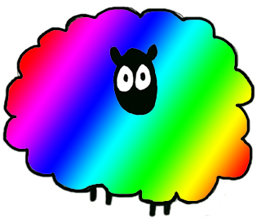
Welcome to Ashfield Guild!

You’ll find us a friendly, enthusiastic and perhaps a tiny bit crazy bunch!
Here are a few things that’ll be handy to know as you settle in.
Chairman – Ellena Kirk
Secretary – Sharon Bond
Treasurer – Ellena Kirk
We’re affiliated with the nationwide Association of Guilds of Weavers, Spinners and Dyers. We aren’t a formal teaching organisation, but we are happy to share skills with new and existing members.
Website http://ashfieldguild.btck.co.uk/ or Google Ashfield Guild. Have a look around; there are very useful tutorials, pictures of past events, suppliers, lots to see.
We meet 2nd and 4th Thursdays of each month from 6.30-9.30pm at Annesley and Felley Parish Hall, off Byron Road, Annesley Village, Notts NG15 0AH.
The timings are flexible, you don’t have to attend for the whole evening and we don’t take a register! Notices are normally around 7.30 to give people chance to arrive.
There’s a charge each meeting of £2.50 and tea, coffee and biscuits are available for 50p. There are 2 tins to put your money in-just be sure to get the right one!
In addition to these meetings, some evenings and weekends we have longer workshops, do displays for the public and attend other similar groups in the area. Everyone is very welcome at all these events. Details are on the website under Programme and Events.
Show off night at the end of October is an opportunity to show everyone what you’ve made, we love to ooh and aah over everyone’s projects!
And for those whose creations are gifted almost as soon as they’re finished, on meetings where there’s nothing booked in, we have show off along with spinning clinic to solve any crafty problems.
We are always very open to suggestions for the programme, even things we’ve done in the past, a refresher never hurts! Also very welcome are offers of members’ expertise and/or home to teach/host workshops, get togethers and the like. The programme is compiled towards the end of the year, forward ideas to Ellena any time, and then remind her!
Yearly membership is £12.50 and runs from January. If you join part way through the year, the charge is normally pro rata, at the treasurer’s discretion. You’ll get a membership card.
We keep in touch with an email list. Give your email to Ellena to be included on it. A summary of the important/amusing bits is emailed after each meeting and invitations to any impromptu events and any other spinning related news can be emailed via this list.
Contact details must be given in order to join the Guild. These are kept and used in compliance with the GDPR regulations.
There are various pieces of equipment available for members to use, including a drum carder, knitting machine and Ashford traditional wheels. A full list is on the website on the About Us page. Equipment is returned on the second meeting each month so someone else can have a go if they want to. Sandra is currently Cupboard Monitor and she has a record of who’s got what.
The Guild is run very democratically; throw in your ideas, opinions & skills. We look forward to getting to know you!

