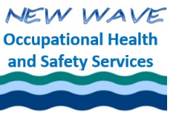
Session Evaluation

Name:
1. Describe the level of quality provided by this course. This may include, but is not limited to: professionalism, reliability, customer service, follow up.
Describe the level of quality provided by the course. This may include, but is not limited to: course content; ability to meet your needs; ability to you engaged.
3. Do you feel you received value from this course? Please explain (e.g. How effective was the course? What was the outcome/benefit? Did/will the course translate into observable change?).
4. Would you recommend this or other courses we provide to others?

Other comments:

Please email completed evaluation to newwaveohs2016@gmail.com
Thanks for your feedback!!

