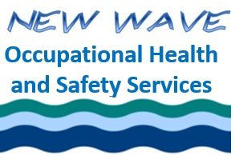
Ethics for the Occupational Health and Safety Professional

Asynchronous Version

Final Quiz
April, 2024
Student Name as you would like it to appear on your certificate:

PLEASE PRINT!!!!!!!

Completion date: _____________________________________________________

- If I have an interest in a contract I oversee but I know that my decisions are not affected by that interest, then I do not have a conflict of interest.

  - True
  - False

- “Social consensus” is a term discussed in the context of:

  - Bias
  - Moral justification
  - Moral intensity
  - Is not a term relevant to ethics

- Human rights, equity, dignity and respect are part of which section of the BCRSP Rules of Professional conduct?

  - Section 2
  - Section 3
  - Section 5
  - Section 9

- “Cost and benefit” is a concept that is most relevant within the framework of:

  - Kantianism
  - Utilitarianism
  - Natural law and natural rights

- When we judge behaviours associated with more serious, negative outcomes as more blameworthy or unethical, we are succumbing to:

  - Framing
  - Distortion of consequences
  - Outcome bias
  - Proximity bias

By checking this box, I attest that I am the person named above and that I completed this quiz and the associated assignment myself with no help from any other person.

Email completed quiz to newwaveohs2016@gmail.com

