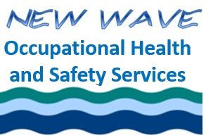
Ethics for the
Occupational Health and Safety Professional
Asynchronous
January, 2022
Learner Evaluation

My knowledge of Ethics:
 | I know very little |  |  |  |  |  | I know all that I  need to know
Before the session | 1 | 2 |  | 3 |  | 4 |  | 5 | 6
After the session | 1 | 2 |  | 3 |  | 4 |  | 5 | 6

 | Totally disagree |  |  | Totally  agree
I felt I had an opportunity to reflect on the material | 1 | 2 | 3 | 4 | 5 | 6
I understood all of the material | 1 | 2 | 3 | 4 | 5 | 6
This material will be useful to me in the future | 1 | 2 | 3 | 4 | 5 | 6
Overall, I was satisfied with the course | 1 | 2 | 3 | 4 | 5 | 6

And one more question. How did you find out about our course?
☐ Internet search (Google, Yahoo, etc.) | ☐ Found on BCRSP website
☐ My employer signed me up  ☐ Referral from an acquaintance/coworker | ☐ Other

Other comments:
Email completed comments to newwaveohs2016@gmail.com

Thanks for your feedback!!

