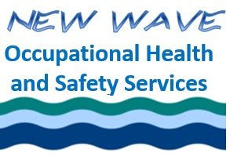
Ethics for the Occupational Health and Safety Professional

Asynchronous Version

Final Quiz

Student Name as you would like it to appear on your certificate:

PLEASE PRINT!!!!!!!

Completion date: _____________________________________________________

- It is “Whistleblowing” only if you tell someone outside your organization about a wrongdoing?

  - True
  - False

- Is cost-benefit analysis an example of:

  - Kantianism
  - Natural Law and Natural Rights
  - Utilitarianism

- Protecting and promoting the safety and health is part of what section of the BCRSP Rules of Professional conduct?

  - Section 1
  - Section 2
  - Section 5
  - Section 9

- Saying “We are not really harming anyone” is an example of:

  - Advantageous comparison
  - Distortion of consequences
  - Euphemistic language
  - Moral justification

- Which of the following is not an aspect of Moral Intensity?

  - Severity of consequences
  - Risk
  - Legal precedent
  - Immediacy
  - Proximity

By checking this box, I attest that I am the person named above and that I completed this quiz and the associated assignment myself with no help from any other person.

Email completed quiz to newwaveohs2016@gmail.com

