Classifying Living Things
In order to study living things, scientists sort (or classify) them into groups based on how they are the same and how they are different. Classifying plants and animals makes it easier for scientists to study and talk about them.
The largest groups into which living things are classified are called kingdoms. Two important kingdoms are the plant kingdom and the animal kingdom.
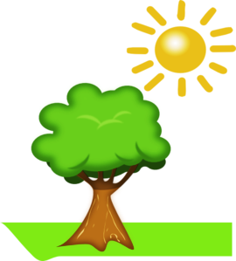
Plants
The plant kingdom includes trees, grass, flowers and all the other plants you see each day.
Plants use the light from the Sun to produce their own food. This allows them to grow almost anywhere, as long as there is enough water.
Plants get their green color from the chlorophyll which is found inside of their leaves. Plants use chlorophyll to collect energy from sunlight. They then use this energy (along with carbon dioxide from the air and water from the soil) to make food.
In this process, called photosynthesis, they not only make food for themselves, but create the fruits, vegetables, and grains that we eat and the oxygen we need to breathe. Plants are very important to the life of almost every other living thing.

Animals
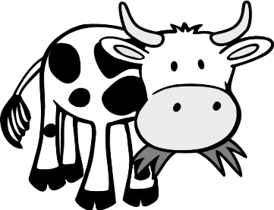
Animals come in many shapes and sizes, and can be found all over the world. Humans are animals; so are fish, cows, insects, snakes, and birds.
Animals cannot make their own food. They depend on other living things, such as plants, algae or other animals for food. Without these other living things, animals could not survive.

- In what important way are plants different from animals?

- What gives plants their green color?

- Why do plants need chlorophyll?

- What is the process called by which plants make their food?

- Where do plants get the energy they need to make their food?

- Where do animals get their food?

- Besides food, what else do plants provide that people (and animals) need to survive?

