ARTICLE I

ADMINISTRATION
- The mission of the Rose City Model Flyers Inc.,(hereafter referred to as the Club) shall be to supervise and control the property and funds of the Club.
- The Club is fully sanctioned by the Model Aeronautics Association of Canada (hereafter referred to as MAAC) and as a fully sanctioned Club will abide by the safety and other regulations of MAAC.
- The powers of the Club shall be:
1. To direct, manage, supervise and control the business, property and funds of the Club
2. To cooperate with MAAC re the standards of flight for radio control model aircraft.

ARTICLE II

MEMBERSHIP
- Members that fly RPAS must be a current member in good standing of MAAC.
- Membership in the Club shall be open to any person who expresses a genuine interest in radio controlled model aircraft and has fulfilled the application process.
- For logistical purposes, membership of said Club will be capped at 55 members.
- Each member is required to pay dues of $100.00 per year on or before the 15th of December each year.
- Each member shall be familiar with the rules of the Club and abide by said rules.

ARTICLE III
ORGANIZATION
- The day to day operation of the Club will be governed by the Executive committee.
- The Executive committee is composed of elected members of the Club.
- The Executive will meet to conduct the business of the Club at the discretion of the Club President in coordination with the Executive Committee.
ARTICLE IV
MEETINGS
- A meeting of the Executive may take place each month, at a time and place to be specified. At such meetings, two thirds of the members of the Executive Committee shall constitute a quorum.
- General meetings may take place at the discretion of the executive.
ARTICLE V
NOMINATIONS AND ELECTIONS
- The officers of the Club shall consist of the following positions. President Vice President Secretary Treasure Safety Officer Director of Events Field Supervisor
- Officers shall be elected each year by the members through a digital ballot system.
- A Nomination Chairperson shall be appointed in September of each year to receive the names of any members of the Club who may wish to apply for any position of the committee.
- The duties of each officer are set out in section 5 of the Constitution.
- The nominator of any member for a position on the executive shall obtain approval of the nominee prior to the formal nomination.
- Nominations shall be open in the month of October of each year.
- Any officer may be removed from office for non-performance of duties. The procedure that shall be followed is the Complaints Process as outlined in Article IV. Should the President of the Club be the accused, The Vice-President shall perform the duty.
- Filling of Vacancies: Should an Office on the Executive become vacant during the Club year, an election to fill the vacancy shall be held at the discretion of the Executive Committee.

ARTICLE VI
COMPLAINTS PROCESS
The following procedure shall be taken with respect to complaints resulting from infractions of the Code of Conduct:
- The infraction shall be reported to the President.
- The President along with the complainant shall ensure that the complaint is in writing.
- The President shall notify the accused with respect to the complaint and shall gather, from the accused, his/her rebuttal in writing.
- The President shall notify the complainant and the accused of the date of the next Executive meeting at which time the complaint will be heard in presence of the Executive Committee.
- Each party shall be given an opportunity to state his/her case to the Executive at the next Executive meeting.
- The Executive shall render a decision in writing with regard to the complaint following the Executive meeting.
- The Executive may resolve a frivolous and vexatious complaint with no action to be taken.
- The Executive may suspend a member for a definite period to be determined by the Executive.
- The Executive may expel a member from the Club if the infraction is detrimental to the interests of the membership.
- The decision of the Executive shall be final. SECTION 2 Any Club member found willfully damaging or removing club property may be expelled from the Club effective immediately.

ARTICLE VII
FINANCE
All revenues, disbursements, etc., of Club funds shall be properly documented in accordance with acceptable business practices.

ARTICLE VIII
FIELD OPERATION TIMES
- Electric or rubber powered aircraft or gliders may be flown from Sun up to Sun down any day of the week.
- Gas or Glow powered aircraft can be flown from 8:00 a.m. to Sun down any day of the week

ARTICLE IX

NORMAL OPERATING PROCEDURES & CLUB SAFETY RULES
- These rules are available on the Rose City Model Flyers RC website (www.rosecitymodelflyers.com), and a current printed copy is in the Club storage container located at the sun shelter.

- Model assembly should be done in the designated pit area.
- Batteries shall not be connected to electric models unless the model is restrained in the start-up area – no exceptions.
- Gas/glow models must be restrained and started in the start-up stands or similar, located in the start-up area. Do not conduct prolonged tuning if other pilots are flying.
- The direction of take-off landing and traffic pattern will be determined by the prevailing winds. If no wind, all take-offs etc. shall be east or west but away from the sun.
- Marshville Airpark flying area from the centre of the flight line is a box 800m left to right and 400m across to the south. All members shall fly within the flying area and must not fly within the flight line and pilot stations. No flying over the pit area or parking area is permitted.
- Hand launching and bungee launching shall be done in agreement with any pilots flying – normally off to one side of the pilot stations.
- Recovery of RPA that land/crash off the runway but in the flying area will be done in agreement with any pilots flying.
- A fire extinguisher must be present for all powered RPA operation and located at all times at the Shelter Area.
- If there is an accident requiring emergency services, cellular service is adequate to call 911. The civic address 40377 Feeder Rd., Wainfleet, ON.
- Pilots may fly in-formation provided they agree to do so. There is a maximum of 6 RPAS airborne at anytime.
- RCMF Club operates within 3nm of an aerodrome as listed in the CFS or CWAS and is required to provide all members with the following information:
a) The aerodrome name is Niagara Central Dorothy Rungeling Airport (Welland / Niagara Central) TC LID: CNQ3 and it is located 2.6 nautical miles (4.81 km) North/West of RCMF Marshville Airpark.
b) The aerodrome has three runways: Runway 05/23 is 3,493 feet long and 100 feet wide, paved and lighted. Runway 16/34 is 2,663 feet long and 50 feet wide, paved and unlighted. Runway 11/29 is 2,341 feet long and 60 feet wide, turf and unlighted.
- Our modeling site is well clear of the established aerodrome traffic pattern and flight over us is generally prevented by the CFS CAUTION. There are no CFS RPA procedures and no other CFS PRO comments that affect our modelling site.
- In the event of a “fly-away” towards the Niagara Central Dorothy Rungeling Airport, you may call the aerodrome operator at 905-714-1000 and advise them of the issue. Our site is in uncontrolled airspace so there is no need to notify ATC.
- RCMF Club members flying should check for Wainfleet/Welland related NOTAM either using the NAV CANADA NOTAM portal or using RPAS Wilco app or similar. If you are the first pilot of the day and have printed a RPAS Wilco site survey, please leave it at the site for fellow modellers to reference.
- The club executive has contacted the operator (OPR) of Welland Central Dorothy Rungeling Airport, and they have expressed no issues with our RPAS site.
- No flying will commence until half an hour after sunrise and will end a half hour before sunset, the time of which is available on the Weather Network App for the town of Wainfleet, Ontario. No night flying is allowed at RCMF Club unless your RPA is brightly lit.
- Visual observers and MAAC “spotters” are recommended. The following are club procedures for ensuring full scale aviation safety:
- ALL members present will assist in spotting while present on the Marshville Airpark site.
- When any member or other person spots a full-scale airplane that might come near the site, they are to yell out “AIRPLANE” in a loud voice or use the “Fox 40” Whistle in the shelter.
- ALL Pilots must immediately descend to as low an altitude as possible and then land as soon as safely able.
- When the full-scale airplane is no longer a threat, the person who gave the warning shall yell “ALL CLEAR”, or the pilots may make that determination themselves, and resume flying.
- No member shall ignore the direction or alert issued by a safety spotter or person who spots a full-scale airplane.
- A safety spotter(s) shall be briefed or trained on any club event procedures to use upon spotting a potential full-scale aircraft confliction.
- When visual observers are required, the club rules are as follows:
- The sole role is to scan the sky for approaching full scale aircraft – do not watch the RPA. Pay particular attention to (whatever direction airplanes come from etc.)
- The visual observer should use the Club handheld receiver to monitor the ATF 123.2 for CYSM.
- The visual observer should stand or sit at the start up stand closest to any pilots flying, but away from the start up stand(s) in use. Be close enough so they can hear you.
- When spotting a potential conflict – yell AIRPLANE in a clear loud voice.
- When you believe the airplane is no longer a problem yell – ALL CLEAR.
- Whenever a visual observer is required, all other club members present must keep unnecessary ambient noise to a minimum. NO run-ups on adjacent start up stands.
- No member shall operate an RPAS if the weather or visibility conditions preclude visual detection of approaching full-scale aircraft. MAAC stipulates a minimum of no cloud below 1000’ AGL and a horizontal visibility minimum of 3 statute miles. Members must consider other obscuring conditions (Fog, Smoke, Haze, etc) which could make spotting full-scale aircraft difficult. If there is no weather information available, these values may be estimated by the safety spotter, who has final say. No RPA or other model aircraft flying will occur below the Club mandated weather minimum:
- Follow any recommendations issued by the Club Safety Officer or their designate without argument or confrontation. Any disagreements may be addressed away from the flight line and pilot area. Failing to follow the safety regulations and rules / guidelines as described by MAAC, the RCMF Inc or TC may result in the termination of club membership.
- If there is any type of near miss or safety concern between a full-scale aircraft and our RPA, ALL FLYING SHALL cease immediately. The members involved should fill out a MAAC reportable occurrence report and submit that to the Club executive and follow MAAC policy with the following exceptions:
- If the member(s) involved believe the risk was very minimal, they may complete their own self declaration or risk assessment using the MAAC form. Submit a copy of the form to the club executive when able and recall you must keep this form for one year (CAR901.49 (2)). Resume flying when done.
- If the member or Club executive deems the event serious, flying will not resume until members are given permission by the Club executive – in writing.
- If there is actual contact between an aircraft and a MAAC RPAS – all flying will cease until MAAC confirms we may resume operations.
- This process is for your protection.

- There are no other risk mitigating strategies required at RCMF Club.
- The Club executive will review these rules at least once a year.

RCMF Club flying area as measured from the center of the pilot stations. Refer to the site flying area map for no-fly zone depictions.

Measurements of the RCMF Marshville Airpark runway is 89 m (N/S) 158 m (E/W).
- A- Depth 400m
- B- Length 800m

Marshville Airpark (RCMF Club) property:
N
The property is 5 acres with farmed fields to the N/S/E/W. Only one access point located at N/E corner. Members only issued key for lock on metal gate. Warning sign located at the entrance area. First Aid / Fire Extinguisher and Club Rules located at Shelter.
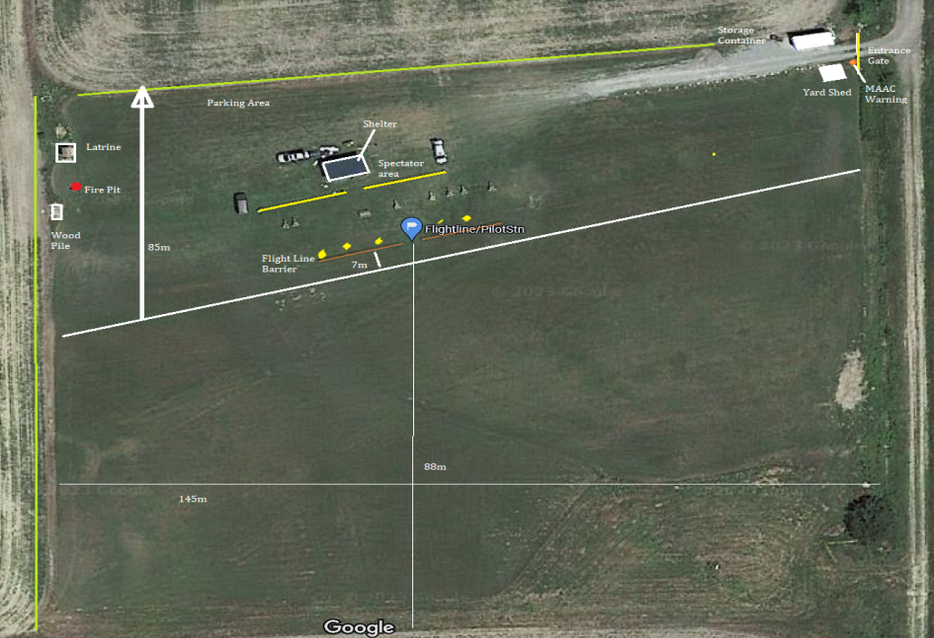
RCMF Marshville Airpark

