**Paper 3D/4D: Decision Mathematics 1 Mark Scheme**

|  |  |  |  |
| --- | --- | --- | --- |
| **Question** | **Scheme** | **Marks** | **AOs** |
| **1(a)** | In the first pass we compare the first value with the second value and we swap these values if the second is larger than the first | B1 | 2.4 |
| We then compare the value which is now second with the third value and swap if the third is larger than the second. We continue in this way until we reach the end of this list | B1 | 2.4 |
|  | **(2)** |  |
| **(b)** |  | M1 | 1.1a |
| *t* = 13.125(seconds) | A1 | 1.1b |
|  | **(2)** |  |
| **(4 marks)** | | | |
| **Notes:** | | | |
| **(a) B1:** Comparing first value with second value, swap if second is larger (oe) – in their  reasoning it must be clear that the first value in the list is being compared with the  second value in the list and swapping if the second is larger than the first **B1:** Compare second with third, (third with fourth), and so on until the end of the list –  must be clear in their reasoning that after the first comparison the second value in the  list is compared with the third value and so on until the end of the list | | | |
| **(b) M1:** Correct method seen – accept 25 for 50000/2000  **A1:** cao | | | |

|  |  |  |  |
| --- | --- | --- | --- |
| **Question** | **Scheme** | **Marks** | **AOs** |
| **2(a)** | A planar graph is a graph that can be drawn so that… | B1 | 1.2 |
| … no arc meets another arc except at a vertex | B1 | 1.2 |
|  | **(2)** |  |
| **(b)** | e.g. ABCDEGFA | B1 | 1.1b |
|  | **(1)** |  |
| **(c)** | Creates two lists of arcs | M1 | 2.1 |
| e.g. BG AD |  |  |
| CG BD | M1 | 1.1b |
| EG AE |  |  |
| CE AF | A1 | 1.1b |
| Since no arc appears in both lists, the graph is planar  (**or** draws a planar version) | A1 | 2.4 |
|  | **(4)** |  |
| **(7 marks)** | | | |
| **Notes:** | | | |
| **(a)**  **B1:** A clear indication that a planar graph ‘can be drawn’ – allow this mark even if  candidate implies that arcs can cross each other  **B1:** cao – no arc meets another arc except at a vertex – technical language must be correct | | | |
| **(b)**  **B1:** Any correct Hamiltonian cycle (must start and finish at A) – must contain 8 vertices  with every vertex appearing only once (except A) | | | |
| **(c)**  **M1:** Creates two list of arcs (with at least three arcs in each list) which contain no common  arcs  **M1:** Four arcs (in each list) and within each list there are no crossing arcs  **A1:** cao  **A1:** Correct reasoning that no arc appears in both lists + so the graph is therefore planar | | | |

|  |  |  |  |
| --- | --- | --- | --- |
| **Question** | **Scheme** | **Marks** | **AOs** |
| **3(a)** | e.g. in the practical problem each vertex must be visited at least once. In the classical problem each vertex must be visited just once | B2,1,0 | 2.4  2.4 |
|  | **(2)** |  |
| **(b)** | Prim’s algorithm on reduced network starting at A: AD, AF, AE, CE, CG | M1 | 1.1b |
| Lower bound = 107 + 17 + 25 = 149 (km) | M1  A1 | 1.1b  1.1b |
|  | **(3)** |  |
| **(c)** | NNA from A: A – D – F – E – C – G – B – A =  NNA from C: C – E – A – D – F – B – G – C = | M1  A1  A1 | 1.1b  1.1b  1.1b |
|  | A1 | 1.1b |
|  | **(4)** |  |
| **(d)** |  | M1  A1 | 2.2b  1.1b |
|  | **(2)** |  |
| **(11 marks)** | | | |
| **Notes:** | | | |
| **(a)**  **B1:** Understands the difference is connected to the number of times each vertex may be visited (but maybe incorrectly attributed). Must be an attempt at a difference (so must refer to both the classical and practical problems explicitly). Technical language (vertex/node) must be correct. Need not imply each/every/all (oe) vertices for this first mark  **B1:** Correctly reasons which is classical and which is practical and correctly states the difference. Must imply that each/every/all (oe) vertices are visited, so for example, ‘the practical problem visits a vertex at least once while the classical visits a vertex only once’ is B1B0 (note that B0B1 is not possible in (a)) | | | |
| **(b)**  **M1:** Correctly applying Prim’s algorithm from node A for the first four arcs (or five nodes)  **M1:** Candidates weight of their RMST + 17 + 25 (the two smallest arcs incident to B)  **A1:** cao (condone lack of units) | | | |
| **(c)**  **M1:** Either one route, must return to A  **A1:** One correct route, must return to A and corresponding length correct (do not is in part (c) if correct lengths seen but are then doubled)  **A1:** Both routes correct and their corresponding lengths correct  **A1:** cao for | | | |
| **(d)**  **M1:** Their numbers correctly used, accept any inequalities or any indication of interval from their 149 to their 159 (so 149 – 159 can score this mark). This mark is dependent on two routes seen in (c), however, neither of the two totals need to be correct. Please note that UB > LB for this mark  **A1:** cao (no follow through on their values) including correct inequalities or equivalent set notation (but condone ) | | | |

|  |  |  |  |
| --- | --- | --- | --- |
| **Question** | **Scheme** | **Marks** | **AOs** |
| **4(a)** | Yes Dijkstra's algorithm can be applied to either a directed or undirected network | B1 | 3.5b |
|  | **(1)** |  |
| **(b)** | Initial tables |  |  |
| 1st iteration | M1  A1 | 1.1b  1.1b |
| 2nd iteration | M1  A1ft | 1.1b  1.1b |
| 3rd  iteration | M1  A1ft | 1.1b  1.1b |
| 4th iteration  no changes therefore optimal | A1 | 1.1b |
|  | **(7)** |  |
| **(c)** | Start at D (4th) row and read across to the B (2nd) column, there is a C there |  |  |
| so the route starts DC. Look at the C row, B column and you see B | B1 | 2.4 |
| The route is therefore DCB | B1 | 2.2a |
|  | **(2)** |  |

|  |  |  |  |
| --- | --- | --- | --- |
| **Question** | **Scheme** | **Marks** | **AOs** |
| **(d)** | D – C –B – A **– B** – D | M1 | 2.2a |
| Length 19 (miles) | A1 | 1.1b |
|  | **(2)** |  |
| **(e)** | Dijkstra’s algorithm finds the shortest distances from **one** vertex to **all** the others. Floyd’s algorithm finds the shortest distance between **every pair** of vertices. | B1  B1 | 2.5  2.5 |
|  | **(2)** |  |
| **(14 marks)** | | | |
| **Question 4 notes:** | | | |
| **(a) B1:** cao(must include mentionof ‘directed’ network)  **M1:** No change in thefirst row and first column of both tables with at least one value in the distance table reduced and one value in the route table changed | | | |
| **(b) A1:** cao  **M1:** No change in thesecond row and second column of both tables with at least two values in the distance table reduced and two values in the route table changed  **A1ft:** Correct second iteration follow through from the candidate’s first iteration  **M1:** No change in thethird row and third column of both tables with at least one value in the distance table reduced and one value in the route table changed  **A1ft:** Correct third iteration follow through from the candidate’s second iteration  **A1:** cao (no change after the fourth iteration) – all previous marks must have been awarded in this part | | | |
| **(c) B1:** Clearindication of how the final route table can be used to get from D to B (therefore must mention the correct rows and columns in their reasoning)  **B1:** Completely correct argument + correct route (DCB) | | | |
| **(d) M1:** Deduce correctly their minimum route from their final distance table (dependent on all M marks in (a)) must begin and end at D  **A1:** cao (length of 19) | | | |
| **(e)**  **B1:** cao – must use correct language ‘**one** vertex to **all** other vertices’  **B1:** cao – must use correct language ‘**every** **pair** of vertices’ | | | |

|  |  |  |  |
| --- | --- | --- | --- |
| **Question** | **Scheme** | **Marks** | **AOs** |
| **5(a)** | Maximise *P* = 12*x* + 20*y* + 16*z* | B1 | 3.3 |
| Subject to | M1  A1  A1  B1 | 3.3  1.1b  1.1b  3.3 |
|  | **(5)** |  |
| **(b)** | The values must all be integers | B1 | 3.3 |
|  | **(1)** |  |
| **(c)** | Variable *y* entered the basic variable column… | M1 | 2.4 |
| …so *y* was increased first | A1 | 2.2a |
|  | **(2)** |  |
| **(d)** | plants | B1 | 3.2a |
|  | **(1)** |  |
| **(e)** | The next pivot must come from a column which has a negative value in the objective row so therefore the pivot must come from column *z* | M1 | 2.4 |
| The pivot must be positive and the least of 92/2 = 46 and 24/0.5 = 48 so the pivot must be the 2 (from column *z*) | A1 | 2.2a |
|  | **(2)** |  |
| **(f)** | P + 10.5*x* + 3*s* + 3.5*t* = 756 so increasing *x*, *s* or *t* will decrease profit | B1 | 2.4 |
|  | **(1)** |  |
| **(g)** | Make 1 *Drama* basket and 46 *Peaceful* baskets | B1 | 2.2a |
|  | **(1)** |  |
| **(h)** | The slack variable, *r*, associated with this type of plant, is currently at 31. Increasing the number of *Impact* plants by a further 20 would have no effect | M1  A1 | 3.1b  3.2a |
|  | **(2)** |  |
| **(15 marks)** | | | |

|  |
| --- |
| **Question 5 notes:** |
| **(a) B1:** Correct objective function/expression (accept in pence rather than pounds e.g. 1200*x* +  2000*y* + 1600*z*)  **M1:** Correct coefficients and correct right-hand side for at least one inequality – accept any inequality or equals  **A1:** Two correct (non-trivial) inequalities  **A1:** All three non-trivial inequalities correct  **B1:** |
| **(b)**  **B1:** cao |
| **(c)**  **M1:** Correct reasoning that *y* has become a basic variable  **A1:** Correct deduction that *y* was therefore increased first |
| **(d) B1**: cao |
| **(e)**  **M1:** Correct reasoning given that the pivot value must come from column *z*  **A1:** Correctly deduce (from correctly stated calculations) that the pivot value is the 2 in  column *z* |
| **(f) B1:** States correct objective function and mention of increasing *x*, *s* or *t* will decrease profit |
| **(g) B1:** cao – in context so not in terms of *y* and *z* |
| **(h) M1:** Identifies the slack variable *r* and its current value of 31  **A1:** Correct interpretation that increasing the number of Impact plants would have no effect |

|  |  |  |  |
| --- | --- | --- | --- |
| **Question** | **Scheme** | **Marks** | **AOs** |
| **6(a)** | **See diagram on next page.** Top and bottom boxes  Top boxes correct | M1  A1 | 2.1  1.1b |
| Bottom boxes correct | A1 | 1.1b |
|  | **(3)** |  |
| **(b)** | See diagram below  T:\SAMS 2016 Material\AS and A level Maths\Pre typesetting graphics\Completed work to QD\D52533A\Second proof\D52533A_GRAPHICS_SAMs_GCE_Mathematics_8FM0_2D_Sep16_2ND_Proof-page-005.jpg |  |  |
| At least 8 activities + 4 floats with clear distinction between activity and their corresponding float | M1 | 2.5 |
| Correct critical activities + 4 correct non-critical activities | A1 | 1.1b |
| All 13 correct | A1 | 1.1b |
|  | **(3)** |  |
| **(c)** | T:\SAMS 2016 Material\AS and A level Maths\Pre typesetting graphics\Completed work to QD\D52533A\Second proof\D52533A_GRAPHICS_SAMs_GCE_Mathematics_8FM0_2D_Sep16_2ND_Proof-page-006.jpg | M1 | 1.1b |
| Bars correct to time = 13 | A1 | 1.1b |
| Bars correct from 14 to 24 | A1 | 1.1b |
|  | **(3)** |  |
| **(d)** | Until time 4 only A and B can happen.  After time 4, there are 6 worker-days to cover, but only 4 worker-days available.  Hence the project cannot be completed by time 24 with three workers. | B1  M1  A1 | 3.1a  2.4  2.2a |
|  | **(3)** |  |
| **(12 marks)** | | | |

**Diagram for Question 6(a)**

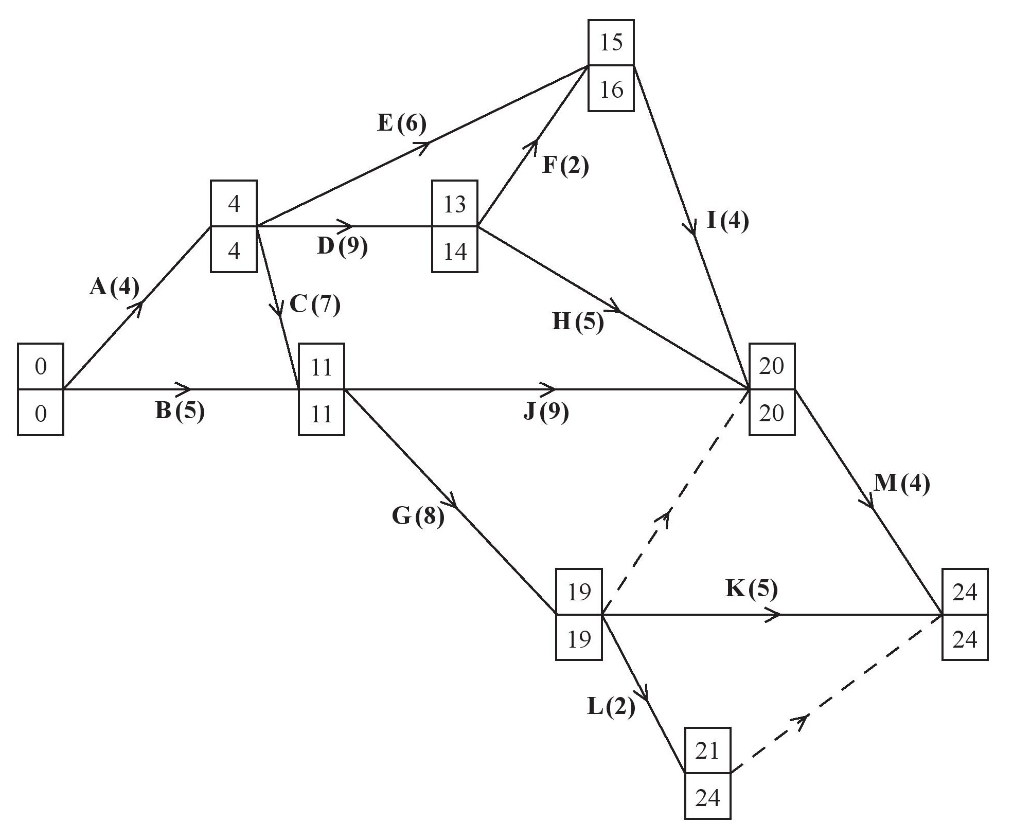

|  |
| --- |
| **Question 6 notes:** |
| **(a) M1:** All top boxes and all bottom boxes completed. For the top boxes all values must be increasing in the direction of the arrows for both the activities and the dummies. For the bottom boxes all values must be decreasing in the opposite direction to the arrows for both the activities and the dummies. While the values need not be correct each value must be increasing or decreasing (as appropriate) in a logical and sequential manner.  **A1:** cao for top boxes  **A1:** cao for bottom boxes  **M1:** At least 8 activities including 4 floats. Scheduling diagram scores M0 – clear distinction must be shown between the notation used for an activity and its float |
| **(b) A1:** Correct critical activities and 4 correct non-critical activities  **A1:** cao (all 13 correct activities) |
| **(c) M1:** Plausible histogram with no holes or overhangs (must go to at least 10 on the time axis)  **A1:** Histogram correct to time 13  **A1:** Histogram correct from time 14 to time 24 |
| **(d)** **B1:** Considering an appropriate process to adjust Grid 2 so that no activity must be completed by a 4th worker, for example, a correct argument that until time 4 only activities A and B can happen (so no activity can use the spare worker before time 4)  **M1:** Uses their histogram to explain when the number of workers is greater or less than the minimum number found in (b)  **A1:** Correctly deduces that the project cannot be completed by time 24 – this mark is dependent on a correct histogram seen in (d) |

|  |  |  |  |
| --- | --- | --- | --- |
| **Question** | **Scheme** | **Marks** | **AOs** |
| **7(a)** | Simplex can only work with  constraints | B1 | 3.5b |
|  | **(1)** |  |
| **(b)** | M is an arbitrary large real number | B1 | 2.5 |
|  | **(1)** |  |
| **(c)** | where is a surplus variable and  is an artificial variable | B1 | 2.4 |
|  | **(1)** |  |
| **(d)** | Let  (where  is an arbitrary large number) | M1  A1 | 2.1  1.1b |
|  | **(2)** |  |
| **(e)** | |  |  |  |  |  |  |  |  |  |  | | --- | --- | --- | --- | --- | --- | --- | --- | --- | --- | | b.v. |  |  |  |  |  |  |  | Value | Row Ops | |  | 0 | 1 | ½ | ½ | 0 | 1 | 1 | 19/2 |  | |  | 0 | 3 | 1/2 | 1/2 | 1 | 0 | 0 | 5/2 |  | |  | 1 | 1 | ½ | ½ | 0 | 0 | 0 | 25/2 |  | |  | 0 | 1 | 1/2 | 3/2 | 0 | 0 |  | 75/2 |  | | M1  A1  A1 | 1.1b  1.1b  1.1b |
| |  |  |  |  |  |  |  |  |  |  | | --- | --- | --- | --- | --- | --- | --- | --- | --- | --- | | b.v. |  |  |  |  |  |  |  | Value | Row Ops | |  | 0 | 2 | 1 | 1 | 0 | 2 | 2 | 19 |  | |  | 0 | 4 | 0 | 0 | 1 | 1 | 1 | 12 |  | |  | 1 | 0 | 0 | 0 | 0 | 1 | 1 | 3 |  | |  | 0 | 2 | 0 | 2 | 0 | 1 |  | 47 |  | | M1  A1  B1 | 1.1b  1.1b  2.4 |
|  | B1ft | 1.1b |
|  | **(7)** |  |
| **(12 marks)** | | |

|  |
| --- |
| **Question 7 notes:** |
| **(a) B1:** Correctly states the limitation of the Simplex model – Simplex involves iterations which allow movement from one vertex in the feasible region to another vertex (in the feasible region). If all constraints are of the form  this means that the origin is always a feasible solution and therefore can act as the initial starting point for the problem. However, the constraint means that the origin is not feasible and so the algorithm is unable to begin. |
| **(b) B1:** cao including the correct mathematical language (must include ‘arbitrary’, ‘large’ and ‘real’) |
| **(c)**  **(B1:** Correctly states both the inequality  and the equationtogether with an explanation of the meaning behind the variables  and |
| **(d)**  **M1:**  and substitutes their expression for  **A1:** Correct mathematical argument including sufficient detail to allow the line of reasoning to be followed to the correct conclusion **–** dependent on previous B mark in (c) |
| **(e) M1:** Correct pivot located, attempt to divide row. If negative value used then no marks  **A1:** Pivot row correct (including change of b.v.) and row operations used at least once, one of columns  or Value correct  **A1:** cao for values (ignore b.v. column and Row Ops)  **M1:** Pivot row consistent (following their previous table) including change of b.v. and row operations used at least once, one of columns  or Value correct  **A1:** cao on final table (ignore Row Ops)  **B1:** The correct Row Operations explained either in terms of the ‘old’ or ‘new’ pivot rows  **B1ft:** Correctly states the final values of *P*,from their correct corresponding rows of the final table |