Question 1
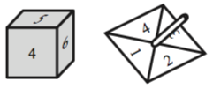
Joe rolls a 6-sided dice and spins a 4-sided spinner.
The dice is labelled 1, 2, 3, 4, 5, 6
The spinner is labelled 1, 2, 3, 4
Joe adds the score on the dice and the score on the spinner to get the total score.
He records the possible total scores in a table.
(a) Complete the table of possible total scores.
+ | 1 | 2 | 3 | 4 | 5 | 6
1 | 2 | 3 | 4 | 5 | 6 | 7
2 | 3
3 | 4
4 | 5
(b) Write down all the ways in which Joe can get a total score of 5
One of them has been done for you.
(c) Write down all the ways Joe can get a total score of 8 or more.

Question 4
Nathalie is playing a board game.
She must throw two fair 6-sided dice.
She must get a 1 on each dice to start the game.
Work out the probability that she will not start the game on her first go.

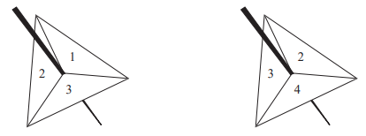
Question 5
Michelle has two fair 3-sided spinners. Michelle spins each spinner once.
Each spinner lands on a number.
Michelle multiplies these two numbers together to get her score.
- Work out the probability that Michelle’s score is at least 8
- Work out the probability that Michelle’s score is 4

Question 7
Javier has two sets of cards.
Each set contains 4 cards, one marked A, one marked B, one marked C and one marked D.
Javier is going to take at random one card from each set.
The table shows all possible pairs of cards that Javier could take.
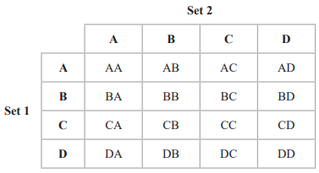
Find the probability that Javier will take at least one card marked C.

Question 8
Rayna has a fair 4-sided spinner.
The spinner can land on 3, 5, 7 or 9.
Rayna spins her spinner twice.
She adds the two numbers together to get the total.
- Complete the table to show the total for each possible outcome.
One has been done for you.
 |  | 1st spin
2nd spin |  | 3 | 5 | 7 | 9
 | 3
 | 5 |  |  | 12
 | 7
 | 9

- Write down the probability that she will get a total of 10.
- Write down the probability that she will get a total greater than 12.

