Question 1
Use a word from the box which best describes the probability of each of the following event.
When you throw an ordinary coin you get a tail.

Question 2
Use a word from the box which best describes the probability of each of the
following event.
When you throw an ordinary dice you get a number less than 7.

Question 3
Bill has some counters in a bag.
3 of the counters are red.
7 of the counters are blue.
The rest of the counters are yellow.
Bill takes at random a counter from the bag.
The probability that he takes a yellow counter is $\frac{2}{7}$.
How many yellow counters are in the bag before Bill takes a counter?

Question 4
Lukas has a fair ordinary dice.
Lukas rolls the dice once.
On the probability scale below, mark with a cross (×) the probability that Lukas gets an odd number.
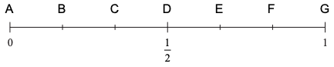

Question 5
Lukas has a fair ordinary dice.
Lukas rolls the dice once.
On the probability scale below, mark with a cross (×) the probability that Lukas gets the number 2
(1 mark)

Question 6
Write down the probability of an event that is impossible.

Question 7
The probability that Jamil will be late for work is 0.2. Work out the probability that Jamil will not be late for work.

Question 8
A bag contains only red bricks and blue bricks.
There is a total of 20 bricks in the bag.
The probability that a brick taken at random from the bag will be red is $\frac{2}{5}$.
How many blue bricks are there in the bag?

Question 9
An ordinary fair dice is thrown once.
On the probability scale below, where would you mark the probability that the dice lands on an odd number?
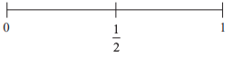

Question 10
An ordinary fair dice is thrown once.
Write down the probability that the dice lands on a number greater than 4

