SECTION B: MECHANICS K
Answer ALL questions.
4.1 A light see-saw is 10 m long with the pivot 3 m from the left.
Figure 1
a A 4 kg weight is placed on the left-hand end of the see-saw. Write down the anticlockwise moment about the pivot. (3 marks)
b A force of magnitude F N is applied to the right-hand end of the see-saw. The force acts vertically downwards. Write down the clockwise moment about the pivot due to this weight. (1 mark)
c Find the value of F for which the system is in equilibrium. (3 marks)

5.3 An object resting on a rough surface is attached to a rope angled at 30° to the horizontal. The rope is pulled with a force of P N. The mass of the object is 5 kg.
Figure 1
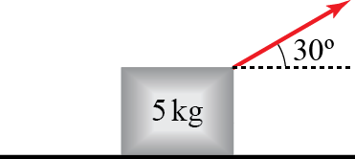
a Draw a diagram showing all the forces acting on the object. Describe the origin of each force using words. (4 marks)
b By resolving forces in the horizontal and vertical directions, calculate the magnitude of each force in the diagram, giving your answers in terms of P where appropriate. (4 marks)
c If P = 20, the object does not slip. Use this information to give a bound on $μ$ in the form of an inequality. (6 marks)

8.3 A ball falling vertically through viscous fluid is subject to a drag force of magnitude kv N, where v m s⁻¹ is the speed of the ball at time t seconds. The mass of the ball is 1 kg.
a Draw a force diagram showing the forces on the ball. (2 marks)
b Find an expression for v when the ball is in equilibrium. (2 mark)
c Explain why (3 marks)
d Show, by substitution, that satisfies this equation in part c. (3 marks)
e Explain why this solution agrees with your answer to part b. (1 mark)
f Describe one limitation of this model. (1 mark)

7.1 A 10 m long, uniform ladder has a mass of 6 kg and makes an angle of 20° with a smooth vertical wall. It stands on a rough horiztonal floor, which has coefficient of friction 0.3 with the bottom of the ladder.
Figure 1
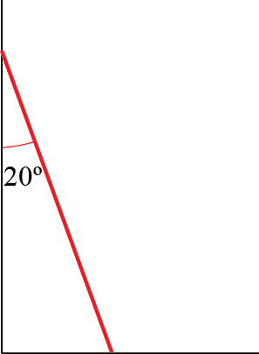

a Draw a diagram showing all the forces acting on the ladder. Describe the origin of each force using words. (4 marks)
b Calculate the magnitude of each force and hence determine whether or not the ladder slips. (13 marks)

