**SECTION B: MECHANICS J**

**Answer ALL questions.**

**5.1** An object rests on a rough surface and is pushed horizontally with force of 6 N. The mass of the object is 5 kg and the coefficient of friction between the object and the surface is 0.3.

**a** Draw a diagram showing all the forces acting on the object. Describe each of the forces using words and calculate their values. **(6 marks)**

**b** The horizontal force acting on the object is increased to *P* N. Find the largest value of *P* for which the object does not slip. **(3 marks)**

**6.2** A ball, modelled as a particle moving freely under gravity, is launched at 2 m s−1 from the origin at angle 45° above the horizontal.  
(In this question, take *g* = 10 m s−2)

**a** Find the coordinates of the particle when it is at its maximum height. **(10 marks)**

On another occasion, the projectile is again is launched at 2 m s−1 from the origin at angle 45° above the horizontal. It travels a horizontal distance *d* m before hitting a vertical wall and then falling straight to the ground.

**Figure 2**

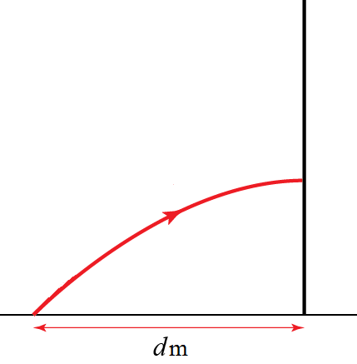

**b** Find the maximum height attained if *d* = 0.1. Give your answer in cm. **(5 marks)**

**c** Describe a possible limitation of this model. **(1 marks)**

**7.2** Three forces, **F**1, **F**2 and **F**3, act on a circular lamina of radius 5 cm. The origin is at the centre of the lamina.







The net force on the lamina is zero.

**a** Find the value of $f$. **(2 marks)**

**b** Find the total moment about the origin. Give your answer in N m. **(4 marks)**

**8.1** The position of a particle is **r** metres. Initially **r** = **i**.The velocity of the particle at time *t* seconds is **v** m s−1 where **v** = *t***i** + 3*t*2̴**j**

**a** Find **r** in terms of *t*. **(3 marks)**

**b** Find the acceleration of the particle when *t* = 4. **(4 marks)**

**c** Find the position of the particle when it is 1 m from the *x*-axis. **(2 marks)**