Pearson Edexcel Level 3
GCE Mathematics
Advanced Level
Paper 3: Statistics & Mechanics
Practice Paper H  Time: 2 hours | Paper Reference(s)
 | 9MA0/03
You must have:
Mathematical Formulae and Statistical Tables, calculator

Candidates may use any calculator permitted by Pearson regulations. Calculators must not have the facility for algebraic manipulation, differentiation and integration, or have retrievable mathematical formulae stored in them.

Instructions
• Use black ink or ball-point pen.
• If pencil is used for diagrams/sketches/graphs it must be dark (HB or B).
• Answer all questions and ensure that your answers to parts of questions are clearly labelled.
• Answer the questions in the spaces provided – there may be more space than you need.
• You should show sufficient working to make your methods clear. Answers without working may not gain full credit.
• Inexact answers should be given to three significant figures unless otherwise stated.

Information
• A booklet ‘Mathematical Formulae and Statistical Tables’ is provided.
• There are 12 questions in this paper. The total is 100.
• The for each question are shown in brackets – use this as a guide as to how much time to spend on each question.

Advice
• Read each question carefully before you start to answer it.
• Try to answer every question.
• Check your answers if you have time at the end.
• If you change your mind about an answer, cross it out and put your new answer and any working underneath.
SECTION A: STATISTICS

Answer ALL questions.

1. The distributions for the heights for a sample of females and males at a UK university can be modelled using normal distributions with mean 165 cm, standard deviation 9 cm and mean 178 cm, standard deviation 10 cm respectively.

A female’s height of 177 cm and a male’s height of 190 cm are both 12 cm above their means.

By calculating z-values, or otherwise, explain which is relatively taller.
(Total 4 marks)
_____________________________________________________________________________

2. The table shows some data collected on the temperature, in °C, of a cup of coffee, c, and the time, t in minutes, after which it was made.

t | 0 | 2 | 4 | 5 | 7 | 11 | 13 | 17 | 25
c | 81.9 | 75.9 | 70.1 | 65.1 | 60.9 | 51.9 | 50.8 | 45.1 | 39.2

The data is coded using the changes of variable x = t and y = log₁₀ c.

The regression line of y on x is found to be y = 1.89 − 0.0131x.

(a) Given that the data can be modelled by an equation of the form c = ab^{t} where a and b are constants, find the values of a and b.
(3)

(b) Give an interpretation of the constant b in this equation.
(1)

(c) Explain why this model is not reliable for estimating the temperature of the coffee after an hour.
(1)
(Total 5 marks)
_____________________________________________________________________________

3. The table below shows the number of gold, silver and bronze medals won by two teams in an athletics competition.

 | Gold | Silver | Bronze
Team A | 29 | 17 | 18
Team C | 21 | 23 | 17

The events G, S and B are that a medal is gold, silver or bronze respectively. Let A be the event that team A won a medal and C team C won a medal. A medal winner is selected at random. Find

(a) P(G),
(2)

(b) P([AS]').
(2)

(c) Explain, showing your working, whether or not events S and A are statistically independent. Give reasons for your answer.
(2)

(d) Determine whether or not events B and C are mutually exclusive. Give a reason for your answer.
(2)

(e) Given that 30% of the gold medal winners are female, 60% of the silver medal winners are female and 40% of the bronze medal winners are female, find the probability that a randomly selected medal winner is female.
(2)
(Total 10 marks)
_____________________________________________________________________________

4. A certain type of cabbage has a mass M which is normally distributed with mean 900 g and standard deviation 100 g.

(a) Find P(M < 850).
(1)

10% of the cabbages are too light and 10% are too heavy to be packaged and sold at a fixed price.

(b) Find the minimum and maximum weights of the cabbages that are packaged.
(3)
(Total 4 marks)
_____________________________________________________________________________

5. The data and scatter diagram (Figure 1) show the weight of chickens, x kilograms, and the average weight, y grams, of eggs laid by a random sample of 10 chickens.

Weight of chickens (kg) | 2.9 | 1.9 | 1.6 | 2.7 | 3.1 | 2.2 | 2.7 | 1.9 | 1.7 | 2.6
Average weight of eggs (g) | 58 | 56 | 55 | 66 | 47 | 63 | 49 | 56 | 53 | 53

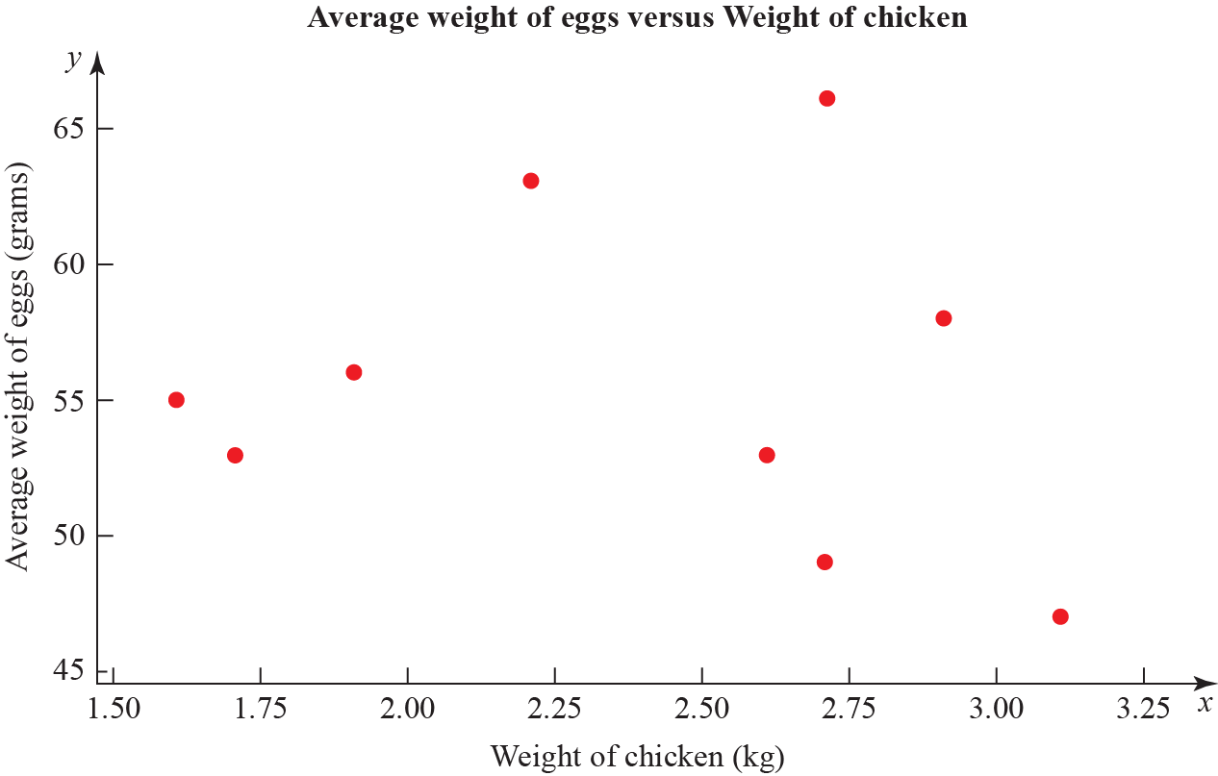

Figure 1

The product moment correlation coefficient for the average weight of eggs and weight of chickens is −0.136.

(a) Test for evidence of a negative population product moment correlation coefficient at the 2.5% significance level. Interpret this result in context.
(3)

(b) Explain why even if the population product moment correlation coefficient between two variables is close to zero there may still be a relationship between them.
(2)
(Total 5 marks)
____________________________________________________________________________

6. (a) State the conditions under which the normal distribution may be used as an appoximation to the binomial distribution X ~ B(n, p).
(2)

(b) Write down the mean and variance of the normal approximation to X in terms of n and p.
(2)

A manufacturer claims that more than 55% of its batteries last for at least 15 hours of continuous use.

(c) Write down a reason why the manufacturer should not justify their claim by testing all the batteries they produce.
(1)

To test the manufacturer’s claim, a random sample of 300 batteries were tested.

(d) State the hypotheses for a one-tailed test of the manufacturer’s claim.
(1)

(e) Given that 184 of the 300 batteries lasted for at least 15 hours of continuous use a normal approximation to test, at the 5% level of significance, whether or not the manufacturer’s claim is justified.
(7)
(Total 13 marks)
_____________________________________________________________________________

7. The mean body temperature for women is normally distributed with mean 36.73 °C with variance 0.1482 (°C)². Kay has a temperature of 38.1 °C.

(a) Calculate the probability of a woman having a temperature greater than 38.1 °C.
(2)

(b) Advise whether should Kay get medical advice. Give a reason for your advice.
(1)
(Total 3 marks)
_____________________________________________________________________________
8. To investigate if there is a correlation between daily mean temperature (°C) and daily mean pressure (hPa) the location Hurn 2015 was randomly selected from:

Camborne 2015 Camborne 1987
Hurn 2015 Hurn 1987
Leuchars 2015 Leuchars 1987
Leeming 2015 Leeming 1987
Heathrow 2015 Heathrow 1987

(Source: Pearson Edexcel GCE AS and A Level Mathematics data set.)

(a) State the definition of a test statistic.
(1)

(b) The product moment correlation coefficient between daily mean temperature and daily mean pressure for these data is −0.258 with a p-value of 0.001. Use a 5% significance level to test whether or not there is evidence of a correlation between the daily mean temperature and daily mean pressure.
(3)

(c) The scatter diagram in Figure 2 shows daily mean temperature versus daily mean pressure, by season, for Hurn 2015. Give two interpretations on the split of the data between summer and autumn.
(2)
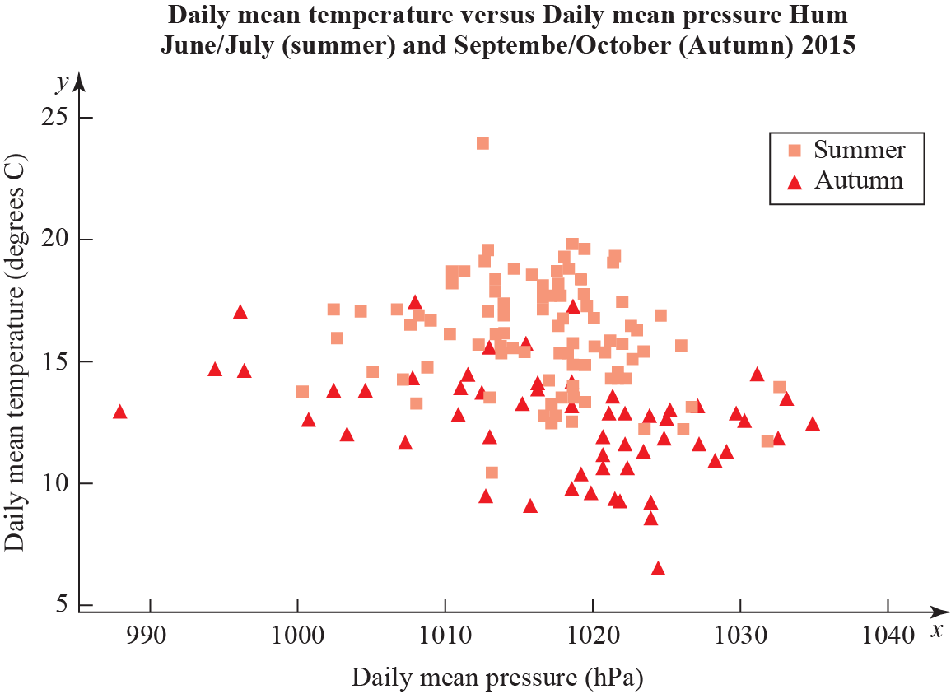

Figure 2
(Total 6 marks)
____________________________________________________________________________
SECTION B: MECHANICS

Answer ALL questions.

9. At time t seconds, a 2 kg particle experiences a force F N, where

(a) Find the acceleration of the particle at time t seconds.
(3)

The particle is initially at rest at the origin.

(b) Find the position of the particle at time t seconds.
(6)

(c) Find the particle’s velocity when t = 1.
(3)
(Total 12 marks)
____________________________________________________________________________

10. An archer shoots an arrow at 10 m s⁻¹ from the origin and hits a target at (10, −5) m. The initial velocity of the arrow is at an angle θ above the horizontal. The arrow is modelled as a particle moving freely under gravity.
(In this question, take g = 10 m s⁻².)

(a) Show that (tan θ − 1)² = 1.
(11)

(b) Find the possible values of .
(3)
(Total 14 marks)
_____________________________________________________________________________
11. Figure 3 shows a 5000 kg bus hanging 12 m over the edge of a cliff with 1000 kg of gold at the front. The gold sits on a wheeled cart. A group of n people, each weighing 70 kg, stands at the other end. The bus is 20 m long.

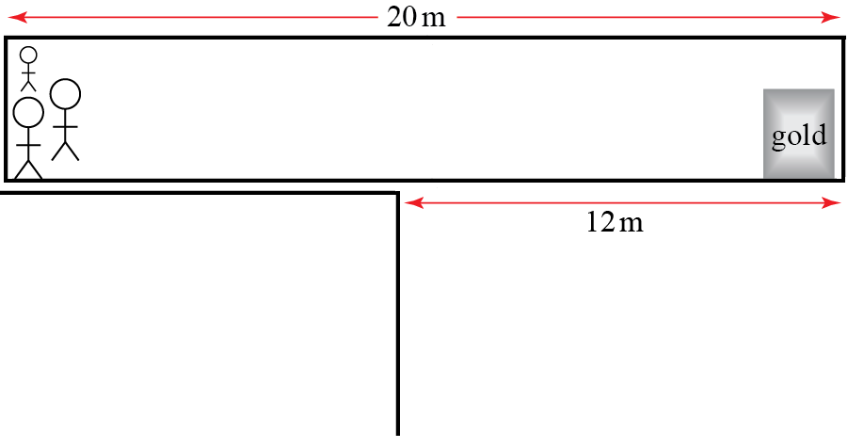

Figure 3

(a) Write down the total clockwise moment about the cliff edge in terms of n.
(7)

(b) Find the smallest number of people needed to stop the bus falling over the cliff.
(2)

(c) One person needs to walk to the end of the bus to retrieve the gold. Find the smallest number of people needed to stop the bus falling over the cliff in this situation, including the one retrieving the gold.
(4)
(Total 13 marks)
_____________________________________________________________________________

12. A car travels along a long, straight road for one hour, starting from rest. After t hours, its acceleration is a km h⁻², where a = 180 − 360t.

(a) Find the speed of the car, in km h⁻¹ in terms of t.
(2)

The speed limit is 40 km h⁻¹.

(b) Find the range of times during which the car is breaking the speed limit. Give your answer in minutes.
(4)

(c) Find the average speed of the car over the whole journey.
(5)
(Total 11 marks)
_____________________________________________________________________________

TOTAL FOR PAPER IS 100

