**NAME:**

**PAPER N**

**Date to be handed in:**

**MARK (out of 100):**

|  |  |  |  |  |  |  |  |  |  |  |  |  |  |  |  |
| --- | --- | --- | --- | --- | --- | --- | --- | --- | --- | --- | --- | --- | --- | --- | --- |
| **Qu** | **1** | **2** | **3** | **4** | **5** | **6** | **7** | **8** | **9** | **10** | **11** | **12** | **13** | **14** | **15** |
|  |  |  |  |  |  |  |  |  |  |  |  |  |  |  |  |

**Pure Mathematics**

**A Level: Practice Paper**

**Time: 2 hours**

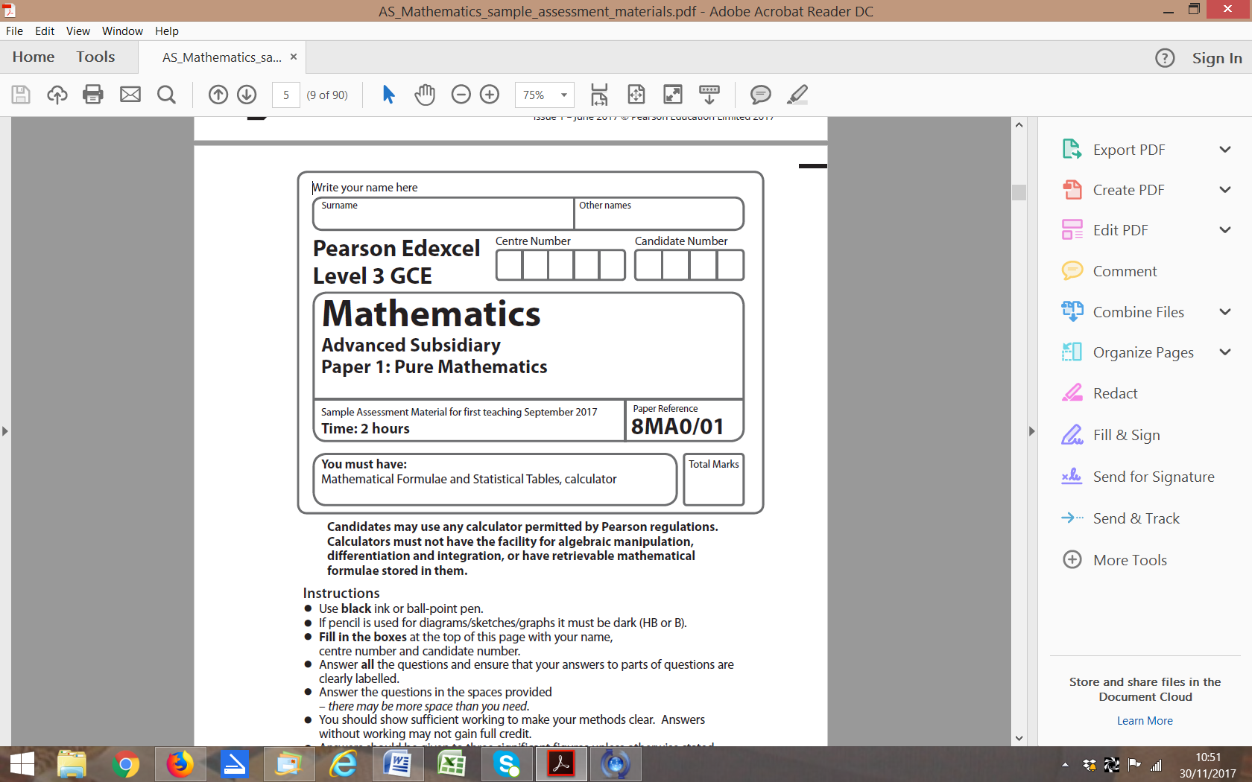

**Questions to revise:**

**1** In a rainforest, the area covered by trees, *F*, has been measured every year since 1990.

It was found that the rate of loss of trees is proportional to the remaining area covered by trees.

Write down a differential equation relating *F* to *t*, where *t* is the numbers of years since 1990.  **(2 marks)**

**2** Find the angle that the vectormakes with the positive *y*-axis. **(3 marks)**

**3** Use proof by contradiction to show that there exist no integers *a* and *b* for which 25*a* + 15*b* = 1 **(4 marks)**

**4** Find **(5 marks)**

**5** Use proof by contradiction to prove the statement: ‘The product of two odd numbers is odd.’ **(5 marks)**

**6 **

Given that f (*x*) can be expressed in the form  find the values of *A*, *B* and *C*.

**(6 marks)**

**7** A triangle has vertices *A*(−2, 0, −4), *B*(−2, 4, −6) and *C*(3, 4, 4).

By considering the side lengths of the triangle, show that the triangle is a right-angled triangle.

**(6 marks)**

**8** A large arch is planned for a football stadium.

The parametric equations of the arch are , , 

where *x* and *y* are distances in metres.

**a** Find the cartesian equation of the arch. **(3 marks)**

**b** Find the width of the arch. **(2 marks)**

**c** Find the greatest possible height of the arch. **(2 marks)**

**9** , where *x* is in radians.

**a** Show that f(*x*) = 0 has a root *α* between *x* = 1.9 and *x* = 2.0. **(2 marks)**

**b** Using *x*0 = 1.95 as a first approximation, apply the Newton–Raphson procedure once to

f(*x*) to find a second approximation to *α*, giving your answer to 3 decimal places. **(5 marks)**

**10** The diagram shows a logo comprised of a rhombus surrounded by two arcs.

Arc *BAD* has centre *C* and arc *BCD* has centre *A*.

Some of the dimensions of the logo are shown in the diagram.

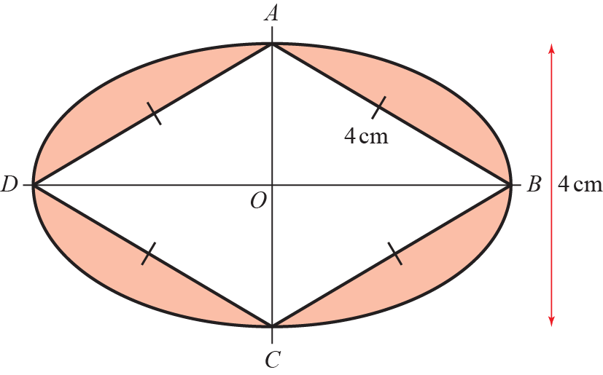

Prove that the shaded area of the logo is **(8 marks)**

**11** A toy soldier is connected to a parachute. The soldier is thrown into the air from ground level.

The height, in metres, of the soldier above the ground can be modelled by the equation

, where *H* is height of the soldier above the ground and *t* is the time

since the soldier was thrown.

**a** Show that **(4 marks)**

**b** Using the differentiated function, explain whether the soldier was increasing or decreasing

in height after 2 seconds. **(2 marks)**

**c** Find the exact time when the soldier reaches a maximum height. **(2 marks)**

**12** The diagram shows the graph of h(*x*).

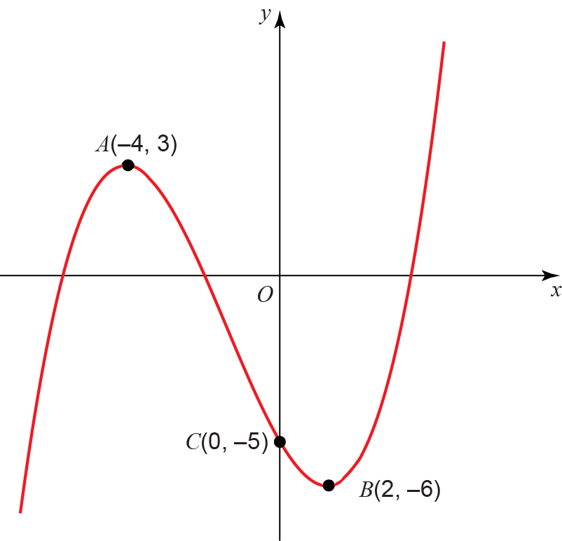

The points *A*(−4, 3) and *B*(2, −6) are turning points on the graph and *C*(0, −5) is the *y*-intercept.

Sketch on separate diagrams, the graphs of

**a** *y* = |f(*x*)| **(3 marks)**

**b** *y* = f(|*x*|) **(3 marks)**

**c** *y* = 2f(*x* + 3) **(3 marks)**

Where possible, label clearly the transformations of the points *A*, *B* and *C* on your new diagrams

and give their coordinates.

**13** At the beginning of each month Kath places £100 into a bank account to save for a family holiday.

Each subsequent month she increases her payments by 5%.

**a** Assuming the bank account does not pay interest, find the amount of money in the account

after 9 months. **(3 marks)**

Month *n* is the first month in which there is more than £6000 in the account.

**b** Show that  **(4 marks)**

Maggie begins saving at the same time as Kath.

She initially places £50 into the same account and plans to increase her payments by a constant amount each month.

**c** Given that she would like to reach a total of £6000 in 29 months, by how much should Maggie

increase her payments each month?

**(2 marks)**

**14** The first three terms in the binomial expansion of  are 

**a** Find the values of *a* and *b.* **(5 marks)**

**b** State the range of values of *x* for which the expansion is valid. **(2 marks)**

**c** Find the value of *c*. **(2 marks)**

**15** A large cylindrical tank has radius 40 m.

Water flows into the cylinder from a pipe at a rate of 4000π m3 min−1.

At time *t*, the depth of water in the tank is *h* m.

Water leaves the bottom of the tank through another pipe at a rate of 50π*h* m3 min−1.

**a** Show that *t* minutes after water begins to flow out of the bottom of the cylinder,

 **(6 marks)**

**b** When *t* = 0 min, *h* = 50 m.

Find the exact value of *t* when *h* = 60 m. **(6 marks)**

**(TOTAL: 100 MARKS)**