**NAME:**

**PAPER M**

**Date to be handed in:**

**MARK (out of 100):**

|  |  |  |  |  |  |  |  |  |  |  |  |  |  |  |
| --- | --- | --- | --- | --- | --- | --- | --- | --- | --- | --- | --- | --- | --- | --- |
| **Qu** | **1** | **2** | **3** | **4** | **5** | **6** | **7** | **8** | **9** | **10** | **11** | **12** | **13** | **14** |
|  |  |  |  |  |  |  |  |  |  |  |  |  |  |  |

**Pure Mathematics**

**A Level: Practice Paper**

**Time: 2 hours**

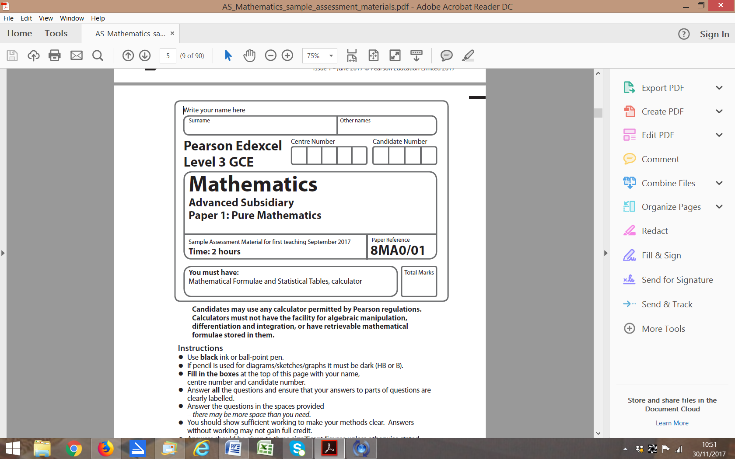

**Questions to revise:**

**1** Prove by exhaustion that  for positive integers from 1 to 6 inclusive.

**(3 marks)**

**2** Solve  in the range. Round your answer to 1 decimal place.

**(4 marks)**

**3** The temperature of a mug of coffee at time *t* can be modelled by the equation , where is the temperature, in °C, of the coffee at time *t* minutes after the coffee was poured into the mug and  is the room temperature in °C.

**a** Using the equation for this model, explain why the initial temperature of the coffee is independent of the initial room temperature. **(2 marks)**

**b** Calculate the temperature of the coffee after 10 minutes if the room temperature is 20 °C. **(2 marks)**

**4** Given that, find the value of *a*. **(5 marks)**

**5** Use proof by contradiction to showthat there are no positive integer solutions to the statement  **(5 marks)**

**6** 

Find the values of the constants *A*, *B* and *C*. **(6 marks)**

**7** The functions p and q are defined by  and 

**a** Given that pq(*x*)= qp(*x*), show that  **(4 marks)**

**b** Explain why  has no real solutions. **(2 marks)**

**8** The curve *C* has equation

**a** Show that *C* is concave on the interval [–5, –3]. **(3 marks)**

**b** Find the coordinates of the point of inflection. **(3 marks)**

**9** For an arithmetic sequence and

**a** Find the value of the 20th term. **(4 marks)**

**b** Given that the sum of the first *n* terms is 78, find the value of *n*. **(4 marks)**

**10** A stone is thrown from the top of a building. The path of the stone can be modelled using the parametric equations,,  where *x* is the horizontal distance from

the building in metres and *y* is the vertical height of the stone above the level ground in metres.

**a** Find the horizontal distance the stone travels before hitting the ground. **(4 marks)**

**b** Find the greatest vertical height. **(5 marks)**

**11** The diagram shows a cuboid whose vertices are *O*, *A*, *B*, *C*, *D*, *E*, *F* and *G*.

**a**, **b** and **c** are the vectors,  and  respectively.

The points *M* and *N* lie on *OA* such that 

The points *K* and *L* lie on *EF* such that 

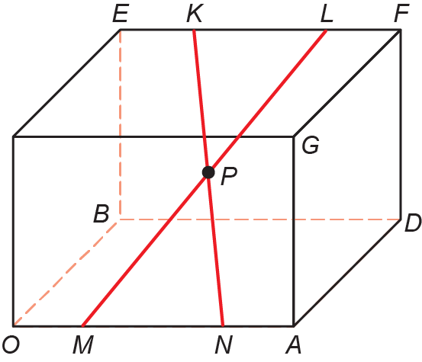

Prove that the diagonals *KN* and *ML* bisect each other at *P*. **(10 marks)**

**12** 

**a** Given that , find the values of the constants *A* and *B*. **(5 marks)**

**b** Find the exact value of **(5 marks)**

**13** ****, 

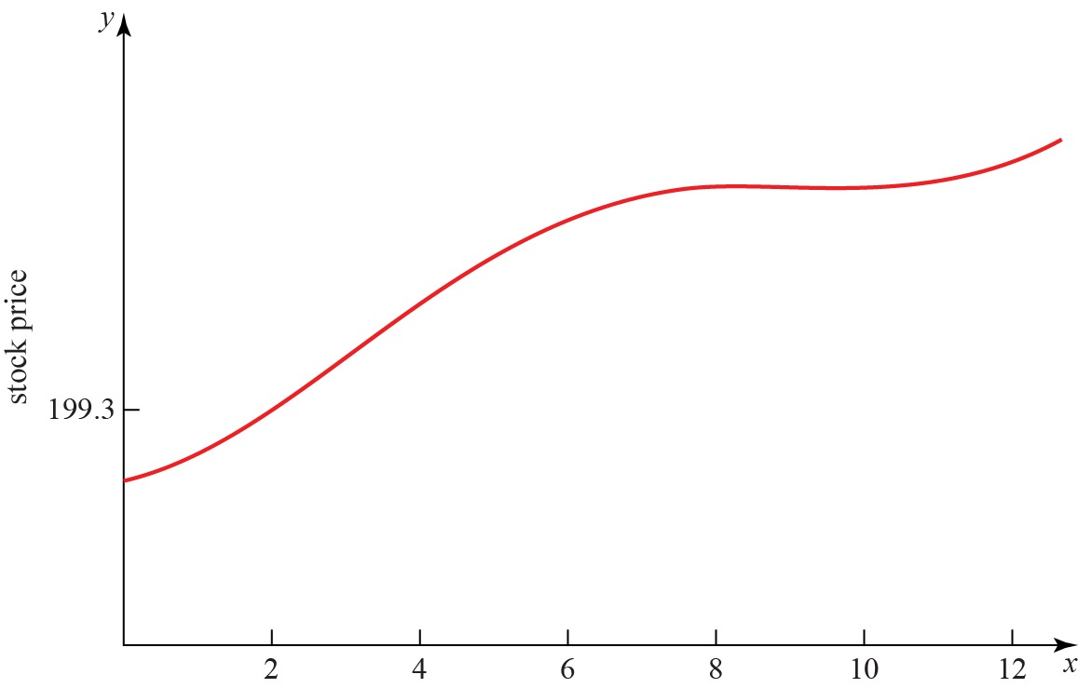

**a** The diagram shows a graph of the price of a stock during a 12-hour trading window.

The equation of the curve is given above.

Show that the price reaches a local maximum in the interval  **(5 marks)**

**b** Figure 1 shows that the price reaches a local minimum between 9 and 11 hours after trading begins.

Using the Newton–Raphson procedure once and taking t0 = 9.9 as a first approximation,

find a second approximation of when the price reaches a local minimum. **(6 marks)**

**14** 

**a** Find the values of the constants *A*, *B* and *C*. **(6 marks)**

**b** Hence, or otherwise, expandin ascending powers of *x*, as far as the *x*2 term.

**(6 marks)**

**c** Explain why the expansion is not valid for **(1 mark)**

**(TOTAL: 100 MARKS)**