**NAME:**

**PAPER L**

**Date to be handed in:**

**MARK (out of 100):**

|  |  |  |  |  |  |  |  |  |  |  |  |  |  |  |
| --- | --- | --- | --- | --- | --- | --- | --- | --- | --- | --- | --- | --- | --- | --- |
| **Qu** | **1** | **2** | **3** | **4** | **5** | **6** | **7** | **8** | **9** | **10** | **11** | **12** | **13** | **14** |
|  |  |  |  |  |  |  |  |  |  |  |  |  |  |  |

**Pure Mathematics**

**A Level: Practice Paper**

**Time: 2 hours**

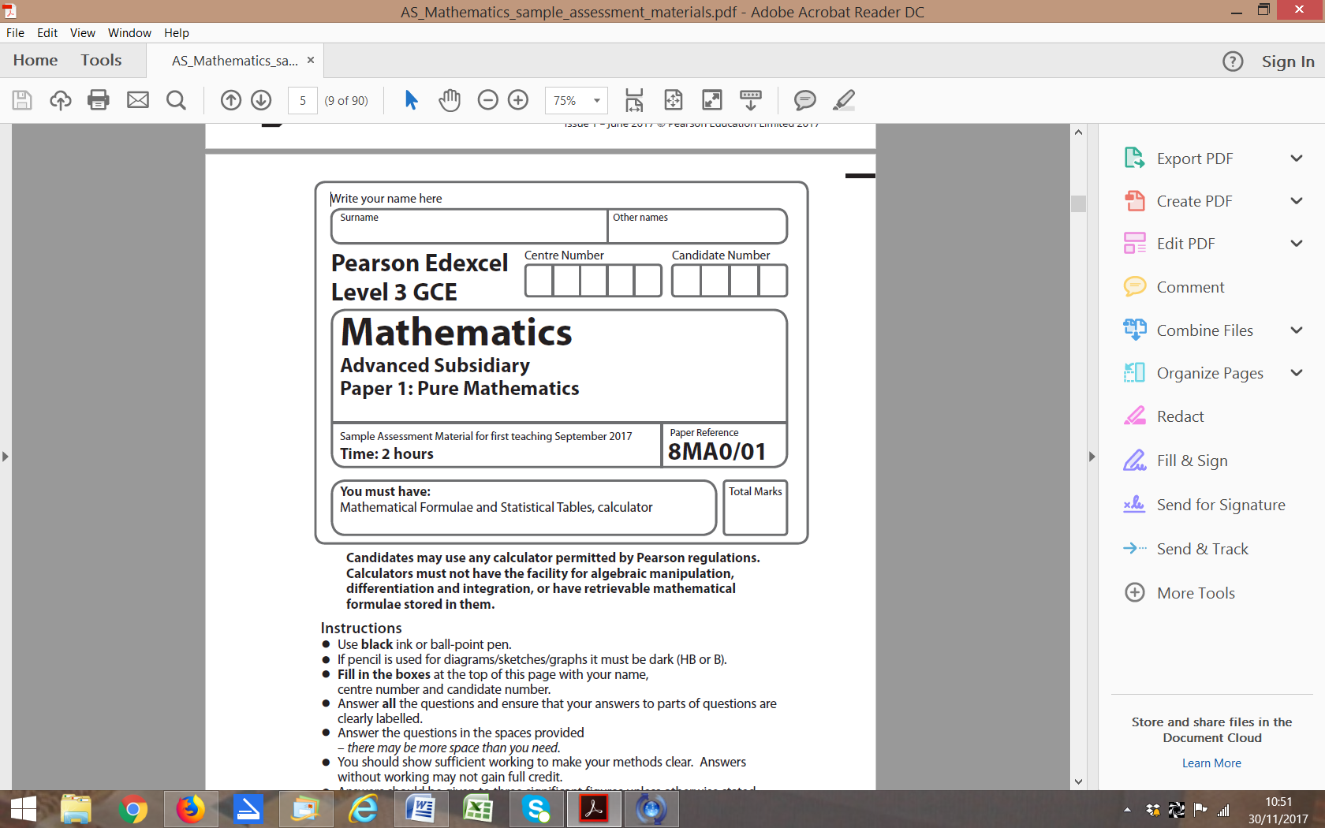

**Questions to revise:**

**1** It is suggested that the sequence  produces only prime numbers.

**a** Show that ,  and  produce prime numbers. **(2 marks)**

**b** Prove by counter example that the sequence does not always produce a prime number. **(2 marks)**

**2** Find **(4 marks)**

**3** Use proof by contradiction to show that, given a rational number *a* and an irrational number *b*,

*a* − *b* is irrational. **(4 marks)**

**4** Given that, find:

**a** in terms of *y* **(2 marks)**

**b** Show that where *k* is a constant which should be found. **(3 marks)**

**5** **a** Prove that **(3 marks)**

**b** Hence solve, in the interval , the equation  **(3 marks)**

**6** **a** Given that , show that  **(4 marks)**

**b** Hence prove that **(2 marks)**

**7** 

Show that f (*x*) can be written as  and find the values of *P*, *Q*, *R*, *V* and *W*.

**(7 marks)**

**8** The diagram shows a sketch of part of the graph *y* = f(*x*) where 

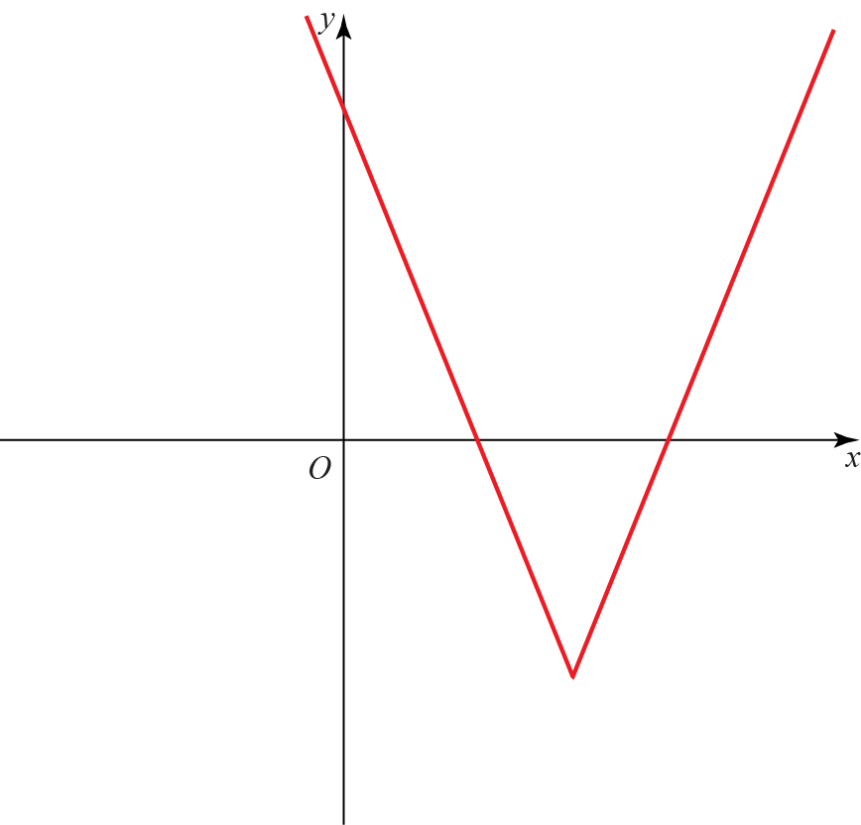

**a** State the range of f. **(1 mark)**

**b** Given that , where *k* is a constant has two distinct roots, state the possible values of *k*.

**(7 marks)**

**9** *C* has parametric equations ,, 

**a** Show that the cartesian equation of *C* is,over an appropriate domain.

**(4 marks)**

Given that *C* is a line segment and that the gradient of the line is −1,

**b** show that the length of the line segment is, where *a* is a rational number to be found.

**(4 marks)**

**10** Given that, find the value of *b* showing each step in your working.

**(8 marks)**

**11** At the beginning of each month Kath places £100 into a bank account to save for a family holiday.

Each subsequent month she increases her payments by 5%.

Assuming the bank account does not pay interest, find

**a** the amount of money in the account after 9 months. **(3 marks)**

Month *n* is the first month in which there is more than £6000 in the account.

**b** Show that  **(4 marks)**

Maggie begins saving at the same time as Kath. She initially places £50 into the same account and plans to increase her payments by a constant amount each month.

**c** Given that she would like to reach a total of £6000 in 29 months, by how much should Maggie

increase her payments each month? **(2 marks)**

**12** A particle of mass 3 kg is acted on by three forces, , 

and .

**a** Find the resultant force *R* acting on the particle. **(2 marks)**

**b** Find the acceleration of the particle, giving your answer in the form **(2 marks)**

**c** Find the magnitude of the acceleration. **(2 marks)**

**d** Given that the particle starts at rest, find the exact distance travelled by the particle

in the first 10 s. **(3 marks)**

**13** 

The graph *y* = h(*t*) models the height of a rocket *t* seconds after launch.

**a** Show that the rocket returns to the ground between 19.3 and 19.4 seconds after launch. **(2 marks)**

**b** Using *t*0 = 19.35 as a first approximation to *α*, apply the Newton–Raphson procedure once

to h(*t*) to find a second approximation to *α*, giving your answer to 3 decimal places. **(5 marks)**

**c** By considering the change of sign of h(*t*) over an appropriate interval, determine if your answer

to part **b** is correct to 3 decimal places. **(3 marks)**

**14** 

**a** Show that the first three terms in the series expansion of f(*x*) can be written as  **(7 marks)**

**b** Find the exact value of f (0.01). Round your answer to 7 decimal places. **(2 marks)**

**c** Find the percentage error made in using the series expansion in part **a** to estimate

the value of f (0.01). Give your answer to 2 significant figures. **(3 marks)**

**(TOTAL: 100 MARKS)**