|  |  |
| --- | --- |
| **Pearson Edexcel Level 3** | |
| **GCE Mathematics**  **Advanced Level**  **Paper 1 or 2: Pure Mathematics** | |
| **Practice Paper A**  **Time: 2 hours** | **Paper Reference(s)** |
| **9MA0/01 or 9MA0/02** |
| **You must have:**  **Mathematical Formulae and Statistical Tables, calculator** | |

**Candidates may use any calculator permitted by Pearson regulations. Calculators must not have the facility for algebraic manipulation, differentiation and integration, or have retrievable mathematical formulae stored in them.**

**Instructions**

• Use black ink or ball-point pen.

• If pencil is used for diagrams/sketches/graphs it must be dark (HB or B).

• Answer **all** questions and ensure that your answers to parts of questions are clearly labelled.

• Answer the questions in the spaces provided – *there may be more space than you need*.

• You should show sufficient working to make your methods clear. Answers without working may not gain full credit.

• Inexact answers should be given to three significant figures unless otherwise stated.

**Information**

• A booklet ‘Mathematical Formulae and Statistical Tables’ is provided.

• There are 15 questions in this paper. The total mark is 100.

• The marks for each question are shown in brackets – *use this as a guide as to how much time to spend on each question.*

**Advice**

• Read each question carefully before you start to answer it.

• Try to answer every question.

• Check your answers if you have time at the end.

• If you change your mind about an answer, cross it out and put your new answer and any working underneath.

**Answer ALL questions.**

**1.** It is suggested that the sequence  produces only prime numbers.

(a) Show that ,  and  produce prime numbers.

**(2 marks)**

(b) Prove by counter example that the sequence does not always produce a prime number.

**(2 marks)**

**___________________________________________________________________________________**

**2.** Find the angle that the vectormakes with the positive *y*-axis.

**(3 marks) ___________________________________________________________________________________**

**3.** , –40 < *x* < 20, *x* is in radians.

(a) Show that the equation g(*x*) = 0 can be written as 

**(3 marks)**

(b) Using the formula,, find, to 3 decimal places, the values of *x*1, *x*2 and *x*3.

**(2 marks) ___________________________________________________________________________________**

**4.** The first 3 terms of a geometric sequence are , . Find the value of *k*.

**(4 marks) ___________________________________________________________________________________**

**5.** 

Show that f (*x*) can be written as  and find the values of *P*, *Q*, *R*, *V* and *W*.

**(7 marks) ___________________________________________________________________________________**

**6.** Figure 1 shows a logo comprised of a rhombus surrounded by two arcs. Arc *BAD* has centre *C* and arc *BCD* has centre *A*. Some of the dimensions of the logo are shown in the diagram.

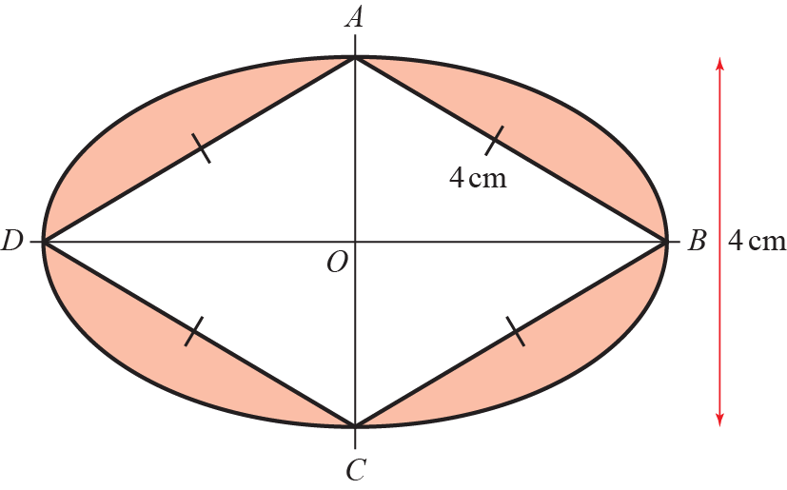

**Figure 1**

Prove that the shaded area of the logo is

**(8 marks) ___________________________________________________________________________________**

**7.** *C* has parametric equations ,, .

(a) Show that the cartesian equation of *C* is,over an appropriate domain.

**(4 marks)**

Given that *C* is a line segment and that the gradient of the line is −1,

(b) show that the length of the line segment is, where *a* is a rational number to be found.

**(4 marks) ___________________________________________________________________________________**

**8.** A toy soldier is connected to a parachute. The soldier is thrown into the air from ground level. The height, in metres, of the soldier above the ground can be modelled by the equation, where *H* is height of the soldier above the ground and *t* is the time since the soldier was thrown.

(a) Show that.

**(4 marks)**

(b) Using the differentiated function, explain whether the soldier was increasing or decreasing in height after 2 seconds.

**(2 marks)**

(c) Find the exact time when the soldier reaches a maximum height.

**(2 marks) ___________________________________________________________________________________**

**9.** (a) Show that.

**(4 marks)**

(b) Hence find the exact value of.

**(5 marks) ___________________________________________________________________________________**

**10.** Use proof by contradiction to show that, given a rational number *a* and an irrational number *b*, *a* − *b* is irrational.

**(4 marks) ___________________________________________________________________________________**

**11.** , *x* ∈ ℝ.

(a) Sketch the graph of *y* = f(*x*), labelling its vertex and any points of intersection with the coordinate axes.

**(5 marks)**

(b) Find the coordinates of the points of intersection of and.

**(5 marks) ___________________________________________________________________________________**

**12.** (a) Prove that 

**(3 marks)**

(b) Use the result to solve, for , the equation .

Give your answer in terms of π. Check for extraneous solutions.

**(4 marks) ___________________________________________________________________________________**

**13.** .

(a) Show that the first three terms in the series expansion of f(*x*) can be written as .

**(7 marks)**

(b) Find the exact value of f (0.01). Round your answer to 7 decimal places.

**(2 marks)**

(c) Find the percentage error made in using the series expansion in part (a) to estimate the value of f(0.01).

Give your answer to 2 significant figures.

**(3 marks) ___________________________________________________________________________________**

**14.** Jacob is making some patterns out of squares. The first 3 patterns in the sequence are shown in Figure 2.

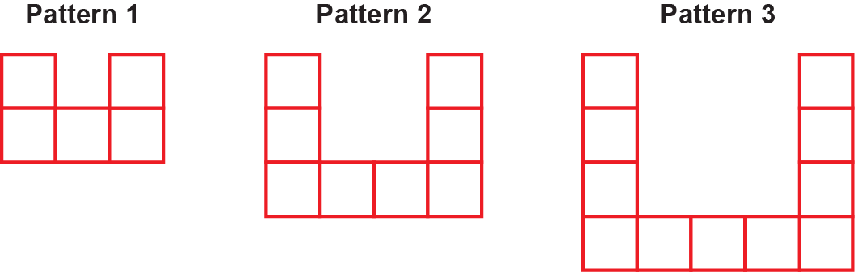

**Figure 2**

(a) Find an expression, in terms of *n*, for the number of squares required to make pattern *n.*

**(2 marks)**

Jacob uses a total of 948 squares in constructing the first *k* patterns.

(b) Show that .

**(2 marks) ___________________________________________________________________________________**

**15.** Figure 3 shows part of the curve with equation. The finite region bounded by the line with equation, the curve and the *x*-axis is shown shaded in the diagram.

Find the area of the shaded region.

**(7 marks)**

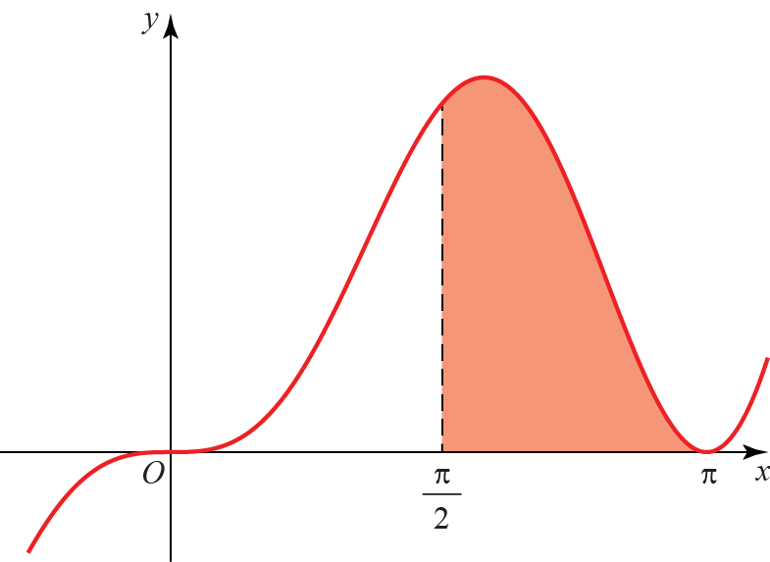

**Figure 3**

**____________________________________________________________________________**

**TOTAL FOR PAPER IS 100 MARKS**

**BLANK PAGE**