**NAME:**

**PAPER I**

**Date to be handed in:**

**MARK (out of 60):**

|  |  |  |  |  |  |  |  |  |
| --- | --- | --- | --- | --- | --- | --- | --- | --- |
| **Qu** | **1** | **2** | **3** | **4** | **5** | **6** | **7** | **TOTAL** |
|  |  |  |  |  |  |  |  |  |

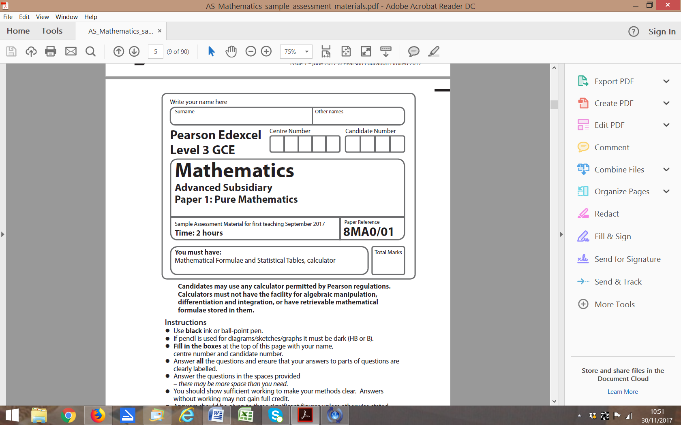

**Paper 2: Statistics and Mechanics**

**Time 1 hour 15 minutes**

**Practice Paper I**

**Questions to revise:**

**SECTION A: Statistics**

**1.** An online newspaper has a large number of readers, some of whom subscribe to extra content that can only be viewed if they pay a monthly fee. Based on reviews on the newspaper’s website, the editor of the newspaper believes that an additional publication could be introduced. Before making this change the editor decides to carry out a sample survey to obtain the opinions of the readers. He uses only those members who subscribe to the additional content.

(a) Define the population that would be generally associated with the newspaper.

**(1)**

(b) Suggest a suitable sampling frame for the survey.

**(1)**

(c) Identify the sampling units.

**(1)**

(d) Give one advantage and one disadvantage that would have resulted from the editor using a census rather than a sample survey.

**(2)**

As a pilot study the editor took a random sample of 25 subscribers.

(e) State two sources of uncertainty that could occur with sampling.

**(2)**

**(Total 7 marks)**

**___________________________________________________________________________**

**2.** Children from schools *A* and *B* took part in a fun run for charity. The times, to the nearest minute, taken by the children from school *A* are summarised in the figure below.

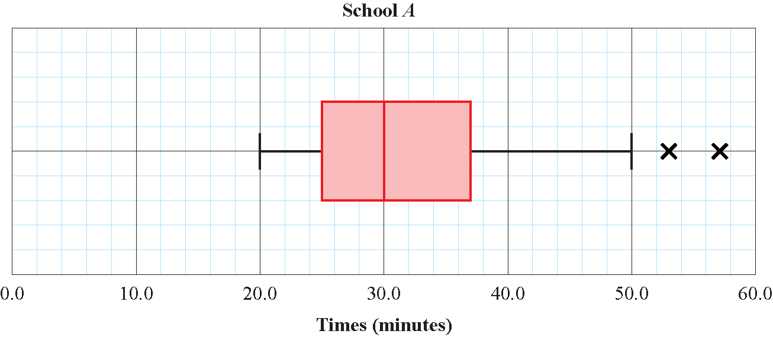

**Figure 2**

(a) (i) Write down the time by which 75% of the children in school *A* had completed the run.

**(1)**

(ii) State the name given to this value.

**(1)**

(b) Explain what the two crosses (×) represent on the box plot above. Interpret these in context.

**(2)**

For school *B* the least time taken by any of the children was 25 minutes and the longest time was 55 minutes. The three quartiles were 30, 37 and 50 minutes respectively.

(c) Use Q3 + 1.5(Q3 – Q1) and Q1 – 1.5(Q3 – Q1) to determine if there are any outliers. Give a reason for your conclusion.

**(3)**

(d) On graph paper, draw a horizontal box plot to represent the data from school *B* so the distribution of the times taken for the fun run by children in school *B* can easily be compared to school *A*.

**(3)**

(e) Compare and contrast the two distributions in context.

**(3)**

**(Total 10 marks)**

**___________________________________________________________________________**

**3.** Figure 2 is a histogram showing the distribution of the time taken in minutes, *t*, by a group of people to swim 500 m.

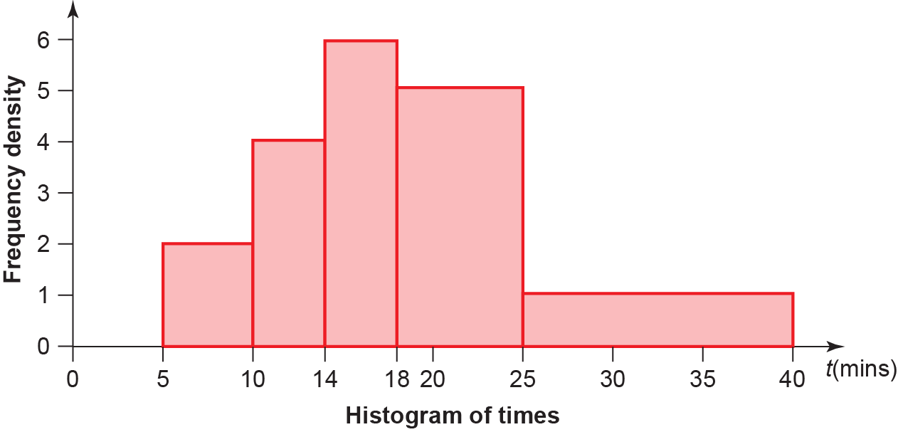

**Figure 2**

(a) Find the probability that a person chosen at random from the group takes longer than 18 minutes.

**(4)**

(b) Estimate the probability that a person chosen at random from the group takes less than 30 minutes.

**(3)**

**(Total 7 marks)**

**___________________________________________________________________________**

**4.** Brad planted 25 seeds in his greenhouse. He has read in a gardening book that the probability of one of these seeds germinating is 0.25. Ten of Brad’s seeds germinated. He claimed that the gardening book had underestimated this probability.

Test, at the 5% level of significance, Brad’s claim. State your hypotheses clearly.

**(Total 6 marks)**

**___________________________________________________________________________**

**SECTION B: Mechanics**

**5.** A ball is thrown vertically upwards with a speed of 16 m s−1 from a point 80 m above the ground.

(a) Find the speed with which the ball strikes the ground.

**(4)**

(b) Find the total time that the ball is more than 85 m above the ground.

**(6)**

When the ball strikes the ground it rebounds with of the speed with which it strikes the ground.

(c) Find the greatest height reached by the ball when it rebounds from the floor.

**(4)**

**(Total 14 marks)**

**___________________________________________________________________________**

**6.** A particle  *P*  is acted upon by three forces **F**1, **F**2 and **F**3 given by **F**1 = (6**i** – 4**j**) N, **F**2 = (–2**i** + 9**j**) N and **F**3 = (*a***i** + *b***j**) N, where *a* and *b* are constants.

Given that *P* is in equilibrium,

(a) find the value of *a* and the value of *b*.

**(2)**

The forceis now removed. The resultant of and is **R**.

(b) Find the magnitude of **R**.

**(3)**

(c) Find the angle, to 0.1°, that **R** makes with **i**.

**(2)**

**(Total 7 marks)**

**___________________________________________________________________________**

**7.** A cyclist is descending down a mountain with constant acceleration. She passes through three checkpoints, *P*, *Q* and *R*, with velocity 6 m s−1, *x* m s−1, and 20 m s−1 repsectively. The time to taken to travel from *P* to *R* is 35 s.

(a) Find the acceleration of the cyclist.

**(2)**

Given that , where *t*1 s is the time taken to travel from *P* to *Q* and *t*2 s is the time taken to travel from *Q* to *R*.

(b) Find the value of *x*.

**(5)**

(c) Find the distance between *P* and *R*.

**(2)**

**(Total 9 marks)**

**___________________________________________________________________________**

**TOTAL FOR PAPER IS 60 MARKS**