**NAME:**

**PAPER H**

**Date to be handed in:**

**MARK (out of 60):**

|  |  |  |  |  |  |  |  |  |
| --- | --- | --- | --- | --- | --- | --- | --- | --- |
| **Qu** | **1** | **2** | **3** | **4** | **5** | **6** | **7** | **TOTAL** |
|  |  |  |  |  |  |  |  |  |

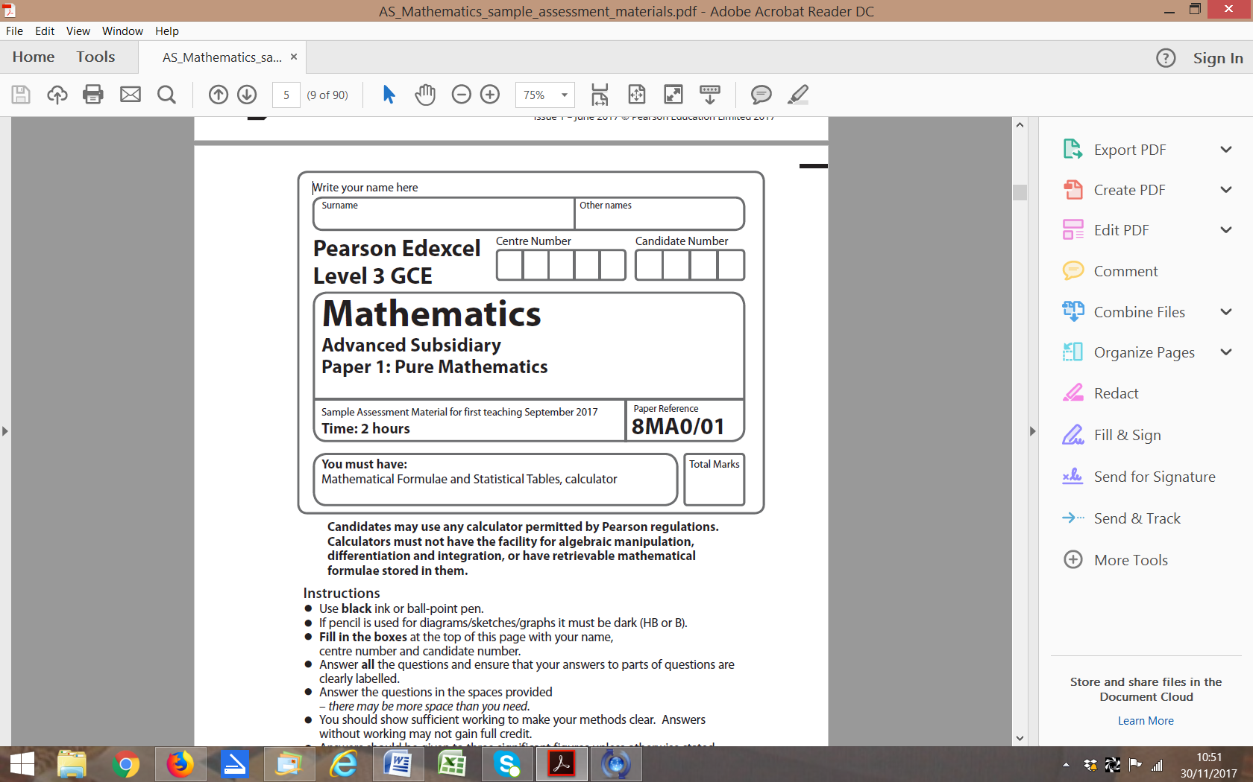

**Paper 2: Statistics and Mechanics**

**Time 1 hour 15 minutes**

**Practice Paper H**

**Questions to revise:**

**SECTION A: Statistics**

**1.** Graham is researching the affects a high protein diet has on the glucose level of adults aged 25 to 35. He decides to collect blood samples from 50 females and 50 males.

(a) State the sampling technique Graham has used.

**(1)**

(b) Give two advantages and one disadvantage of this sampling technique.

**(3)**

Graham then decides to select the 50 male blood samples from an alphabetical list of 300 names of males aged 25 to 35, each of whom has agreed to supply a sample if asked.

(c) Explain how Graham could use a calculator or a random number generator to take a simple random sample from the males aged 25 to 35.

**(3)**

Graham has an equivalent list of 300 females.

(d) Explain how Graham could take a systematic sample of blood from females aged 25 to 35.

**(2)**

**(Total 9 marks)**

**___________________________________________________________________________**

**2.** A travel agent sells flights to different destinations from Southstead airport. The distance of the destination from the airport is denoted *d* where *d* is measured in 100 km units so that *d* = 2.2 represents a distance of 220 km. Values of *d* and the associated fare £*f* are recorded for a random sample of 6 destinations.

|  |  |  |  |  |  |  |
| --- | --- | --- | --- | --- | --- | --- |
| **Destination** | *A* | *B* | *C* | *D* | *E* | *F* |
| ***d* (100 km)** | 2.2 | 4.0 | 6.0 | 2.5 | 8.0 | 5.0 |
| ***f* (£)** | 18 | 20 | 25 | 23 | 32 | 28 |

(a) Using the axes opposite, complete a scatter diagram to illustrate this information.

**(2)**

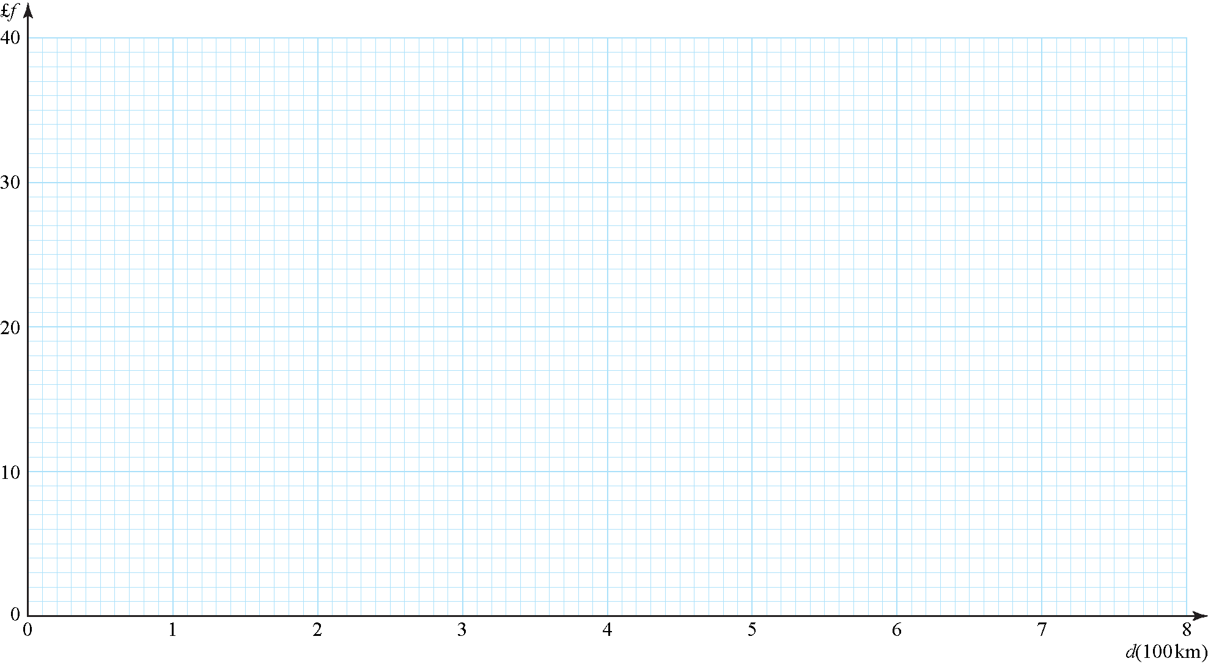

**Figure 1**

(b) Explain why a linear model may be appropriate to describe the relationship between *f*and *d*.

**(1)**

(c) State which of *f* and *d* should be considered the response variable.

**(1)**

(d) Use a line of best fit to estimate a fare £*f* for a flight to a destination which is 700 km away.

**(2)**

(e) Comment on the reliability of your estimate, giving a reason for your answer.

**(1)**

Jane is planning her holiday and wishes to fly from Southstead airport to a destination 180 km away.

(f) State if it is sensible for Jane to estimate the fare of her flight using the scatter graph, giving a reason for your answer.

**(1)**

**(Total 8 marks)**

**___________________________________________________________________________**

**3.** On a randomly chosen day the probability that Bill travels to school by car, by bicycle or on foot is,andrespectively. The probability of being late when using these methods of travel is ,andrespectively.

(a) Draw a tree diagram to represent this situation.

**(3)**

(b) Find the probability that on a randomly chosen day

(i) Bill travels by foot and is late,

**(2)**

(ii) Bill is not late.

**(2)**

**(Total 7 marks)**

**___________________________________________________________________________**

**4.** A company claims that a quarter of the bolts sent to them are faulty. To test this claim the number of faulty bolts in a random sample of 50 is recorded.

(a) Give two reasons why a binomial distribution may be a suitable model for the number of faulty bolts in the sample.

**(2)**

(b) Using a 5% significance level with the model of a binomial distribution, find the critical region for a 2-tail test of the hypothesis that the probability of a bolt being faulty is 0.25. The probability of rejection in each tail should be less than 0.025.

**(4)**

**(Total 6 marks)**

**___________________________________________________________________________**

**SECTION B: Mechanics**

**5.** An ice hockey puck is hit and initially travels with a velocity of (14**i** + 22**j**) m s−1

(a) Find the speed of the puck.

**(3)**

(b) Find the angle of direction of motion the puck makes with the unit vector **j**.

**(4)**

(c) State the effect of modelling the ice as a smooth surface.

**(1)**

(d) A hockey puck has a density of 1.4 g cm−3. Convert this into kg m−3.

**(4)**

**(Total 12 marks)**

**___________________________________________________________________________**

**6.** A sled is moving down a steep hill in a straight line. At time *t* s, the acceleration of the sled is *a* m s−2 where , 0 ⩽ *t* ⩽ 20. When *t* = 0 the sled is at rest at the top of the hill.

Find the distance the sled travels in the first 10 s of its motion.

**(Total 5 marks)**

**___________________________________________________________________________**

**7.** A car starts from the point *A*. At time *t* s after leaving *A*, the distance of the car from *A* is*s*m, where, 0 ⩽ *t* ⩽ 25. The car reaches the point *B* when *t* = 25.

(a) Find the distance *AB*.

**(2)**

(b) Show that the car travels with a constant acceleration and state the value of this acceleration.

**(3)**

A runner passes through *B* when *t* = 0 with an initial velocity of 2 m s−1 running directly towards *A*. The runner has a constant acceleration of 0.1 m s−2.

(c) Find the distance from *A* at which the runner and the car pass one another.

**(8)**

**(Total 13 marks)**

**___________________________________________________________________________**

**TOTAL FOR PAPER IS 60 MARKS**