NAME:
PAPER G

Date to be handed in:

MARK (out of 60):

Qu | 1 | 2 | 3 | 4 | 5 | 6 | 7 | TOTAL

Paper 2: Statistics and Mechanics
Time 1 hour 15 minutes
Practice Paper G

Questions to revise:

SECTION A: Statistics

1. Before redecorating the school canteen the headteacher decided to survey the opinion of staff and students.

(a) Explain why the headteacher decided to take a stratified sample of staff and students.
(1)

(b) Suggest a suitable sampling frame.
(1)

(c) Identify the sampling units.
(1)

There are 250 students and 30 staff at the school.

(d) Explain how the headteacher could take a stratified sample of size 60.
(3)

(e) Suggest a problem that might arise with the sampling frame when selecting the staff and students.
(1)
(Total 7 marks)
___________________________________________________________________________

2. Cotinine is a chemical that is made by the body from nicotine which is found in cigarette smoke. A doctor tested the blood of 12 patients, who claimed to smoke one packet of cigarettes per day, for cotinine. The results are shown below.

Patient | A | B | C | D | E | F | G | H | I | J | K | L
Cotinine level,  x (ng/ml) | 160 | 390 | 169 | 175 | 125 | 420 | 171 | 250 | 210 | 258 | 186 | 243

(a) The lower quartile of these data is 170 ng/ml. Find the upper quartile.
(2)

A doctor suspects that some of his patients have been smoking more than one packet of cigarettes per day. He decides to use Q3 + 1.5(Q3 – Q1) to determine if any of the cotinine results are far enough away from the upper quartile to be considered as outliers.

(b) Identify which patient(s) the doctor suspects may have been smoking more than one packet of cigarettes per day on this basis. Show your working clearly.
(3)
(Total 5 marks)
___________________________________________________________________________

3. Figure 1 is a Venn diagram showing the number of students in a class who read any of three popular magazines A, B and C.

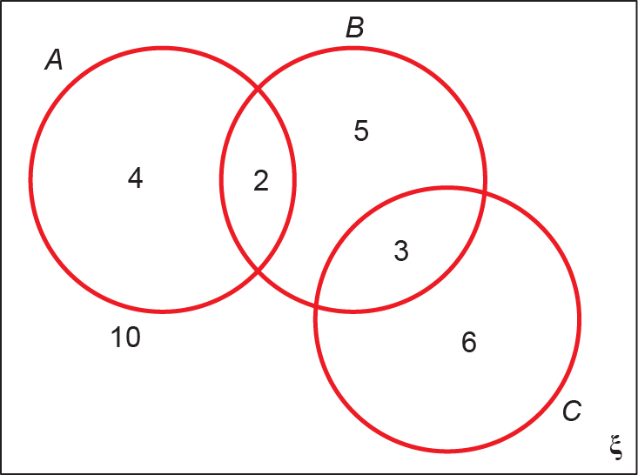

Figure 1

One of these students is selected at random.
(a) Show that the probability that the student reads more than one magazine is.
(2)

(b) Find the probability that the student reads A or B (or both).
(2)

(c) Write down the probability that the student reads both A and C and explain what this probability tells you about A and C.
(2)

(d) Given that the student reads at least one of the magazines, find the probability that the student reads C.
(1)

(e) Determine whether or not reading magazine B and reading magazine C are independent.
(3)
(Total 10 marks)
___________________________________________________________________________

4. The discrete random variable X has probability function

where k is a positive constant.

(a) Show that k = 0.25
(2)

Two independent observations X₁ and X₂ are made of X.

(b) Show that P(X₁ + X₂ = 5) = 0
(1)

(c) Find the complete probability function for X₁ + X₂.
(3)
(d) Find P(1.3 ⩽ X₁ + X₂ ⩽ 3.2)
(2)
(Total 8 marks)
___________________________________________________________________________

SECTION B: Mechanics

5. A person runs across a field from point A to point B with a speed of 5.3 m s⁻¹ and then runs back from point B to point A with a speed of 4.8 m s⁻¹.

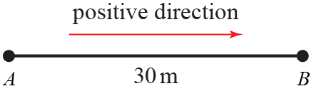

Figure 1

Taking the positive direction as shown in the diagram, state the person’s

(a) velocity when travelling from A to B,
(1)

(b) velocity when travelling from B to A.
(1)

Another person runs 30 m from A in the exact opposite direction of B to a point C.

(c) State this person’s displacement from A at the point C.
(1)
(Total 3 marks)
___________________________________________________________________________

6. A car is initially travelling with a constant velocity of 15 m s⁻¹ for T s. It then decelerates at a constant rate fors, reaching a velocity of 10 m s⁻¹. It then immediately accelerates at a constant rate fors reaching a velocity of 20 m s⁻¹.

(a) Sketch a velocity–time graph to illustrate the motion.
(3)

(b) Given that the car travels a total distance of 1312.5 m over the journey described, find the value of T.
(4)
(Total 7 marks)
___________________________________________________________________________

7. A car of mass 1200 kg pulls a trailer of mass 400 kg along a straight horizontal road. The car and trailer are connected by a tow-rope modelled as a light inextensible rod. The engine of the car provides a constant driving force of 3200 N. The horizontal resistances of the car and the trailer are proportional to their respective masses. Given that the acceleration of the car and the trailer is 0.4 m s⁻²,

(a) find the resistance to motion on the trailer,
(4)

(b) find the tension in the tow-rope.
(3)

When the car and trailer are travelling at 25 m s⁻¹ the tow-rope breaks. Assuming that the resistances to motion remain unchanged,

(c) find the distance the trailer travels before coming to a stop.
(4)

(d) State how you have used the modelling assumption that the tow-rope is
inextensible.
(1)
(Total 12 marks)
___________________________________________________________________________

8. A particle P travels in a straight line.

At time t s, the displacement of P from a point O on the line is s m. At time t s, the acceleration of P is (12t – 4) m s⁻². When t = 1, s = 2 and when t = 3, s = 30.

Find the displacement when t = 2.
(Total 8 marks)
___________________________________________________________________________

TOTAL FOR THIS PAPER IS 60 MARKS

