NAME:
PAPER F

Date to be handed in:

MARK (out of 60):

Qu | 1 | 2 | 3 | 4 | 5 | 6 | 7 | 8 | 9 | TOTAL

Paper 2: Statistics and Mechanics
Time 1 hour 15 minutes
Practice Paper F

Questions to revise:

SECTION A: Statistics

1. (a) Explain what is meant by the word ‘population’.
(1)

Jo needs to conduct a survey to investigate the type of kitchen cleaner people prefer. She wants a random sample of people who use kitchen cleaners. She decides to stand in a busy high street on a Saturday afternoon and attempt to get shoppers to answer her questions.

(b) State the sampling technique Jo has used.
(1)

Having been unsuccessful in obtaining enough data from her previous attempt, Jo decides to look at the electoral register for a town and selects a sample of 50 households to contact. She decides to select every 10th name on the electoral register to add to her sample.

(c) State the sampling technique Jo has used.
(1)

(d) Give two reasons why Jo may again be unsuccessful getting the data required using this sampling technique.
(2)

(e) Suggest an alternative method for Jo to use and explain your reasons.
(2)
(Total 7 marks)
___________________________________________________________________________

2. A company assembles drills using components from two sources. Goodbuy supplies the components for 85% of the drills whilst Amart supplies the components for the rest.

It is known that 3% of the components supplied by Goodbuy are faulty and 6% of those supplied by Amart are faulty.

(a) Represent this information on a tree diagram.
(3)

An assembled drill is selected at random.

(b) Find the probability that the drill is not faulty.
(3)
(Total 6 marks)
___________________________________________________________________________

3. A couple wish to go on a holiday sometime in July or August. They cannot decide whether to visit Perth in Australia or Beijing in China. The weather will be a deciding factor. The box plots show the daily mean temperature and daily rainfall for Perth and Beijing in July and August 2015. Based on the box plots, state three observations that may help the couple decide whether to spend their holiday in Perth or Beijing.

Figure 3

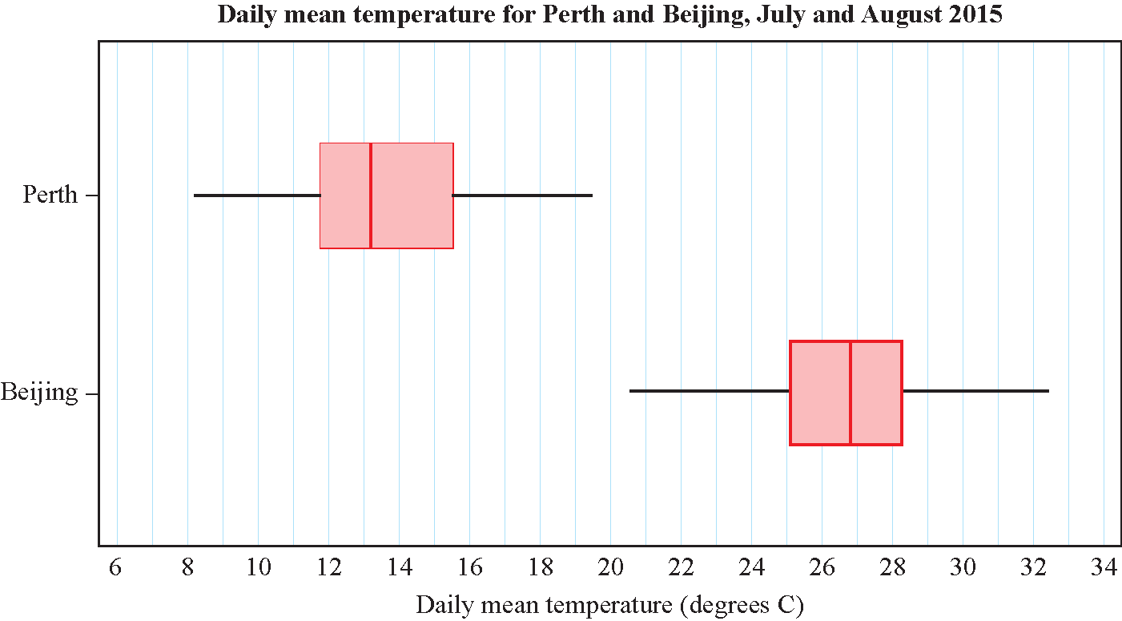

Figure 3

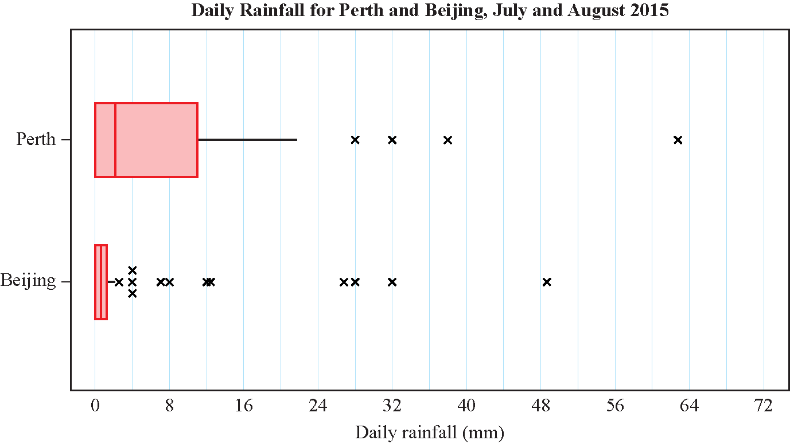

Figure 4
(Total 5 marks)
___________________________________________________________________________
4. Emma throws a fair coin 15 times and records the number of times it shows a head.

(a) State the appropriate distribution to model the number of times the coin shows a head giving any relevant parameter values.
(2)

(b) Find the probability that Emma records:

(i) exactly 8 heads
(2)

(ii) at least 4 heads.
(2)
(Total 6 marks)
___________________________________________________________________________

5. A single observation x is to be taken from a binomial distribution B(20, p).

This observation is used to test H₀: p = 0.3 against H₁: p ≠ 0.3

(a) Under H₀: X~B(20, 0.3), using a 5% level of significance, find the critical region for this test. You should state the probability of rejection in each tail, which should be less than 2.5 %.
(3)

(b) State the actual significance level of this test.
(1)

The actual value of x obtained is 3.

(c) State a conclusion that can be drawn based on this value, giving a reason for your answer.
(2)
(Total 6 marks)
___________________________________________________________________________

SECTION B: Mechanics

6. A boat travels from A to B and then from B to C. The displacement from A to B is (−28i + 80j) m. The displacement from B to C is (130i + 15j) m.

(a) Find the total distance the boat travelled in moving from A to C.
(4)

(b) Find the angle the vector makes with the unit vector i.
(4)
(Total 8 marks)
___________________________________________________________________________

7. A racing car starts from rest at the point A and moves with constant acceleration.of 11 m s⁻² for 8 s. The velocity it has reached after 8 s is then maintained for T s. The racing car then decelerates from this velocity to 40 m s⁻¹ in a further 2 s, reaching point B.

(a) Sketch a velocity–time graph to illustrate the motion of the racing car. Include the top speed of the racing car in your sketch.
(5)

(b) Given that the distance between A and B is 1404 m, find the value of T.
(3)
(Total 8 marks)
___________________________________________________________________________

8. A particle of mass 6 kg is initially at rest and is then acted upon by a force R = (ai + 10j) N on a bearing of 300°.

(a) Find the exact value of a.
(3)

(b) Calculate the magnitude of R.
(2)

(c) Work out the magnitude of the acceleration of the particle.
(2)

(d) Find the time it takes for the particle to travel a distance of 640 m.
(2)
(Total 9 marks)
___________________________________________________________________________

9. A particle P moves along a straight line. Initially, P is at rest at a point O on the line.
At time t s, the velocity of P is v m s⁻¹, where , 0 ⩽ t ⩽ 8.

Find the values of t and the corresponding values of v when the acceleration of P is instantaneously zero.
(Total 5 marks)
___________________________________________________________________________

TOTAL FOR THIS PAPER IS 60 MARKS

