Pearson Edexcel Level 3
GCE Mathematics
Advanced Subsidiary
Paper 2: Statistics & Mechanics
Specimen paper  Time: 1 hour 15 minutes | Paper Reference(s)
 | 8MA0/02
You must have:
Mathematical Formulae and Statistical Tables, calculator

Candidates may use any calculator permitted by Pearson regulations. Calculators must not have the facility for algebraic manipulation, differentiation and integration, or have retrievable mathematical formulae stored in them.

Instructions
• Use black ink or ball-point pen.
• If pencil is used for diagrams/sketches/graphs it must be dark (HB or B).
• Fill in the boxes at the top of this page with your name, centre number and candidate number.
• Answer all the questions in Section A and Section B.
• Answer the questions in the spaces provided – there may be more space than you need.
• You should show sufficient working to make your methods clear. Answers without working may not gain full credit.
• Inexact answers should be given to three significant figures unless otherwise stated.
Information
• A booklet ‘Mathematical Formulae and Statistical Tables’ is provided.
• There are 4 questions in this section. The total mark for this paper is 60.
• The marks for each question are shown in brackets – use this as a guide as to how much time to spend on each question.
Advice
• Read each question carefully before you start to answer it.
• Try to answer every question.
• Check your answers if you have time at the end.
• If you change your mind about an answer, cross it out and put your new answer and any working underneath.
SECTION A: STATISTICS
Answer ALL questions.

1. A company manager is investigating the time taken, t minutes, to complete an aptitude test. The human resources manager produced the table below of coded times, x minutes, for a random sample of 30 applicants.

Coded time  (x minutes) | Frequency (f ) | Coded time midpoint  (y minutes)
0 ≤ x < 5 | 3 | 2.5
5 ≤ x < 10 | 15 | 7.5
10 ≤ x < 15 | 2 | 12.5
15 ≤ x < 25 | 9 | 20
25 ≤ x < 35 | 1 | 30

(You may use ∑fy = 355 and ∑f y ² = 5675)

(a) Use linear interpolation to estimate the median of the coded times.
(2)

(b) Estimate the standard deviation of the coded times.
(2)

The company manager is told by the human resources manager that he subtracted 15 from each of the times and then divided by 2, to calculate the coded times.

(c) Calculate an estimate for the median and the standard deviation of t.
(3)

The following year, the company has 25 positions available. The company manager decides not to offer a position to any applicant who takes 35 minutes or more to complete the aptitude test.

The company has 60 applicants.

(d) Comment on whether or not the company manager’s decision will result in the company being able to fill the 25 positions available from these 60 applicants. Give a reason for your answer.
(2)

(Total for Question 1 is 9 marks)
___________________________________________________________________________

2. The discrete random variable X ~ B(30, 0.28)

(a) Find P(5 ≤ X < 12).
(2)

Past records from a large supermarket show that 25% of people who buy eggs, buy organic eggs. On one particular day a random sample of 40 people is taken from those that had bought eggs and 16 people are found to have bought organic eggs.

(b) Test, at the 1% significance level, whether or not the proportion p of people who bought organic eggs that day had increased. State your hypotheses clearly.
(5)

(c) State the conclusion you would have reached if a 5% significance level had been used for this test.
(1)

(Total for Question 2 is 8 marks)
___________________________________________________________________________
3. Pete is investigating the relationship between daily rainfall, w mm, and daily mean pressure, p hPa, in Perth during 2015. He used the large data set to take a sample of size 12.

He obtained the following results.

p | 1007 | 1012 | 1013 | 1009 | 1019 | 1010 | 1010 | 1010 | 1013 | 1011 | 1014 | 1022
w | 102.0 | 63.0 | 63.0 | 38.4 | 38.0 | 35.0 | 34.2 | 32.0 | 30.4 | 28.0 | 28.0 | 15

Pete drew the following scatter diagram for the values of w and p and calculated the quartiles.
 | Q₁ | Q₂ | Q₃
p | 1010 | 1011.5 | 1013.5
w | 29.2 | 34.6 | 50.7

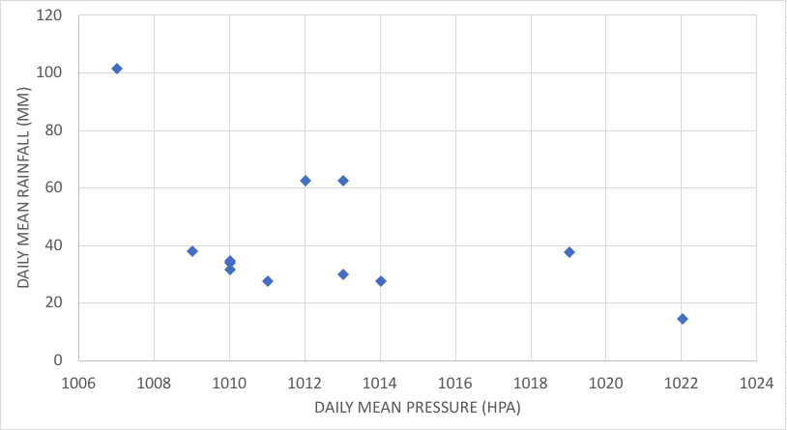

An outlier is a value which is more than 1.5 times the interquartile range above Q3 or more than 1.5 times the interquartile range below Q1.

(a) Show that the 3 points circled on the scatter diagram above are outliers.
(2)

(b) Describe the effect of removing the 3 outliers on the correlation between daily rainfall and daily mean pressure in this sample.
(1)

John has also been studying the large data set and believes that the sample Pete has taken is not random.

(c) From your knowledge of the large data set, explain why Pete’s sample is unlikely to be a random sample.
(1)
John finds that the equation of the regression line of w on p, using all the data in the large data set, is
w = 1023 – 0.223p

(d) Give an interpretation of the figure –0.223 in this regression line.
(1)

John decided to use the regression line to estimate the daily rainfall for a day in December when the daily mean pressure is 1011 hPa.

(e) Using your knowledge of the large data set, comment on the reliability of John’s estimate.
(1)
(Total for Question 3 is 6 marks)
___________________________________________________________________________

4. Alyona, Dawn and Sergei are sometimes late for school.

The events A, D and S are as follows:
A Alyona is late for school
D Dawn is late for school
S Sergei is late for school

The Venn diagram below shows the three events A, D and S and the probabilities associated with each region of D. The constants p, q and r each represent probabilities associated with the three separate regions outside D.

0.1
0.05
r
A
D
S

(a) Write down 2 of the events A, D and S that are mutually exclusive. Give a reason for your answer.
(1)

The probability that Sergei is late for school is 0.2. The events A and D are independent.

(b) Find the value of r.
(4)

Dawn and Sergei’s teacher believes that when Sergei is late for school, Dawn tends to be late for school.

(c) State whether or not D and S are independent, giving a reason for your answer.
(1)

(d) Comment on the teacher’s belief in the light of your answer to part (c).
(1)

(Total for Question 4 is 7 marks)
___________________________________________________________________________

SECTION B: MECHANICS
Answer ALL questions.

1. A small ball is projected vertically upwards from a point A which is 19.6 m above the ground. The ball strikes the ground, for the first time, 4 s later.

The motion of the ball is modelled as that of a particle moving freely under gravity.

(a) Use the model to find the speed of the ball as it hits the ground for the first time.
(3)
The ball rebounds from the ground with a vertical speed of 14.7 m s^{–1} and next comes to instantaneous rest at the point B.

(b) Use the model to find the height of B above the ground.
(2)
In a refined model of the motion of the ball, the effect of air resistance is included and this refined model is now used to find the speed of the ball as it hits the ground for the first time

(c) How would this new value of the speed of the ball as it hits the ground for the first time compare with the value found using the initial model in part (a)?
(1)
(Total 6 marks)
___________________________________________________________________________

2. A car travels along a straight horizontal road between two sets of traffic lights. The distance between the two sets of traffic lights is 1500 m.

In a model of the journey, the car leaves the first set of traffic lights, accelerating uniformly from rest until it reaches a speed of V m s^{–1}, then immediately decelerates uniformly until it comes to rest at the second set of traffic lights. The car completes the journey between the two sets of lights in 120 s.

(a) Sketch a velocity-time graph which represents the above model of the journey of the car between the two sets of traffic lights.
(2)
(b) Using the model, find the value of V.
(2)
It is given that the car accelerates uniformly for T seconds.

(c) Explain why there is a range of possible values for T which satisfy the requirements of the model.
(2)
(d) Suggest one improvement to the model that would make it more realistic.
(1)
(Total 7 marks)
___________________________________________________________________________
3.

P (0.4 kg)

Q (M kg)

2 m

Figure 1

A ball, P, of mass 0.4 kg rests on a rough horizontal table and is attached to one end of a thin rope. The rope passes over a pulley which is fixed at the edge of the table. The other end of the rope is attached to another ball, Q, of mass M kg which hangs freely below the pulley, as shown in Figure 1.

The system is released from rest with the rope taut and with Q at a height of 2 m above the ground and Q moves downwards with acceleration 2.5 m s^{–2}. In the subsequent motion P does not reach the pulley before Q reaches the ground.

The balls are modelled as particles, the rope as a light and inextensible string and the pulley as being small and smooth. The total resistance to the motion of P is modelled as having constant magnitude 1.5 N. The acceleration due to gravity is modelled as being 10 m s^{–2}.

Using this model, find, to 2 significant figures,

(a) (i) the tension in the rope,
(ii) the value of M,
(6)

(b) the time, after release, for Q to hit the ground.
(2)

(c) State one limitation of the model which will affect the accuracy of your answer to part (a). (1)
(Total 9 marks)
___________________________________________________________________________

4. A particle P moves along a straight line such that at time t seconds, t 0, its velocity, v m s^{–1}, is given by
v = 16 – 3t²

Find

(a) the distance travelled by P in the first second,
(3)

(b) the value of t at the instant when P changes its direction of motion,
(2)

(c) the value of t at the instant when P returns to its starting point.
(3)
(Total 8 marks)
___________________________________________________________________________

TOTAL FOR THIS PAPER: 60 MARKS

BLANK PAGE

