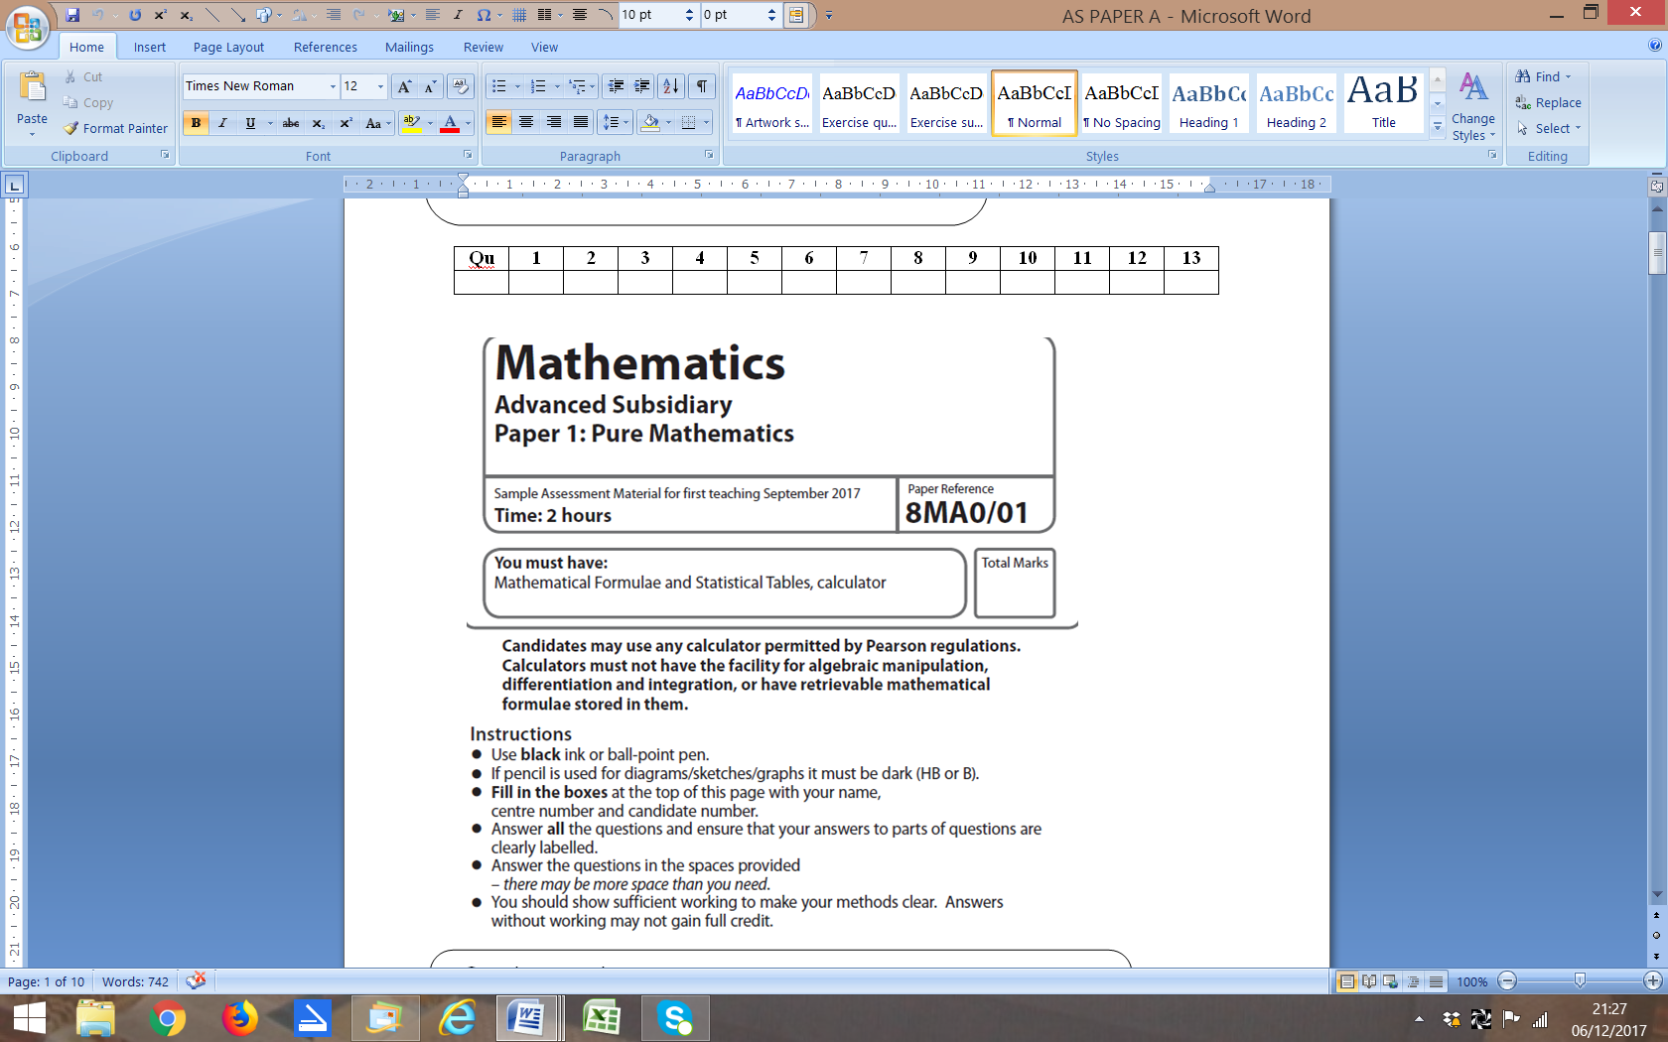

**PAPER A Mark Scheme**

|  |  |
| --- | --- |
| Considers the expression  either on its own or as part of an inequality/equation with 0 on the other side.  **1.** | **M1** |
| Makes an attempt to complete the square. For example, stating:  (ignore any (in)equation) | **M1** |
| States a fully correct answer:  (ignore any (in)equation) | **A1** |
| Interprets this solution as proving the inequality for all values of *x*. Could, for example, state that  as a number squared is always positive or zero, therefore . Must be logically connected with the statement to be proved; this could be in the form of an additional statement. So (for all *x*) or by a string of connectives which must be equivalent to “if and only if”s. | **A1** |
|  | **Total: 4 marks** |

**NOTE:** Any correct and complete method is acceptable for demonstrating that  for all *x*.

(e.g. finding the discriminant and single value,

finding the minimum point by differentiation

or completing the square and showing that it is both positive and a minimum, sketching the graph

supported with appropriate methodology etc).

|  |  |
| --- | --- |
| **2a** | **B1** |
| Correct substitution of (4, −7) or (−6, 11) and their gradient into *y* = *mx* + *b* or *y* − *y1* = *m*(*x* − *x*1) o.e. to find the equation of the line.  For example, or or or . | **M1** |
| 5*y* + 9*x* − 1 = 0 or −5*y* − 9*x* + 1 = 0 only | **A1** |
|  | **(3 marks)** |
| so. Award mark for seen.  **2b** | **B1** |
| so . Award mark for  seen. | **B1** |
| Area = | **B1** |
|  | **(3 marks)** |
|  | **Total: 6 marks** |

|  |  |
| --- | --- |
| Makes an attempt to begin solving the equation. For example, states that  **3** | **M1** |
| Uses the identity  to write, | **M1** |
| States or implies use of the inverse tangent.  For example,  or | **M1** |
| Shows understanding that there will be further solutions in the given range, by adding 180° to 30° at least once.  (ignore any out of range values). | **M1** |
| Subtracts 20 and divides each answer by 3.  (ignore any out of range values). | **M1** |
| States the correct final answers to 1 decimal place. cao | **A1** |
| **4** | **Total: 6 marks** |

|  |  |  |  |
| --- | --- | --- | --- |
| Uses appropriate law of logarithms to write | | **M1** | |
| Inverse log11 (or 11 to the) both sides. | | **M1** | |
| Derives a 3 term quadratic equation. | | **M1** | |
| Correctly factorisesor uses appropriate technique to solve their quadratic. | | **M1** | |
| Solves to find | | **A1** | |
| Understands that stating that this solution would require taking the log of a negative number, which is not possible. | | **B1** | |
|  | **Total: 6 marks** | |

|  |  |
| --- | --- |
| Equates the **i** components for the equation **a** + **b** = *m***c** o.e. 2*p* + 6 = 4*m*  **5a** | **B1** |
| Equates the **j** components for the their equation **a** + **b** = *m***c** −5 − 3*p* = −5*m* | **B1** |
| Makes an attempt to find *p* by eliminating *m* in some way.  For example,o.e. or o.e. | **M1** |
| *p* = 5 | **A1** |
| **NOTES:** Alternatively, M1: attempt to eliminate *p* first. A1: *m* = 4 and *p* = 5 | **(4 marks)** |
| Using their value for *p* from above, makes a substitution into the vectors to form **a** + **b**  **5b**  10**i** – 5**j** + 6**i** – 15**j** | **M1ft** |
| Correctly simplifies. 16**i** – 20**j** | **A1ft** |
| **NOTES: OR**  M1ft: substitute their *m* = 4 into their **a** + **b** = *m***c**. A1ft: correct simplification. | **(2 marks)** |
|  | **Total: 6 marks** |

**6c**

**6a**

**6b**

|  |  |
| --- | --- |
| Makes an attempt to subsitute 7 into the equation, for example, seen. | **M1** |
| 1644 or 1640 only (do not accept non-integeric final answer). | **A1** |
|  | **(2 marks)** |
| It is the initial bacteria population. | **B1** |
|  | **(1 mark)** |
| States that  or that | **M1** |
| Solves to find | **M1** |
| 24 (hours) cao (do not accept e.g. 24.0). | **A1** |
|  | **(3 marks)** |
|  | **Total: 6 marks** |

|  |  |
| --- | --- |
| *y* = *mx* − 2 seen or implied.  **7** | **M1** |
| Substitutes their *y* = *mx* − 2 into  o.e. | **M1** |
| Rearranges to a 3 term quadratic in *x* (condone one arithmetic error). | **M1** |
| Uses , | **M1** |
| Rearranges to  or any multiple of this. | **A1** |
| Attempts solution using valid method. For example, | **M1** |
| or o.e. (NB decimals A0). | **A1** |
|  | **Total: 7 marks** |

**NOTES:** Elimination of *x* follows the same scheme. leading t

This leads to 

Use of  gives  which reduces to  *m* cannot equal 0, so this must be discarded as a solution for the final A mark.

could be used implicitly within the quadratic equation formula.

**8a**

|  |  |
| --- | --- |
| Makes an attempt to find the vector.  For example, writing  or | **M1** |
| Shows a fully simplified answer: | **A1** |
|  | **(2 marks)** |
| Correctly interprets the meaning of , by writing o.e.  **8b** | **M1** |
| Correct method to solve quadratic equation in *q* (full working must be shown).  For example,  or | **M1** |
| *q* – 7 = ±4 or  or | **M1** |
| *q* = 11 | **A1** |
| *q* = 3 | **A1** |
|  | **(5 marks)** |
|  | **Total: 7 marks** |
|  |  |
|  |  |
|  |  |
|  |  |
|  |  |
|  |  |
|  |  |

|  |  |
| --- | --- |
|  |  |
|  |  |
| States or implies the expansion of a binomial expression to the 9th power, up to and including the *x*3 term.  **9a**  or | **M1** |
| Correctly substitutes 2 and *px* into the formula. | **M1** |
| Makes an attempt to simplify the expression (at least one power of 2 calculated and one bracket expanded correctly). | **M1dep** |
| States a fully correct answer: | **A1** |
|  | **(4 marks)** |
|  |  |
| States that 5376*p*3 = − 84  **9bi** | **M1ft** |
| Correctly solves for *p*: *p*3 = −  so *p* = − | **A1ft** |
| Correctly find the coefficient of the *x* term: 2304 (−) = −576  **9bii** | **B1ft** |
| Correctly find the coefficient of the *x*2 term: 4608 (−)2 = 288 | **B1ft** |
|  | **(4 marks)** |
|  | **Total: 8 marks** |

**NOTES**: ft marks – pursues a correct method and obtains a correct answer or answers from their 5376 from part **a**.

|  |  |
| --- | --- |
| States or implies that the angle at *P* is 74° | **B1** |
| States or implies the use of the cosine rule. For example, | **M1** |
| Makes substitution into the cosine rule. | **M1ft** |
| Makes attempt to simplify, for example, stating | **M1ft** |
| States the correct final answer. *QR* = 14.7 km. | **A1** |
|  | **(5 marks)** |
| States or implies use of the sine rule, for example, writing | **M1** |
| Makes an attempt to substitute into the sine rule. | **M1ft** |
| Solves to find *Q* = 78.77…° | **A1ft** |
| Makes an attempt to find the bearing, for example, writing  bearing = 180° – 78.77…° – 33° | **M1ft** |
| States the correct 3 figure bearing as 068° | **A1ft** |
|  | **(5 marks)** |
|  | **Total: 10 marks** |

**10a**

**10b**

**NOTES:** **10a:** Award ft marks for correct use of cosine rule using an incorrect initial angle.

**10b:** Award ft marks for a correct solution using their answer to part (a).

|  |  |
| --- | --- |
| States or implies that area of base is *x*2.  **11a** | **M1** |
| States or implies that total surface area of the fish tank is  Use of a letter other than *h* is acceptable. | **M1** |
|  | **M1** |
| Substitutes for *h* in | **M1** |
| Simplifies to obtain  \* | **A1\*** |
|  | **(5 marks)** |
| Differentiates f(*x*)  **11b** | **B1** |
| Attempts to solve   or | **M1** |
| o.e. (NB must be positive) | **A1** |
| Substitutes for *x* in   o.e. or awrt 6160 | **A1** |
|  | **(4 marks)** |
| Differentiates fʹ(*x*)  o.e.  **11c** | **M1** |
| Substitutes  into fʹʹ(*x*) States , so *V* in part **b** is a maximum value. | **A1** |
|  | **(2 marks)** |
|  | **Total: 11 marks** |

**NOTES: (a):** A sketch of a rectangular prism with a base of *x* by *x* and a height of *h* is acceptable for the first method mark.

**(c):** Other complete methods for demonstrating that *V* is a maximum are acceptable.

For example a sketch of the graph of *V* against *x* or calculation of values of *V* or 

on either side.

|  |  |
| --- | --- |
| Attempts to take out *x* or –*x*.  or | **M1** |
| Fully and correctly factorised cubic.  or | **M1** |
| Correct coordinates written. *A*(−2,0) and *B*(4, 0). | **A1** |
|  | **(3 marks)** |
| Makes an attempt to find  Raising at least one *x* power by 1 would constitute an attempt. | **M1** |
| Fully correct integration seen. (ignore limits at this stage) | **A1** |
| Makes an attempt to substitute limits into integrated function to find the area  between *x* = −2 and *x* = 0 | **M1** |
| Finds the correct answer. | **A1** |
| stated or used as area here or later in solution (could be implied by correct final answer). | **B1** |
| Makes an attempt to substitute limits into integrated function to find the area  between *x* = 0 and *x* = 4 | **M1** |
| Finds the correct answer. | **A1** |
| Correctly adds the two areas.  o.e. | **A1** |
|  | **(8 marks)** |
|  | **Total: 11 marks** |

**12b**

**12a**

**NOTES:**

**12a:** Award method marks for substituting limits even if evaluation at *x* = 0 is not seen.

**12b:** For the first integral, candidates may integrate –f(*x*) between −2 and 0 to obtain a positive

answer directly.

|  |  |  |
| --- | --- | --- |
| Attempt to solve q(*x*) = 0 by completing the square or by using the formula.  **13a**    or | | M1 |
| and/or statement that says *a* = 5 and *b* = 5 | | A1 |
|  | | **(2 marks)** |
| **Figure 1**  **13b**  alevel_ut_p1_u1_markscheme_aw1 | q(0) = −20, so *y* = q(*x*) intersects *y*-axis at (0, −20) and *x*-intercepts labelled (accept incorrect values from part **a**). | B1ft |
| *y* = p(*x*) intersects *y*-axis at (0, 3). | B1 |
| *y* = p(*x*) intersects *x*-axis at (6, 0). | B1 |
| Graphs drawn as shown with all axes intercepts labelled. The two graphs should clearly intersect at two points, one at a negative value of *x* and one at a positive value of *x*. These points of intersection do not need to be labelled. | B1 |
|  | | **(4 marks)** |

|  |  |
| --- | --- |
| Statement indicating that this is the point where p(*x*) = q(*x*)  **13c**  or seen. | **M1** |
| Their equation factorised, or attempt to solve their equation by completing the square.  2*x*2 −19*x* – 46 = 0  (2*x* – 23)(*x* + 2) = 0 | **M1** |
|  | **A1** |
|  | **A1** |
|  | **(4 marks)** |
| *x* < – 2 or o.e.  **13d** | **B1** |
| **NB**: Must see “or” or ∪ (if missing SC1 for just the correct inequalities). | **B1** |
|  | **(2 marks)** |
|  | **Total: 12 marks** |

**NOTES:**

**13a:** Equation can be solved by completing the square or by using the quadratic formula. Either method is acceptable.

**13b:** Answers with incorrect coordinates lose accuracy marks as appropriate. However, the graph accuracy marks can be awarded for correctly labelling their coordinates, even if their coordinates are incorrect.

**13c:** If the student incorrectly writes the initial equation, award 1 method mark for an attempt to solve the incorrect equation. Solving the correct equation by either factorising or completing the square is acceptable.

**(TOTAL: 100 MARKS)**