**NAME:**

**PAPER C**

**Date to be handed in:**

**MARK (out of 100):**

|  |  |  |  |  |  |  |  |  |  |  |  |  |  |
| --- | --- | --- | --- | --- | --- | --- | --- | --- | --- | --- | --- | --- | --- |
| **Qu** | **1** | **2** | **3** | **4** | **5** | **6** | **7** | **8** | **9** | **10** | **11** | **12** | **13** |
|  |  |  |  |  |  |  |  |  |  |  |  |  |  |

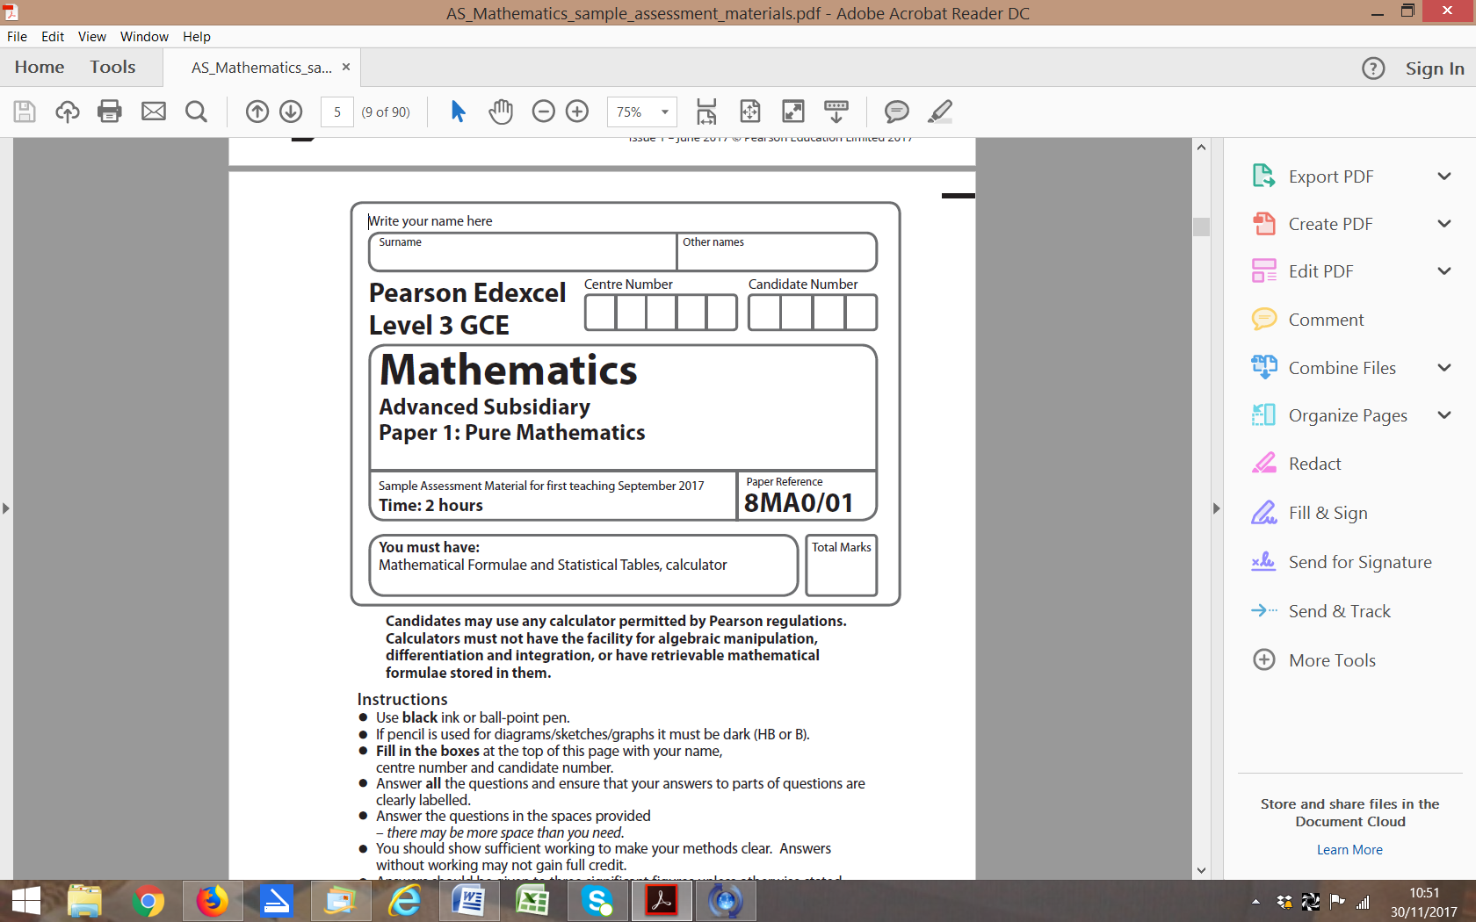

**Practice Paper C:**

**Time 2 hours**

**Questions to revise:**

**1.** Prove, from first principles, that the derivative of 5*x*3 is 15*x*2.

**(Total 4 marks)**

___________________________________________________________________________

**2.** (*a*)Sketch the graph of *y* = 8*x* stating the coordinates of any points where the graph crosses the coordinate axes.

**(2)**

(*b*) (i) Describe fully the transformation which transforms the graph *y* = 8*x* to the graph *y* = 8*x* – 1.

**(1)**

(ii) Describe the transformation which transforms the graph *y* = 8*x* – 1 to the graph *y*= 8*x* – 1+ 5.

**(1)**

**(Total 4 marks)**

___________________________________________________________________________

**3.** In △ *OAB*,  and.

*P* divides *OA* in the ratio 3 : 2 and *Q* divides *OB* in the ratio 3 : 2.

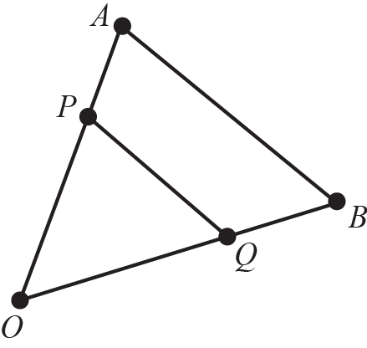

(*a*) Show that *PQ* is parallel to *AB*.

**(4)**

(*b*) Given that the length of *AB* is 10 cm, find the length of *PQ*.

**(1)**

**(Total 5 marks)**

___________________________________________________________________________

**4.** g(*x*) =  + 5, *x* ∈ ℝ.

Sketch the graph *y* = g(*x*).

Label any asymptotes and any points of intersection with the coordinate axes.

**(Total 5 marks)**

___________________________________________________________________________

**5.** f(*x*) = 2*x*3 – *x*2 – 13*x* – 6.

Use the factor theorem and division to factorise f(*x*) completely.

**(Total 6 marks)**

___________________________________________________________________________

**6.** (*a*) Fully expand (*p* + *q*)5.

**(2)**

A fair four-sided die, numbered 1, 2, 3 and 4, is rolled 5 times.

Let *p* represent the probability that the number 4 is rolled on a given roll and let *q* represent the probability that the number 4 is not rolled on a given roll.

(*b*) Using the first three terms of the binomial expansion from part (a), or otherwise, find the probability that the number 4 is rolled at least 3 times.

**(5)**

**(Total 7 marks)**

___________________________________________________________________________

**7.** In △ *ABC*,  and.

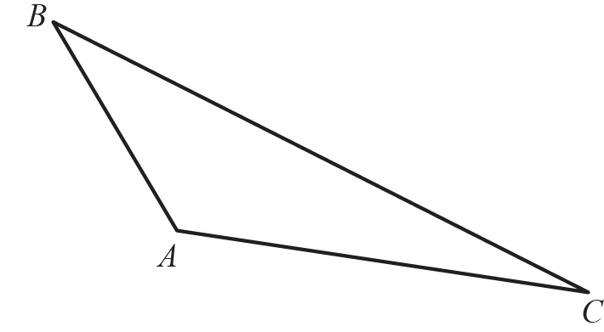

(*a*) Find the size of ∠ *BAC*, in degrees, to 1 decimal place.

**(5)**

(*b*) Find the exact value of the area of △ *ABC*.

**(3)**

**(Total 8 marks)**

___________________________________________________________________________

**8.** The points *A* and *B* have coordinates (3*k* − 4, −2) and (1, *k* + 1) respectively, where *k* is a constant.

Given that the gradient of *AB* is − ,

(*a*) show that *k* = 3,

**(2)**

(*b*) find an equation of the line through *A* and *B*,

**(3)**

(*c*) find an equation of the perpendicular bisector of *A* and *B.* Leave your answer in the form *ax + by + c = 0* where *a*, *b* and *c* are integers.

**(4)**

**(Total 9 marks)**

___________________________________________________________________________

**9.** A stone is thrown from the top of a cliff.

The height *h*, in metres, of the stone above the ground level after *t* seconds is modelled by the function

h(*t*) = 115 + 12.25*t* – 4.9*t* 2.

(*a*) Give a physical interpretation of the meaning of the constant term 115 in the model.

**(1)**

(*b*) Write *h*(*t*) in the form *A* – *B*(*t* – *C*)2, where *A*, *B* and *C* are constants to be found.

**(3)**

(*c*) Using your answer to part (*b*), or otherwise, find, with justification

1. the time taken after the stone is thrown for it to reach ground level,

**(3)**

(ii) the maximum height of the stone above the ground and the time after which this maximum height is reached.

**(2)**

**(Total 9 marks)**

___________________________________________________________________________

**10.** The diagram shows △ *ABC* with *AC* = 8*x* – 3, *BC* = 4*x* – 1, ∠ *ABC* = 120° and ∠ *ACB* = 15°.

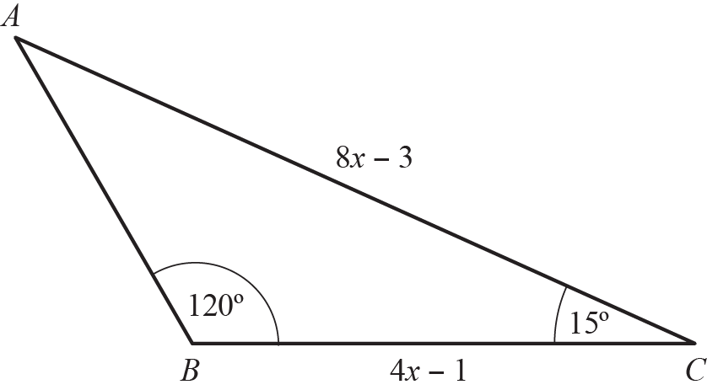

(*a*) Show that the exact value of *x* is 

**(7)**

(*b*) Find the area of △ *ABC*, giving your answer to 2 decimal places.

**(3)**

**(Total 10 marks)**

___________________________________________________________________________

**11.** (*a*) Given that , find the two possible values of *a*.

**(6)**

(*b*) Labelling all axes intercepts, sketch the graph of  for 0 ≤ *x* ≤ 2.

**(2)**

(*c*) With reference to the integral in part a and the sketch in part (*b*), explain why the larger value of *a* found in part (*a*) produces a solution for which the actual area under the graph between *a* and 2*a* is not equal to 1. State whether the area is greater than 1 or smaller than 1.

**(2)**

**(Total 10 marks)**

___________________________________________________________________________

**12.** The diagram shows the plan of a school running track. It consists of two straight sections, which are the opposite sides of a rectangle, and two semicircular sections, each of radius *r* m.

The length of the track is 300 m and it can be assumed to be very narrow.

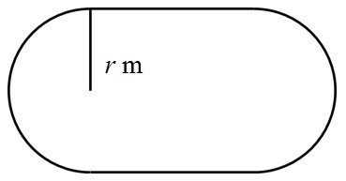

(*a*) Show that the internal area, *A* m2, is given by the formula *A* = 300*r* – *π r* 2.

**(5)**

(*b*) Hence find in terms of π the maximum value of the internal area.   
 You do not have to justify that the value is a maximum.

**(6)**

**(Total 11 marks)**

___________________________________________________________________________

**13.** The value of a car, *V* in £, is modelled by the equation *V* = *abt*, where *a* and *b* are constants and *t* is the number of years since the car was purchased.

The line *l* shown in the diagram illustrates the linear relationship between *t* and  for *t*≥ 0.

The line  meets the vertical axis at (0, log440 000) as shown. The gradient of  is .

log4 *V*



*l*

*O t*

(*a*) Write down an equation for .

**(2)**

(*b*) Find, in exact form, the values of *a* and *b*.

**(4)**

(*c*) With reference to the model, interpret the values of the constant *a* and *b*.

**(2)**

(*d*) Find the value of the car after 7 years.

**(1)**

(*e*) After how many years is the value of the car less than £10 000?

**(2)**

(*f*) State a limitation of the model.

**(1)**

**(Total 12 marks)**

___________________________________________________________________________

**END OF PAPER (TOTAL: 100 MARKS)**

**BLANK PAGE**