**NAME:**

**PAPER B**

**Date to be handed in:**

**MARK (out of 100):**

|  |  |  |  |  |  |  |  |  |  |  |  |  |  |
| --- | --- | --- | --- | --- | --- | --- | --- | --- | --- | --- | --- | --- | --- |
| **Qu** | **1** | **2** | **3** | **4** | **5** | **6** | **7** | **8** | **9** | **10** | **11** | **12** | **13** |
|  |  |  |  |  |  |  |  |  |  |  |  |  |  |

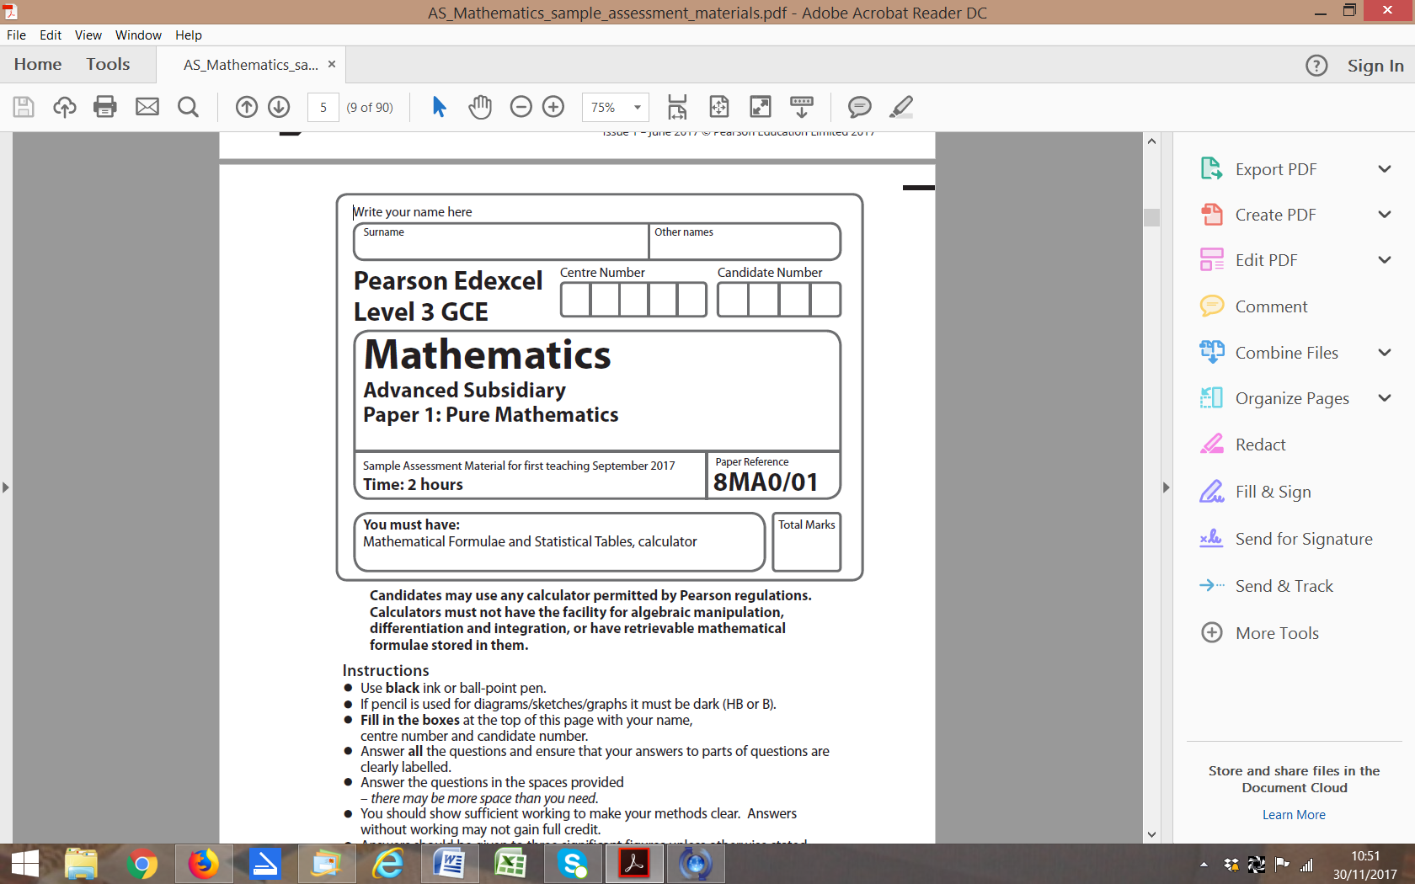

**Practice Paper B:**

**Time 2 hours**

**Questions to revise:**

**1.** A teacher asks one of her students to solve the equation 2 cos 2*x* + √3 = 0 for 0 ⩽ *x* ⩽ 180°.

The attempt is shown below.













(*a*) Identify the mistake made by the student.

**(1)**

(*b*) Write down the correct solutions to the equation.

**(1)**

**(Total 3 marks)**

**___________________________________________________________________________**

**2.** Find in exact form the unit vector in the same direction as **a** =4**i** –7**j**.

**(Total 3 marks)**

**___________________________________________________________________________**

**3.** Simplify , giving your answer in the form *p*√3 – *q*, where *p* and *q* are positive rational numbers.

**(Total 4 marks)**

**___________________________________________________________________________**

**4.** (*a*) Prove that, if 1 + 3*x*2 + *x*3 < (1 + *x*)3, then *x* > 0.

**(4)**

(*b*) Show, by means of a counter example, that the inequality 1 + 3*x*2 + *x*3 < (1 + *x*)3 is not true for all values of *x*.

**(2)**

**(Total 6 marks)**

**___________________________________________________________________________**

**5.** The curve with equation *y* = h(*x*) passes through the point (4, 19).

Given that h′(*x*) = 15*x*√*x* – , find h(*x*).

**(Total 6 marks)**

**___________________________________________________________________________**

**6.** Find all the solutions, in the interval 0 ⩽ *x* ⩽ 360°, to the equation 8 – 7 cos *x* = 6 sin2 *x*, giving solutions to 1 decimal place where appropriate.

**(Total 6 marks)**

**___________________________________________________________________________**

**7.** (*a*) Expand (1 + 3*x*)8 in ascending powers of *x*, up to and including the term in *x*3, simplifying each coefficient in the expansion.

**(4)**

(*b*) Showing your working clearly, use your expansion to find, to 5 significant figures, an approximation for 1.038.

**(3)**

**(Total 7 marks)**

**___________________________________________________________________________**

**8.** (*a*) Sketch the graph *y* = log9 (*x* + *a*), *a* > 0, for *x* > −*a*, labelling any asymptotes and points of intersection with the *x*-axis or *y*-axis. Leave your answers in terms of *a* where necessary.

**(6)**

(*b*) For *x* > −*a*, describe, with a reason, the relationship between the graphs of *y*= log9(*x*+ *a*)2 and *y* = log9 (*x* + *a*).

**(2)**

**(Total 8 marks)**

**___________________________________________________________________________**

**9.** (*a*) On the grid shade the region comprising all points whose coordinates satisfy the inequalities *y* ≤ 2*x* + 5, 2*y* + *x* ≤ 6 and *y* ≥ 2.

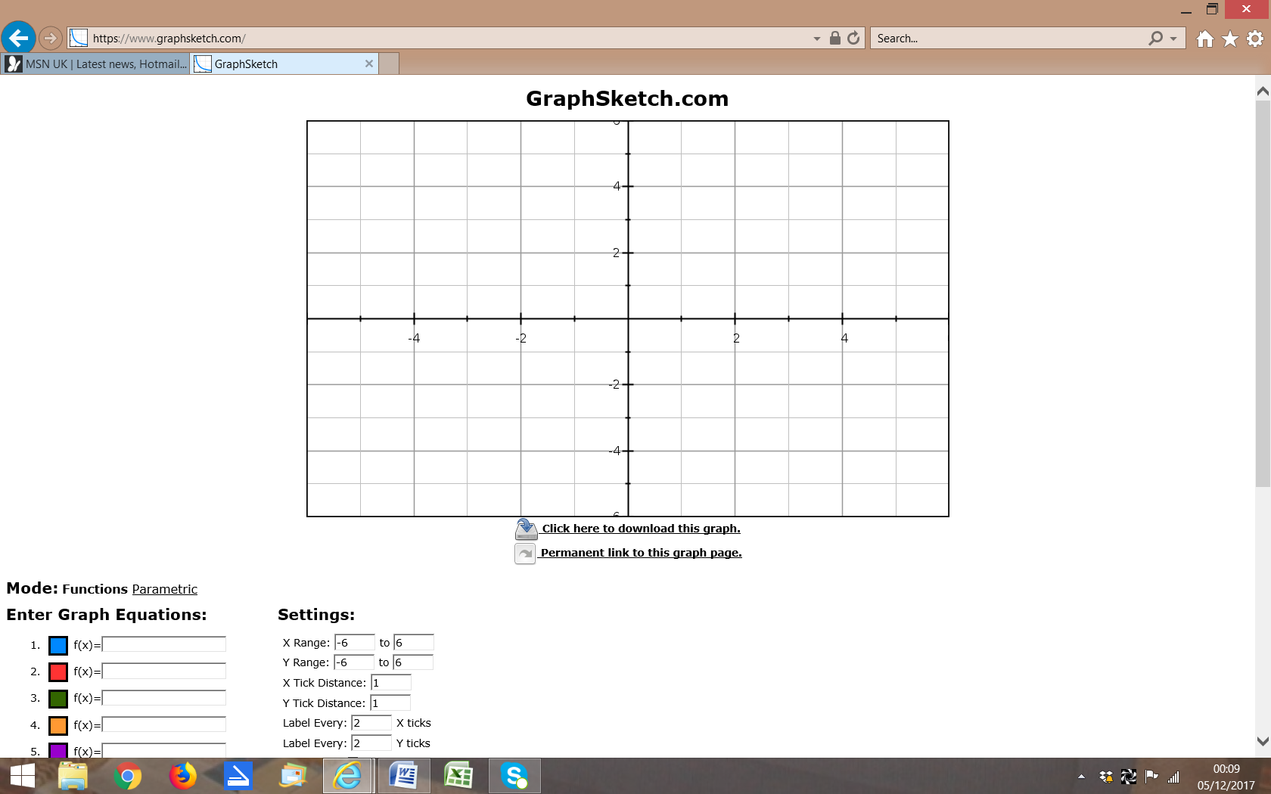

**(3)**

(*b*) Work out the area of the shaded region.

**(5)**

**(Total 8 marks)**

**___________________________________________________________________________**

**10.** A particle *P* of mass 6 kg moves under the action of two forces, *F*1 and *F*2, where

*F*1 = (8**i**− 10**j**) N and *F*2 = (*p***i** + *q***j**) N, *p* and *q* are constants.

The acceleration of *P* is **a** = (3**i** – 2**j**) m s−2.

(*a*) Find, to 1 decimal place, the angle between the acceleration and **i**.

**(2)**

(*b*) Find the values of *p* and *q*.

**(3)**

(*c*) Find the magnitude of the resultant force *R* of the two forces *F*1 and *F*2. Simplify your answer fully.

**(3)**

**(Total 8 marks)**

**___________________________________________________________________________**

**11.** f(*x*) = *x*3 – 7*x*2 – 24*x* + 18.

(*a*) Sketch the graph of the gradient function, *y* = f ʹ(*x*).

(*b*) Use algebraic methods to determine any points where the graph cuts the coordinate axes and mark these on the graph.

(*c*) Using calculus, find the coordinates of any turning points on the graph.

**(Total 9 marks)**

**___________________________________________________________________________**

**12** The diagram shows part of curve with equation *y* = *x*2 – 8*x* + 20 and part of the line with equation *y* = *x* + 6.

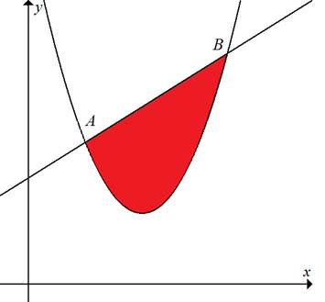

(a) Using an appropriate algebraic method, find the coordinates of *A* and *B.*

**(4)**

The *x*-coordinates of *A* and *B* are denoted *xA* and *xB* respectively.

(b) Find the exact value of the area of the finite region bounded by the *x*-axis, the lines *x*= *xA*and *x* = *xB* and the line *AB*.

**(2)**

(c) Use calculus to find the exact value of the area of the finite region bounded by the *x*-axis, the lines *x* = *xA* and *x* = *xB* and the curve *y* = *x*2 – 8*x* + 20.

**(5)**

(d) Hence, find, to one decimal place, the area of the shaded region enclosed by the  
curve *y* = *x*2 – 8*x* + 20 and the line *AB*.

**(2)**

**(Total 13 marks)**

**___________________________________________________________________________**

**13.** *A* is the centre of circle *C,* with equation *x*2 – 8*x* + *y*2 + 10*y* + 1 = 0.

*P*, *Q* and *R* are points on the circle and the lines *l*1, *l*2 and *l*3 are tangents to the circle at these points respectively.

Line *l*2 intersects line *l*1 at *B* and line *l*3 at *D*.

*l*2 *l*1

*y*

*P* *B*

*E*

*x*

*Q*

*l*3

*D*

*R*

(*a*) Find the centre and radius of *C*.

**(3)**

(*b*) Given that the *x*-coordinate of *Q* is 10 and that the gradient of *AQ* is positive, find the *y*‑coordinate of *Q*, explaining your solution.

**(4)**

(*c*) Find the equation of *l*2, giving your answer in the form *y* = *mx* + *b*.

**(4)**

(*d*) Given that *APBQ* is a square, find the equation of *l*1 in the form *y* = *mx* + *b*.

**(4)**

 intercepts the *y*-axis at *E*.

(*e*) Find the area of triangle *EPA*.

**(4)**

**(Total 19 marks)**

**___________________________________________________________________________**

**END OF PAPER (TOTAL: 100 MARKS)**