SENIOR CITIZEN AND DISABLED/LOW INCOME PERSONS
ADJUSTMENT OF WATER SERVICE CHARGES

Claimant’s Name:
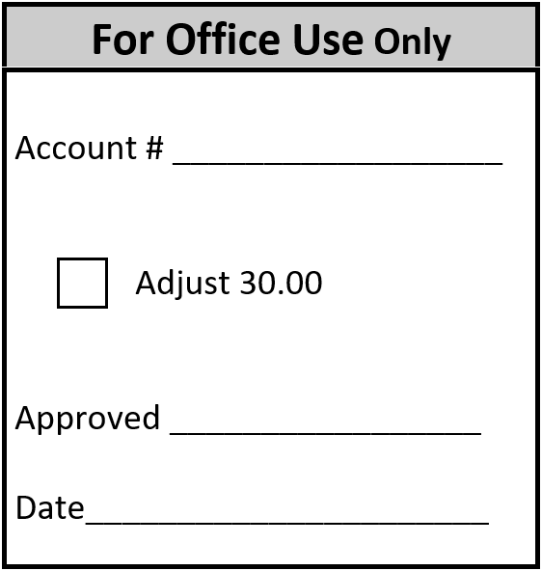
Mailing Address:

City: State: Zip:

DESCRIPTION OF PROPERTY -
Single Family Dwelling Mobile Home
Customer must own the property. Property must be the
primary residence of the Customer.

Service Location:
Parcel Number:

Please check one of the three boxes:
I will be 61 years of age or older on or before December 31 of the year in which this
adjustment is filed.

I am physically disabled and as such, retired from regular gainful employment by
Reason of such disability.

I am a surviving spouse of a person who was approved for this exemption and I am
at least 57 years old.

Any adjustment granted through erroneous information shall be subject to penalty.
I swear under the penalties of perjury that all of the foregoing statements are true.

Signature of Claimant:

Phone Number:

This claim is subject to audit by the Department of Revenue
***Accounts must be current and remain in good standing to receive this Senior Discount***

