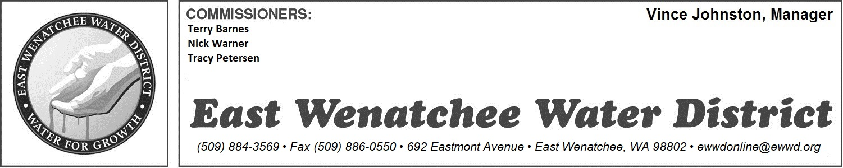

APPLICATION FOR WATER SERVICE

SERVICE ADDRESS:

APPLICANT’S NAME:

PHONE:

MAILING ADDRESS (if different than above):

EMAIL ADDRESS:

**************************************************************************************************************************

Did you buy the property? Yes No

Are you renting? Yes No

Effective Date:

SIGNATURE:
(By signing your name electronically, you are agreeing that your electronic signature is the legal equivalent of your manual signature.)

Please email this form back to ewwdonline@ewwd.org

*************************************************************************************************************************

The undersigned applicant hereby applies for a water connection to the above described property. The applicant is the owner or customer of the described property or the authorized agent of the owner. By signing this application, the applicant agrees, as a condition of the East Wenatchee Water District providing and continuing service to the above described property, to comply with all provisions of the District’s cross connection control program, and other such rules and regulations now existing or which may be established from time to time governing the public water system. The applicant specifically agrees to install and maintain at all times their plumbing system in compliance with the most current edition of the plumbing code having jurisdiction as it pertains to the prevention of water system contamination, prevention of pressure surges and thermal expansion in their water piping. For thermal expansion, it shall be assumed that a check valve is installed by the East Wenatchee Water District on the water service. Further, the applicant agrees not to make a claim against the East Wenatchee Water District or its agents or employees for damages and/or loss of production, sales or service, in case of water pressure variations, or the disruption of the water supply for water system repair, routine maintenance, power outages, and other conditions normally expected in the operation of a water system.

The District does not guarantee the quality of water on the customer’s side of the meter, in the customer’s service line, or household plumbing, related to taste, odor, or to growth of bacteria.

The District is not responsible for installation, operation, maintenance or replacement of any plumbing or equipment on the customer’s side of the meter vault.

