My Version from Grand Ma:
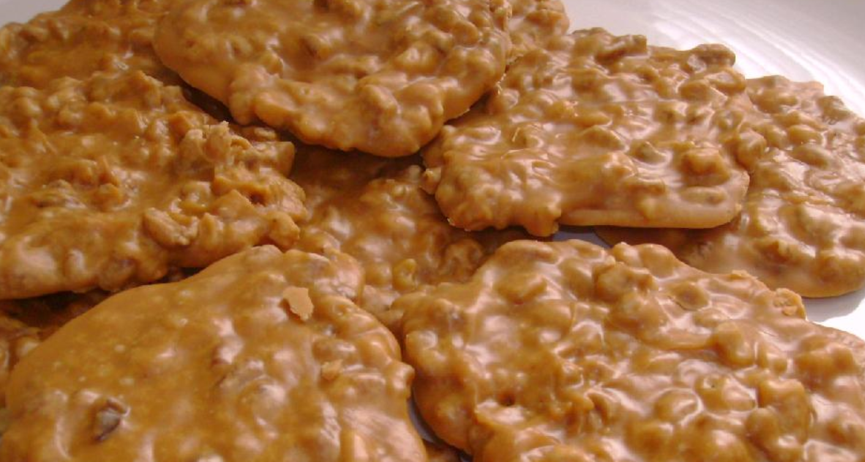
2 cups white sugar
2 cans condense milk
Bag of pecan pieces or halves
Tee spoon of vanilla extract
½ stick of unsalted or salted butter
Sturdy pot (preferably non-stick w/a handle)
Combine the condense milk and sugar in your pot (size for making a stew let’s say) over medium heat. With a wooden spoon (or largest spoon you have), stir until the sugar dissolves and ingredients are well blended. Continue to cook, stirring, stirring, and more stirring until smooth and light brown, about 8 minutes.
Add the vanilla and pecans and continue to cook, stirring, until the mixture turns a darker brown. You want to keep stirring as the mixture will start to stiffen.
Remove from the heat and drop by the spoonful onto wax paper or create a sheet of candy on a well buttered sheet pan. Let cool.
Use a good knife (a butter knife works well ) to cut into 1” X 2” blocks. Pralines can be stored in an airtight container at room temperature for up to 2 weeks.

Easiest and quick version:
I saw this recipe on FB from a share, and thought I’d share:

