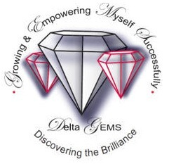
DELTA SIGMA THETA SORORITY, INCORPORATED
Tucson Alumnae Chapter
DELTA GEMS: Growing and Empowering Myself Successfully
JEWELS IN OUR GALAXY
Applications Available
The Delta G.E.M.S., sponsored by the Tucson Alumnae Chapter, has partnered with the Sierra Vista Unified School District to reach out to more girls who may benefit from the program. The Delta GEMS is a FREE mentoring and leadership program for High School girls ages 14-18, offering a road map for college and career planning through activities that provide opportunities for self-reflection and individual growth.

Delta GEMS are for:
▲ Young women ages 14-18 who are in Grades 9 through 12.
▲ Young women who have potential but need guidance, support, and skills to achieve success.
▲ Young women who are interested in developing leadership skills.
▲ Young women who are actively pursuing college and/or career options.
▲ Young women who need encouragement and support in pursuit of higher learning.
▲ Young women identified by authorized partners of Delta chapters and/or former Delta Academy participants.

The Goal for our Delta GEMS:
▲ Instill the need to excel academically.
▲ Provide tools that enable girls to achieve high levels of academic success.
▲ Assist girls in proper goal setting and planning for their futures; and,
▲ Create compassionate, caring, and community-minded young women by actively involving them in service learning and community service opportunities

For more information and applications:
- Sierra Vista GEMS – Please email Mrs. Ramona McCaa or the Delta GEMS committee at tacsvdeltagems@gmail.com.
- Tucson GEMS – Please email Mrs. Ramona McCaa or the Delta GEMS committee at tactucsondeltagems@gmail.com.

