All Things Cheer and Dance Australia
Athlete Registration excel file Instructions
Here is a quick instruction guide if you choose to use the excel file for your registrations. Please note that this must be completed on a desktop computer and using excel only.

Step 1. Save the file to your computer and insert your program name at the start of the file name. Eg. “Shooting Stars Allstars”

Step 2. Open the file; you will be required to fill in the “Yellow” cells. Please start with the first tab “Registration Details”. For multiple location gyms please fill in only information if relevant. I.e. Address, if you want a point of contact for each location. Please only fill in one billing address.
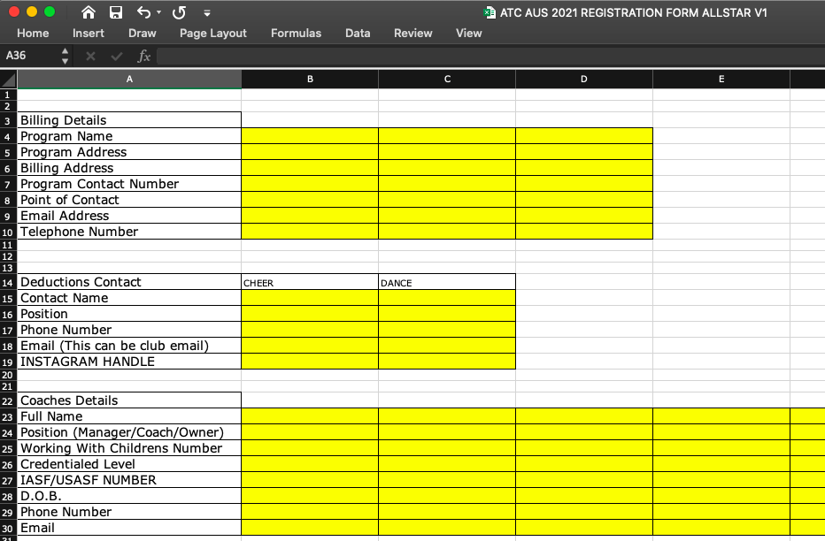

For our deduction system please fill in the contact details where your deductions will be emailed and a contact who will be at the event to dispute any deductions.

Step 3.
Please go to Tab 2 “Team Roster”
In Cell G2, Please select which event you are registering for.
In Cell G4, Please enter your programs name as it will be announced in the schedule.

Step 4. In column G under “Athlete Full Name” please enter your athletes full name e.g. Samantha Citizen. This is where you will list all competing athletes you can either load all athletes at once or list them by team however list each athlete only ONCE. In Column H please fill in the corresponding athletes date of birth (enter dates as DD/MM/YY and it will change automatically you do not need to write months). As you enter Names this will automatically calculate the Number of athletes registered. Please do not include any athletes that will not be competing.

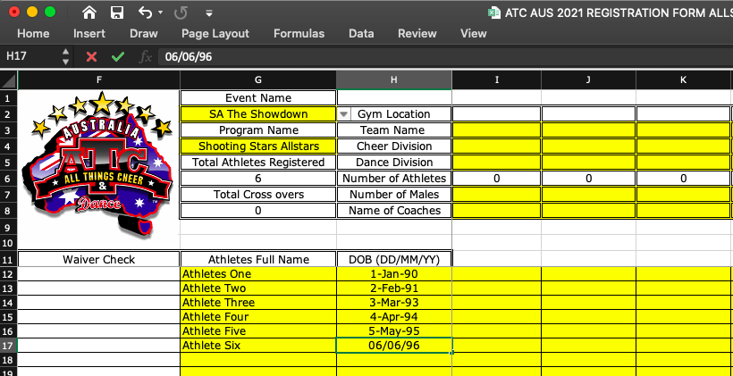

Step 5.
Team registrations (only fill in the yellow boxes) In Column I (2‐8) Please fill in the following details or choose from the drop down box as per your teams. For multiple locations please fill in gym location, if only one then leave blank. Please select the appropriate cheer or dance division. It will automatically calculate the number of athletes later, no need to fill in this section. Please fill in number of males and Coaches Names.

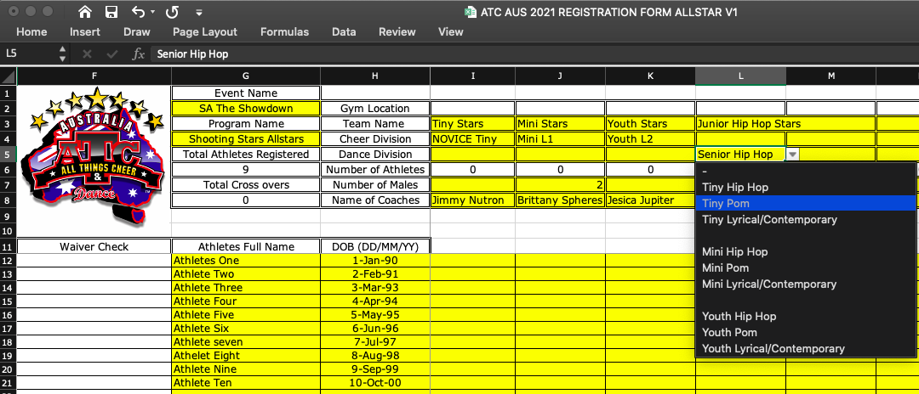

Step 6. Selecting athletes In the same row as your athletes name please denote which athlete is in that team with a “1” in that cell. If they are not in the team please leave that cell blank. Please do this for every athlete in this team. The total number of athletes in that team will be calculated in row 6 for the corresponding team.
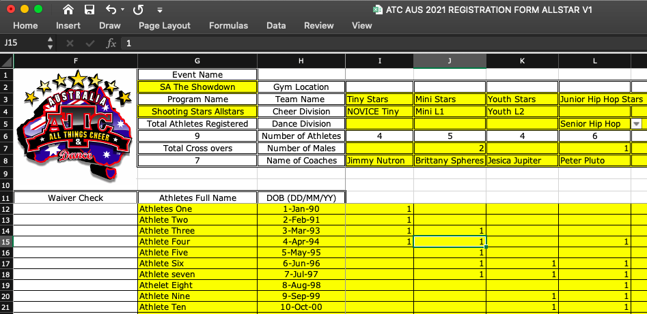

Step 7. Repeat Steps 5 and 6 for the rest of your teams. Please fill in all cheer teams then dance teams (Please refer to your registration packs for divisions offered). Team Numbers, total entries and total crossovers will self calculate. If you find any issues please let us know when you email them

Step 8. Once all teams are done please upload to the website via the registration links

Thank you and should you have any questions please do not hesitate to contact us.

Team ATC Australia
info@allthingscheer.com.au

