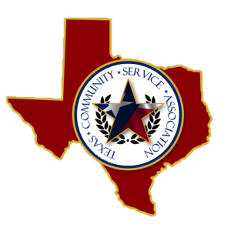

Board of Directors
2015-2018

OFFICERS
President
David L Peters
Smith County Juvenile Probation
Vice President
Israel Tena
El Paso Juvenile Probation

Treasurer
Lonnie Rogers
33rd & 424th Judicial District CSCD

Secretary
Senae Williams
Victoria County Juvenile Probation
Historian
Guadalupe Garza
Bexar County CSCD

BOARD MEMBERS

Santos Aguilar
Gillespie County CSCD

Chris Shirley
Gregg County Juvenile Probation

Joby McDaniel
Cass County CSCD

M’Leesa Seals
Hale County CSCD

ADVISORY COMMITTEE

Karla Bautista

Jared Grimes

Agenda

TCSA ANNUAL BOARD MEETING
Holiday Inn Express Waco South
5701 Legends Lake Parkway Waco, TX 76712
PHONE: 254.732.1028 FAX: 254.732.2787
Wednesday, October 27, 2021
12:30 pm to 2:30 pm

I. Call meeting to order (12:30p.m.)
II. Recording of General Membership Meeting Actions
A. Election of New Board Members
B. 2022 Conference Location
C. Financial Audit Report
III. Board Nomination/Appointment of New Officers
IV. Status of Board Tasks/Issues
1. IRS Reporting Requirements
2. Quarterly Newsletter
V. Items for Discussion, Consideration and/or Approval
A. Visibility/Sustainability of Association
1. Newsletters
2. Website/Facebook
3. Become Active within other Associations
VI. Date/City for next meeting:
VII. Other Business
VIII. Adjournment

