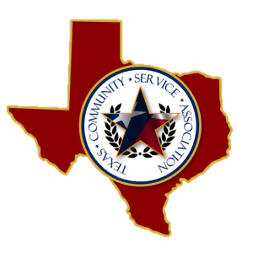

Board of Directors
2015-2018

OFFICERS
President
David L Peters
Smith County Juvenile Probation
Vice President
Israel Tena
El Paso Juvenile Probation

Treasurer
Lonnie Rogers
33rd & 424th Judicial District CSCD

Secretary
Senae Williams
Victoria County Juvenile Probation
Historian
Guadalupe Garza
Bexar County CSCD

BOARD MEMBERS

Santos Aguilar
Gillespie County CSCD

Chris Shirley
Gregg County Juvenile Probation

Joby McDaniel
Cass County CSCD

M’Leesa Seals
Hale County CSCD

ADVISORY COMMITTEE

Karla Bautista

Jared Grimes

TCSA SPECIAL BOARD MEETING
ZOOM (virtual)
October 19, 2021
10:00 AM – 11:00 AM

- Call Meeting to order

- Approve minutes from special board meeting 6/21/2021 and 9/14/2021

- Ratification of previously approved minutes
  - Membership Dues
  - Luncheon Catering Menu

- Status of Waco and conference plans-
  - Topics and presenters
  - Hotel
  - Door Prizes
  - Catering (George’s)
  - Social Events
  - Registration
  - Task assignments

- Board Members up for re-election (Joby, Santos, & Senae)
a. Advisory position will all be up for election as well.

- Discussion/Additional New Business

- Next Meeting- Oct. 27, 2021

- Adjourn Meeting

