The Royal Canadian Legion
District “A” (Ontario)

District Commander  Mark Rogers | 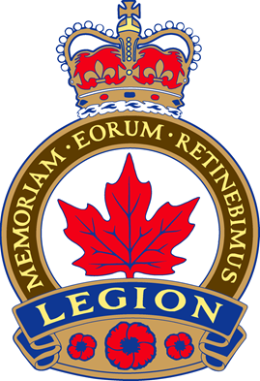 | Deputy District Commander  Caroline Mayo
March 2021

Dear Comrades of District A;

I hope that all of you have been staying safe and that you have taken the opportunity to make needed improvements to your branch and your branch operations as needed.

Unfortunately we have had to cancel our spring convention. Current restrictions are not at a point where we are able to convene as a large group. However Ontario Command and District A programs still need your help. A letter was sent out in December 2020 on donations to Ontario Command programs. I would also like to remind you of the District A Hospital Trust Fund and the District A Care and Comfort Fund. Both of these are always in need of funds as the work at Parkwood and Sunnybrook continues and our care and Comfort fund is still taking care of veterans and their dependents in their homes. These funds are mostly made up of donations from branch Poppy funds and I encourage every branch to use their poppy funds as they are meant to be used.

Cheques to the District A Hospital Trust fund should be made out as follows and DO NOT need a SUF. Contact your zone commander for my or the district treasurer address to send cheques.

R.C.L. District A Hospital Trust Fund

Cheques to the District A Care and Comfort Fund should be made out as follows:

R.C.L. District A Care and Comfort Fund

Yours In Comradeship,

Mark Rogers

Mark Rogers, District A Commander

