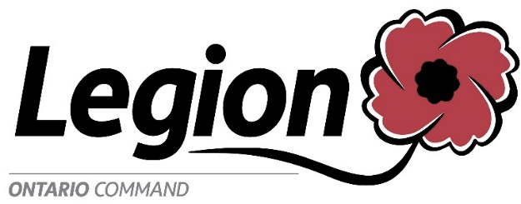
The Royal Canadian Legion
89 Industrial Parkway North
Aurora ON L4G 4C4

Veterans Hot Line: 437-228-4747
Fax: 905-841-9992
Email: rclontariocommand@on.legion.ca
Website: www.on.legion.ca

FOR IMMEDIATE RELEASE

27 March 2020

Legion Branches, Ontario Command Continue to Support Veterans

The Royal Canadian Legion, Branches and Ladies’ Auxiliaries in Ontario Command continue to support our Veterans and their families through these trying times.

We understand that during this time of crisis there are needs and financial distress and we remind Veterans and their families that the Royal Canadian Legion is only an email away to assist. Our Provincial and Branch Service Officers will help in completing any applications for assistance free of charge.

Although our Branches and offices are closed to the public, we remain committed to provide the necessities for our Veterans. If any Veteran requires assistance they can contact their local Branch or contact direct to Ontario Command email rclontariocommand@on.legion.ca and if you provide your full contact information, someone will get back to you as soon as possible. We have Provincial staff, including Provincial Service Officers, working from home who are in contact with Veterans Affairs Canada on a daily basis.

Our Mission: TO SERVE VETERANS, WHICH INCLUDES SERVING MILITARY AND RCMP MEMBERS AND THEIR FAMILIES TO PROMOTE REMEMBRANCE AND TO SERVE OUR COMMUNITIES AND OUR COUNTRY.

For further information please contact email: rclontariocommand@on.legion.ca, or as listed below for individual staff:

Veterans Hot Line – 437-228-4747

Homeless Veterans Program – jkemp@on.legion.ca and/or psweeny@on.legion.ca

Service Bureau (Aurora) – mrohmann@on.legion.ca and/or adina@on.legion.ca
Service Bureau (North Bay) – sculling@on.legion.ca and/or rabud@on.legion.ca
Service Bureau (Kanata) – proyle@on.legion.ca and/or shannon@on.legion.ca
Service Bureau (London) – rhyndman@on.legion.ca and/or dsnyders@on.legion.ca

- 30 -

