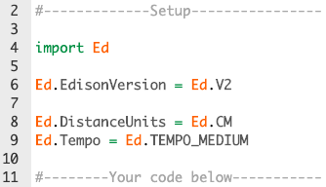
To Start: Watch Explore EdPy:
https://meetedison.com/robot-programming-software/edpy/
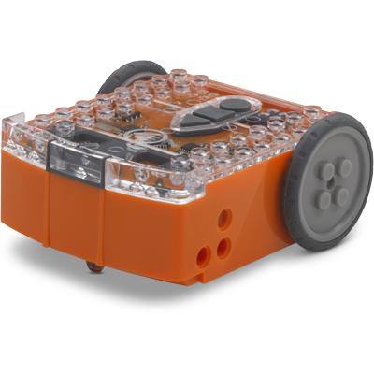
Go Program: www.edpyapp.com
Edison Basics:
- Drive:
Write the function and parameters for the Edison Drive code..

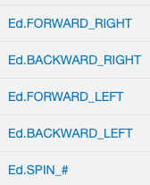
- Turn
Describe what each line of code does?

- While
Write the While loop command and condition that is true

- For
Write the For loop command using a range function

Take it further: Write the pseudocode for an algorithm that combines inputs & outputs.

