To Start: Watch Explore EdScratch: meetedison.com/robot-programming-software/edscratch

Go Program: www.edscratchapp.com
Edison Basics:
- Move:
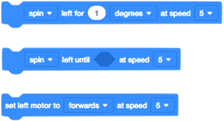
Draw the block to get Edison to move
- Turn
What does each turn blocks do?

- Outputs
List all the outputs: Draw the blocks:

- Inputs
List all of the sensors: Draw the blocks:

Take it further: Write the pseudocode for an algorithm that combines inputs & outputs.

