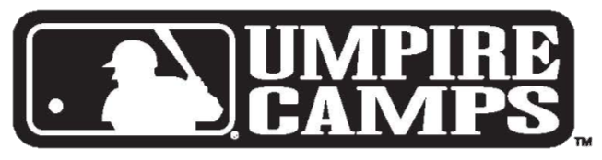
MAJOR LEAGUE BASEBALL
FREE ONE-DAY
UMPIRE CLINIC

WHEN

WHERE
Saturday, Sept. 11, 2021
8:00 a.m. - 12:00 p.m.
Registration begins at 7:30 a.m.
- Rain or Shine
121 Financial Ballpark
Home of the Jacksonville Jumbo Shrimp
301 A Philip Randolph Blvd Jacksonville, FL 32202.

WHO

MLB
Staff includes former umpires, current MLB

Supervisors and Observers, as well as Minor League and NCAA officials, such as
· Charlie Reliford · Ed Rapuano · Jeff Kellogg ·
· Cris Jones · Rich Rieker · And More! ·

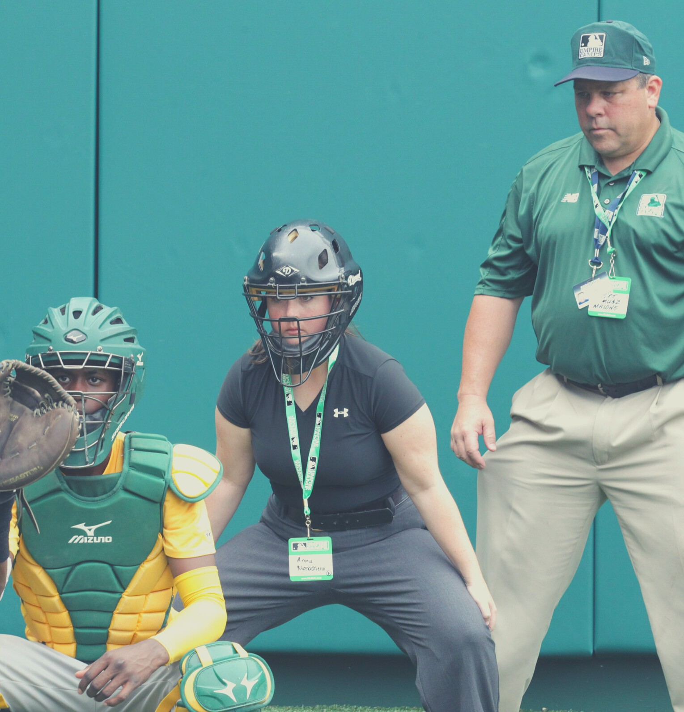
WANT TO BE A
PROFESSIONAL UMPIRE?
MLBUC will be looking for
SCHOLARSHIP CANDIDATES
for 2022 Umpire Schools!
REGISTER NOW!
http://mlbsurveys.2021-MLBUC- Registration.alchemer.com/s3/
Walk Ups Always Welcome!

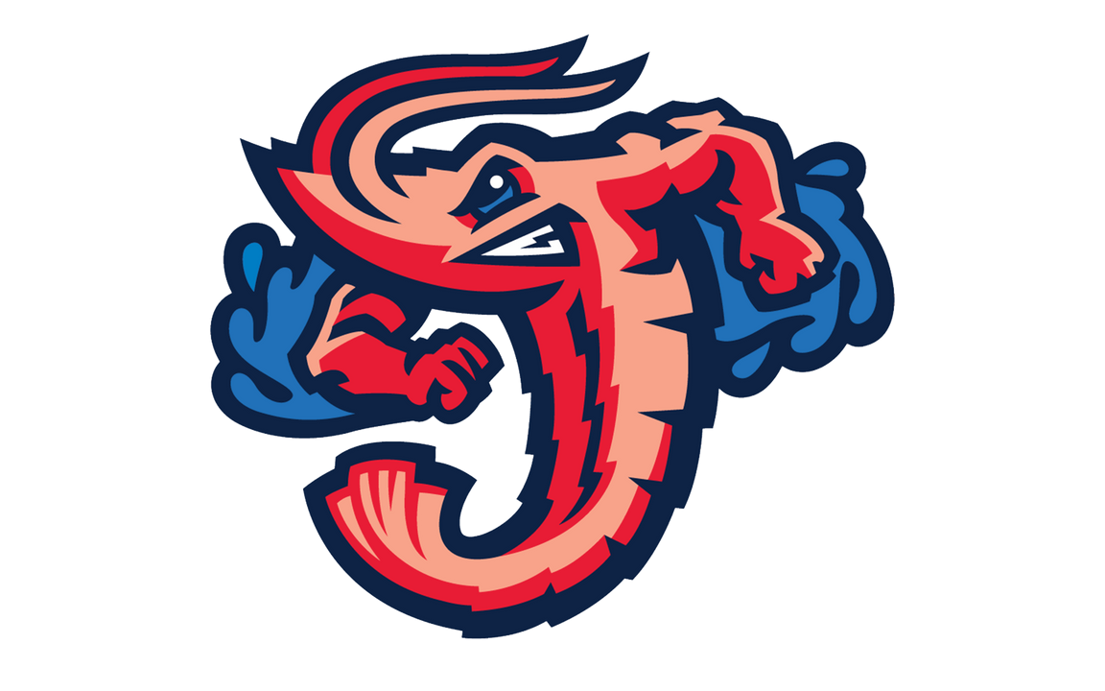
For Jacksonville Ticket info, please go to www.milb.com/jacksonville
VISIT MLBUC ONLINE
www.mlbuc.com www.facebook.com/mlb.camps
@MLBUmpCamps mlbumpirecamps@mlb. com

