Forward an executed original of this document by mail to Steve Dietz; 203 Mae Street; Logan, OH 43138 or by email to dietz41@gmail.com.
Signed forms must be received thirty days prior to the trip departure date.

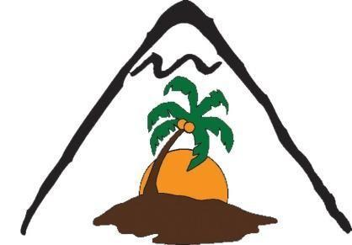
The Village Mountain Mission Project

Personal Information

Last | First | Middle |  |  |  | Date of Birth
Street Address |  |  |  |  |  | Mobile
City |  |  |  | State | Zip | Passport Number
Email Address

Emergency Contact Information
Name Relationship Phone number
Contact # 1
Contact # 2

Contact # 3

Insurance Information
Name of Insurance Company |  | Subscriber Name and Subscriber # or SSN
Insurance Phone # |  | Group Number (On ID card)
Relationship to subscriber

Additional Information: Attached additional information as needed.
Medical Conditions

Current Medications and Dosage

Known Allergies and Drug Sensitivity

Special instructions and treatment preferences

By signing, I hereby certify that the above information,  to the best of my knowledge, is correct.  If the participant is a minor, a parent or guardian must sign the following Consent for Medical Treatment form. | Signature | Date

Consent for Medical Treatment of Minor Participant:

I the undersigned, parent/guardian of the Participant (a minor), do hereby authorize the adult leader(s) as agent(s) for the undersigned to consent to any X-ray examination, anesthesia, medical or surgical diagnostic procedures or treatment, and hospital or other medical care for the Participant, which is deemed necessary or advisable in the best judgment of the attending physician and performed by or under supervision of a physician, surgeon or member of the medical staff of the facility furnishing medical services. It is understood that this authorization is given in advance of any specific diagnosis, treatment, hospital or other medical care required, but is given to provide authority on the part of the Agent for any treatment deemed advisable. It is understood that in the event of a serious illness or injury, reasonable efforts to reach me will be attempted.

In case of accident or illness and medical attention is required for the Participant, it should be obtained, and I accept full responsibility for all expenses incurred. I waive all claims against the Agent, the leaders of these activities, and all officers, agents, trustees, and representatives of the Village Mountain Mission.

Father / Mother or Guardian Signature __________________________________Date _______

For Use by Notary Public
Notary Seal
Some countries require all releases covering minors to be notarized. Both parents/legal guardians should sign, even if one is accompanying the minor child. |  | Subscribed and sworn before me on this the _____  day of ________(yr) ______  My commission expires:  __________(yr)_____  Signature Notary Public

