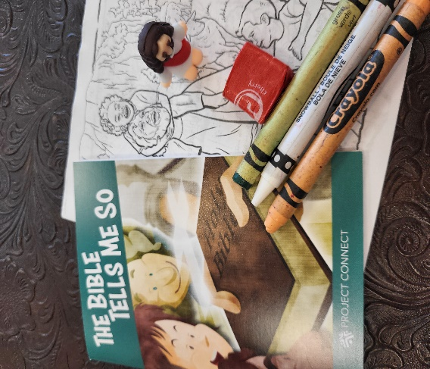We really had a successful fair and gave out about 400 little pocket Jesus figures to talk about Jesus. We had teens, grandparents, and parents took them for their children. We gave away 2 Spanish bibles and several in English as well as highlighting our Project Connect with helpful pamphlets. I usually take extras around to our local churches as well. We gave out 300 children's packets noted in the picture.