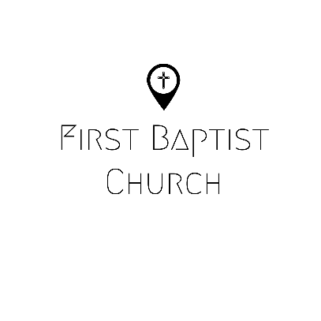
Parents/Legal Guardians,
Welcome back to a new AWANA year! We at First Baptist Church of Juniata County are so thankful for the opportunity to offer our AWANA program in the 2020/21 school year. We are looking forward to working with your children and giving them the opportunity to know, love, and serve Jesus. We are welcoming a new AWANA Commander, Sharon Brown, who will be leading the program! Sharon has taught children’s Sunday School for many years and has a heart for teaching children about the Lord.
Because of the COVID-19 pandemic, there will be some new policies and procedures implemented to help provide safety and peace of mind for families and volunteers. First Baptist Church is committed to making our best effort to create a safe atmosphere for our families and volunteers, while also recognizing the personal freedom and responsibility of each individual. Please carefully read the following:
- Children and leaders will be allowed, but not required to wear masks or face coverings at AWANA. Leaders will encourage use of hand sanitizer/handwashing between activities.
- Parents will be responsible for monitoring their child’s symptoms prior to bringing them to AWANA. If a child has had a fever or other symptoms of illness within the last 24 hours, we ask that parents do not bring them.
- In previous years, FBC AWANA has operated on the Juniata County School District schedule, meaning if the schools are closed, there is no AWANA that night. We will continue to operate this way for weather-related closures but will not directly adhere for COVID-19 related closures. If we should need to cancel for COVID-19 related reasons, we will directly communicate this with the parents.
- Our child check-in system (KidCheck) will continue to be used this year. This check-in/check-out system is used to ensure the safety of the children in our program. Like last year, parents can utilize the KidCheck app for express check-in OR we will have a volunteer at the KidCheck station who will man the computer to allow for touchless check-in/out.
If you have questions or concerns, please contact Sharon Brown or Pastor Caleb Hanna.
God has richly blessed us this year with the resources, leaders, and opportunity to influence and instruct children in the Word of God. We look forward to seeing Him work!

---------------------------------------------------------------------------------------------------------------------------------------
(please return signed portion to First Baptist Church of Juniata County)

I, as a parent and/or legal guardian, fully understand, acknowledge, and agree that I am voluntarily waiving and releasing First Baptist Church of Juniata County and it’s volunteers and employees from any and all liability coming from participation in AWANA Clubs, including, but not limited to exposure or transmission of COVID-19.
Parent/Guardian Signature: ___________________________________________ Date: ____________

