2021 CLEARVIEW HIGH SCHOOL BASEBALL

The mission is to prepare, instruct, sculpt, and develop our student-athletes. In doing so, our staff will create a positive, enthusiastic learning environment. The program vision is to transform our student athlete baseball players from teenagers into men. These men will become fathers, husbands, teachers, businessmen, doctors, etc.. We want to impact their lives to prepare them for the next 40-50 years, not just the next 4. We will teach the process of winning and as a byproduct they will become winners on and off the field.
The coaching staff is committed to:
- Each baseball player is a Student first and an Athlete second.
- Assisting players to reach their full potential on the field and in the classroom.
- Establish a “NO EXCUSES” mentality that can be applied to the student athlete for the rest of his life.
- Developing character in our players by teaching them to be responsible and accountable for their words and their actions.
- Leading by example, demonstrating a passion and respect for the game and the opponent.
- Assisting our athletes to achieve high standards through motivation, dedication, commitment and patience.
- Modeling and expecting honesty, punctuality, and a committed desire to be the best
- Encouraging communication, integrity, and confidence on the field, in the classroom and in the community.
- Instill an “Open Door” policy to allow students to feel comfortable enough to talk to a coach even if it doesn’t have to do with baseball.
- Instill respect for teammates, opponents, coaches, umpires, parents, fans, Clearview High School and it’s community.
- Providing an experience for our athletes that is rewarding, memorable and fun.
- Hold ourselves and our players accountable for actions and reactions on and off the field.
We, as coaches, are here to help these young student athletes grow into young men, whether or not they continue their path in baseball or not does not change our mindset. We are here to ultimately shape lives and have a positive effect on as many student athletes as possible.

Player/Coach Communication
If a player has a problem concerning their well-being let us know immediately. If ever you have a concern or a problem with a coach or teammate do not go home with it. The coach’s office is always open. Come in, in person, and discuss it. We are here for you. We will not discuss problems electronically. Do not go home upset!
If you want to know what you need to improve as a player, it is your responsibility to ask after practice. The purpose of coaching is to make you better as a player, but more importantly as a person. We are here to help!
Family members please maintain contact through email;

Any issues with availability must be communicated in person and backed with written documentation from a parent BEFORE or it will be treated as an unexcused absence. All unavoidable vacations during the season must be notified before the season or the player will be subjected to the team's unexcused attendance policy.

Our Coaches are people, many of us Teachers, Fathers, Husbands, and Brothers that give their time away from their families to help kids. Remember they are these things before they are high school baseball coaches. Please continue to respect that at all times as many of you have for years. We thank you.
While playing and coaching at the high school and collegiate level we have gained tremendous experience. Our motivation is to maximize our athletes and enrich their high school experience. If you have a need to discuss something with a coach, the following is the proper protocol. The chain of communication is as follows and must be initiated by the player:
- First ask yourself:
  - Have you made every off season workout & lift?
  - Are you being coachable & a positive teammate?
  - Are you being coachable & a positive teammate?
  - Are you working to get better on your own?
  - Have you gotten here for early work or stayed after?
If the answer to all questions is yes; initiate a conversation with:
- Assistant Coaches or Head Coach
- Follow up with those coaches or Head Coach
- Coaching Staff and Athletic Director
- Athletic Director & Principals
We will ONLY discuss concerns/issues related to your child and will not discuss other players. Any meeting will end immediately if this protocol is not followed. All communication should follow the chain of communication in order. A player’s focus must be about improving themselves and how they can help the team, not comparing to others.
The coaching staff feels that face to face communication is the best form of communication to prepare our players for life. Therefore, we will not discuss any issues via email or on the phone. Our staff will never be available before, during or after a game.

RULES
- We do not have a list of rules in our program. We have only one. DO THE RIGHT THING!! Any decision you make will affect you, your family, and your teammates. If you feel as though this decision will negatively affect any or all of the three. DON’T DO IT! Any negative decisions will be subject to Administration decisions or coach’s discretion.

PLAYING TIME
- Playing time is determined by how you practice, game performance, and by the coaching staff. If you have a question about playing time it is your responsibility as a player to talk to us. We will give you things to work on and answer your questions. This must be done at practice. We will not discuss playing time before, during, or after a game. Also, we will not discuss playing time with your parents, especially if you have not already talked to us.

EXCUSED ABSENCES
- Excused absences from practice include but are not limited to: missing school due to illness, death in the family, or college visits. These absences do not result in additional consequences. We do expect these absences to be communicated to the coaching staff prior to the absence. They are also not subject to missing a game unless the game is the day of or after the absence. **School Policy** If a player has an unexcused absence he cannot practice if he is not in school. If a player misses a practice the day before a game the coach may sit or choose not to start that player.

DISCIPLINE ISSUES
- All student athletes are held to a higher standard than the average student. Punctuality, communication, academics, and day to day behavior all fall under disciplinary issues. As coaches we work closely with administration to ensure our players uphold these standards. All actions of players are subject to the coach's discretion. Discipline actions are up to the Head Coach depending on severity. This may include extra running, getting demoted (to JV), sitting on the bench, or removal from the program.

EARNING A VARSITY LETTER
- Players must be academically and athletically eligible at the conclusion of the season.
- Players must be a member of the VARSITY team at the conclusion of the season.
- There is no amount of innings played that guarantees a varsity letter, coach’s discretion will be used when the above requirements are met.

OTHER TEAMS / AAU / LEGION
- We understand and love that fact that our players play on other teams. These teams do not override, supersede, or can interfere with what we do in season. Most organizations are aware that their players are HS players first. During the off-season or in-season our workouts and practices must come first. When our season ends the priorities can adjust.

Social Media Policy and Guidelines

Playing and competing in athletics at Clearview Regional High School is a privilege. Student‐athletes at Clearview are held in the highest regard and are seen as role models in the community. As leaders you have the responsibility to portray your team, your school, and yourself in a positive manner at all times. Facebook, Twitter, Instagram, text messaging, and other social media outlets have increased in popularity globally and are used by the majority of students/student‐athletes here at Clearview in one form or another. Student‐athletes should be aware that third parties including the media, faculty, future employers, and NJSIAA officials could easily access your profiles and view all personal information. This includes all pictures, videos, comments, and postings. Inappropriate material found by third parties affects the perception of you, the student-athlete, the athletic department, and the Clearview School District. Examples of inappropriate and offensive behaviors concerning participation in online communities may include depictions or presentations of the following:
➢ Photos, videos, comments or postings showing the personal use of alcohol, drugs, or tobacco. ➢ Photos, videos, and comments that are sexual in nature. This includes links to websites of a pornographic nature and other inappropriate material.
➢ Content online that is unsportsmanlike, derogatory, demeaning, or threatening towards any other individual or entity (examples: derogatory comments regarding another institution; taunting comments aimed at another student-athlete, coach or team at another institution (or your own), and derogatory comments against race and/or gender).
➢ No posts should depict or encourage unacceptable, violent or illegal activities (examples: hazing, sexual harassment/assault, gambling, discrimination, fighting, vandalism, academic dishonesty, underage drinking, and illegal drug use). If a student‐athlete’s profile and its contents are found to be inappropriate in accordance with the above listed behaviors, he/she will be subject to the following penalties:

1. Warning & Parental Contact- First Offense
2. A meeting with Director of Athletics and Head Coach- Second Offense
3. Penalties as determined by the athletic department, including but not limited to possible suspension from his athletic team. - Third Offense Follow
The Pioneers at Our Website: www.clearviewbaseball.com (All offenses carry possible game suspension(s).) If you are ever in doubt of the appropriateness of your online public material, consider whether it upholds and positively reflects your own values and ethics as well as the Clearview Athletic Department’s and the Clearview District as a whole. Remember, always present a positive image and do not do anything to embarrass yourself, the team, your family, or the District. By signing below, you affirm that you understand the Clearview Baseball Social Media Policy and Guidelines. Also, you affirm that failure to adhere to this policy and guidelines may result in consequences that include suspension from the team and subject to additional penalties imposed by the Clearview Regional School District.

Goal Setting

Goal setting is an important part of measuring success and maintaining focus during the season. You are responsible for filling out the goal sheet below. Once you have completed this sheet you will turn it in so I can make a copy for my records. Then I will return the sheet to you. Put the sheet somewhere you can see it and are reminded of the goals you set for yourself and team. We will refer to this sheet as a coaching staff when we feel refocusing toward our goals is needed.

Player name

 | Academic Goals | Individual Athletic Goals | Team Goals
Short term goals are designed to focus you during the season. What are your goals for this grading period, individually this season, and as a team?
Long term goals focus you beyond the season. What do you hope to accomplish in the next year or two academically, individually, and as a team?

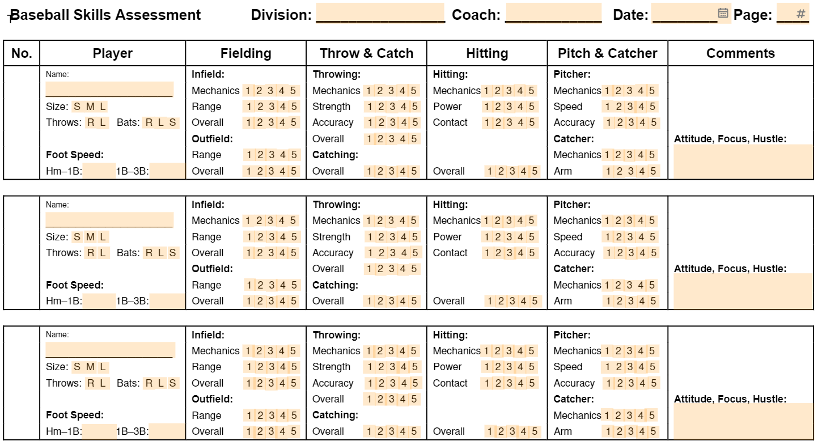

Here is our tryout evaluation form. Each player will receive a copy filled out from the coaching staff. We ask that the athlete fills out this form honestly to the best of his ability. This will be cross referenced with the coaching staff as we finalize our roster. If cuts are to be made the staff will sit down with each player to go over this evaluation. This will give each play an opportunity to play in 1 scrimmage. If our program makes cuts, this tentative day will be on April 12 after our scrimmage. Each player must have 6 practices before being able to play in a scrimmage. We may not extend this period if a player doesn’t get paperwork in on time. Medical concerns will be addressed with the head coach. Our evaluation will be face to face with the staff and player.

Social Media Info

Twitter : @ClearviewBB @CoachRegs
Instagram : @Clearviewbaseball
Google Classroom : ota7yzx
Remind 101 : Text - 81010 Message - bfhc32

Coaches Email

dreagan@clearviewregional.edu
tdougherty@clearviewregional.edu
kbeyrouty@clearviewregional.edu
rhoffman@clearviewregional.edu
mvicente@clearviewregional.edu

CLEARVIEW BASEBALL PLAYER CONTRACT

It is an honor and privilege to be a Clearview Regional High School baseball player. I agree to represent my team, my coaches, my parents, and the Clearview community with pride, respect, and good sportsmanship. Furthermore, I agree to uphold the following…

- I will hustle all the time, no matter the situation, and play with intensity. This attitude represents the value of playing with enthusiasm. Fans, coaches, and teammates all recognize and appreciate the player who plays hard all the time.
- I will do what it takes to be prepared both mentally and physically for practice and games. This attitude represents preparedness. Good players understand the value of going into a game with a plan of attack instead of just showing up and hoping to have a good game.
- I will demonstrate good character during practice and games. This reflects the value of pride. How you conduct yourself is a direct reflection of yourself, your family, your school, and your community.
- I can compete with anybody; no one is too good for me to beat. This reflects the value of competitiveness, which means playing to win every time. A true competitor believes in his ability to persevere and win the battle no matter what the situation is.
- I will be a good teammate. This places the value on being a trustworthy teammate, which means taking care of yourself on and off the field, taking responsibility to make the big play to help your team win, being a supportive teammate when you are not in the game or when you are playing poorly, and not being a disruptive force in the dugout with either your mouth or your actions.
- I will make sure my body and mind are rested so I can play at my best. Being properly rested for games and practices is essential for peak performance.
- I will value the importance of education and work hard in school.
Education will take you farther than athletics. Make a commitment to excellence in the classroom.
- I will count each day as a blessing, no matter how badly I may feel or play. Despite your problems, there are many people who would love to be in your shoes.

I _____________________________ understand that my failure to live up to this agreement, and its expectations, will negatively affect my baseball performance and my playing time.

______________________________________________
Player’s Signature Date

____________________________________________________
Parent’s Signature Date

