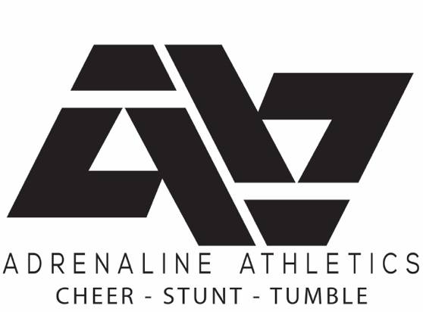 Health & Safety Policy
Updated - Monday, September 7, 2020

Adrenaline Athletics Ltd. is committed to a healthy and safe environment for everyone involved in our programs. Adrenaline has developed a policy intended to reduce health risks in regard to COVID-19. All policies have been developed using the Alberta Governments guidelines however additional measures have also been added. Further programs will be added to this list as we are able to offer them.
Safety
- Teams will operate in cohorts of 16 people. This includes both staff and athletes.
- A cohort is defined as a group of children and staff members assigned to them who stay together throughout the day, cohorts will remain the same for the duration of the season.
- If more than one child is registered from the same family, they are required to be in the same cohort.
- Staff members, parents or guardians and children must not attend the program if they are sick, even if symptoms resemble a mild cold. Symptoms to look for include fever, cough, shortness of breath, sore throat, runny nose, nasal congestion, headache, and a general feeling of being unwell.
- MANDATORY - COVID-19 Athlete Daily Self-Assessment to be completed by a parent or guardian each day prior to entering the building
- Adrenaline Athlete COVID-19 Self-Assessment Test
- Staff will ask parents and guardians to check the temperatures of their children daily before coming to the program. Parents and guardians should be reminded of this requirement when children are first registered for the program and through visible signage at entrances and drop off areas.
- Parents will be required to complete a daily google intake form for symptom screening.
- Adrenaline Athletics will keep daily records of anyone entering/attending the practices to facilitate contact tracing in the event of an outbreak.
- No visitors or special guests will be permitted into the viewing/athlete lounge area.
- If any program is connected to a confirmed or probable case of COVID-19 we will close to allow for contact tracing, if directed to by AHS. Adrenaline Athletics will then adhere to any further recommendations from Alberta Health.
Illness
- If a child develops symptoms while at the program, the child will be isolated away from other children and the parent or guardian will be notified and required to come and pick up the child immediately.
- All items used by the child will be cleaned and disinfected as soon as the child has been picked up. Items that cannot be cleaned and disinfected (e.g. paper, books, cardboard puzzles) will be removed from the gym and stored in a sealed container for a minimum of 10 days.
Drop off and Pick up Procedures
- Cohorts will be separated for the duration of practices as much as possible.
- Parents/care givers are NOT to enter the facility at anytime.
- Drop off & Pick Ups must be done in a timely manner and within 10 minutes of the schedule class start/end time.
- All participants and staff are required to wash/sanitize hands upon entry and when leaving for the day.
Physical Distancing
- All efforts will be made to avoid close greetings like hugs or handshakes and Adrenaline Athletics will encourage physically distant greetings such as “air fives” and waves.
- Staff will encourage and plan for as many physically distant activities such as shadow tag and avoid activities that require clustering around a particular item or small area. Be aware that not all activities will maintain physical distancing of 2 meters and some activity supplies will be shared (within the same cohort only).
- No food is to be shared with other participants. Participants will be required to wash hands before and after eating. Participants will be spaced out during all eating times.
Public Spaces
- Groups will be limited to 15 people or fewer.
- Individuals will maintain physical distancing of at least 2 metres from others at all times.
- After activities, individuals are required to maintain physical distancing when returning to vehicles or homes.
Activities
- Activities in public spaces will maintain a physical distancing of at least 2 metres.
- Activities in public spaces will not include the sharing of common equipment. Each athlete will be designated a specific area and they will be the only user of that spaces' equipment for the duration of the class.
- If spotting is required, the coach will wear gloves and a mask. The coach will sanitize hands before and after spotting.
- All instructors will maintain a 2 m distance from all participants
Cleaning

- Equipment will be cleaned and disinfected prior to and after each use.
- Public Washrooms will be available during classes.
- All high touch points in the washrooms will be sanitized between classes.
- Hand sanitizer stations will be provided.

Adrenaline Athletics Ltd. 09/2020

