

Sunnybrooke Condo Association Newsletter Spring 2018


During the updating of the by-laws process, we had several people mention that they would like to volunteer in the future.

Some of the upcoming events:
- Spring Clean Up
- Community pot luck gathering
- Sunnybrooke yard sale
- Board Member positions
- Officer positions
- Community yard sale
- (( If you think you may be interested in being on the Board or becoming an officer, please feel free to contact those who are in those positions now. We’re happy to share what our experience has been like! ))
- Have a suggestion? Let us know!

Yard Waste Reminder
- Yard waste should be disposed of at our local recycle center, not in our culverts and common areas.

Dig Safe
Always call Dig Safe before starting those projects to your property.

Have your property surveyed before putting in fences and outbuildings and we strongly advise you obtaining the proper permits from the City of Dover. It is harder and more expensive to take it down after the fact.

- There have been many complaints about speeding. Please adhere to the posted speed limit of 15 mph.

Remember, we have children playing, people walking for exercise and others walking their pets.

Repetitive violations may result in a call to the Dover Police Department and the implementation of speed bumps. Remember: Pedestrians have the right of way!

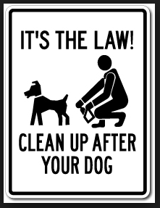

Additionally, please report concerning activities to the Dover Police – Let’s not become an easy target to criminal behavior.

Visit our web site to view a list of the Board Members, Officers, Various documents:
http://sunnybrookecondoassoc.webstarts.com/
Not getting Sunnybrooke notices?
Send your current email address to laurit1818@comcast.net – Lauri Thompson, Secretary


Bicycle Safety

It’s beautiful outside! Kids and families will be out and about on their bicycles. The City of Dover NH and the Dover Police have some advice about keeping everyone safe:

In Dover, helmets are required, under the age of 16, on a public way.

Also, a reflective piece of apparent is required for ½ hour after sunset, until ½ hour before sun rise.

It’s been noticed that at times some kids are in the road, either walking or riding, and not moving aside for cars.

Please take a moment to remind the kids that we all want them to be safe and to take notice of moving vehicles.

Thank you!

