Maryland black suffragists’ history

finally being told 100 years

after women won right to vote

By Jonathan M. Pitts
Baltimore Sun |
Jan 16, 2020 | 11:38 AM

Carolyn Chissell speaks about her great aunt, the Baltimore suffrage leader Augusta Chissell.
In the years leading up to 1920, when women were granted the right to vote, members of prominent suffrage organizations in Maryland packed car caravans en route to rallies, rode cross-state in covered wagons to raise awareness, and traveled to Washington to help lead marches to the White House.
In Baltimore, a smaller group of suffragists had to take up the battle in their own living rooms.
It has long been known that the vast majority of those who fought for the women’s vote in the United States were affluent, educated, white women, largely because they tended to have the time and means to focus on the controversial cause. It is less well known that, for the most part, they excluded women of color.
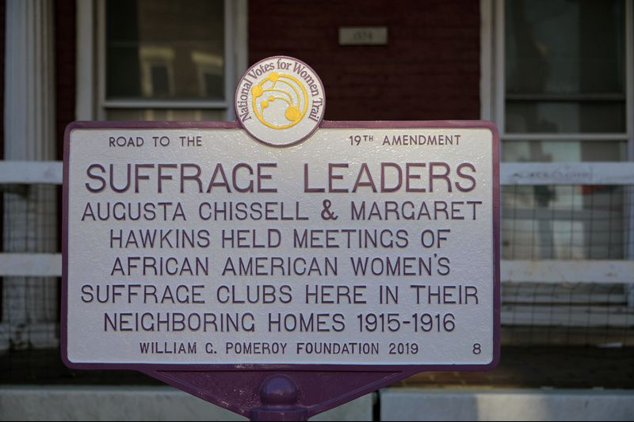

Suffrage Leaders Plaque in West Baltimore
Commemorative plaque outside the homes on Druid Hill Avenue where Augusta Chissell and Margaret Hawkins, leaders in Baltimore's African American suffragist movement, once lived as next-door neighbors. (Karl Merton Ferron / Baltimore Sun)
Here as elsewhere in the country, African American women who backed the women’s vote had to hold meetings in their homes, strategize within black social clubs and mobilize within their church groups, rarely interacting with the larger organizations that most associate with the cause.
As the story of women’s suffrage is being told during the centennial of the ratification of the 19th Amendment, which gave women the franchise, historians are reexploring the role African Americans played in Maryland and beyond.
It’s a story that has been confined to family histories, clippings from black newspapers and the minutes of women’s clubs. But it’s starting to emerge into public view.
Just before Thanksgiving, a commemorative highway marker was dedicated in front of the homes of two African American suffragists, Augusta T. Chissell and Margaret Gregory Hawkins, who lived next door to each other in the 1500 block of Druid Hill Ave. Scholars are compiling biographies of Chissell, Hawkins and their friends and associates in the movement.
Historic notes and documents are being organized and digitized, eventually to be made part of a collection at the Morgan State University library. More markers might be erected in Baltimore in 2020, adding to new commemorative trails across the state and the country.
“So much of the story has been lost, but historians are working hard at telling the true, more diverse story of women’s suffrage,” says Diana Bailey, executive director of the Maryland Women’s Heritage Center in Annapolis, which helped plan the Chissell and Hawkins tribute.
Kacy Rohn was an intern with the Maryland Historical Trust in 2017 when she was tasked with traveling the state to locate sites the organization might commemorate as the centennial approached.
The 19th Amendment to the U.S. Constitution, passed by Congress on June 4, 1919, was ratified by the 36th and deciding state, Tennessee, on Aug. 18, 1920, and went into effect nationwide. (Maryland ratified the amendment in 1941.)
Votes for women: Maryland’s complicated story »
Rohn says she was shocked at how little public awareness remained of the work of such suffragists as Elizabeth King Elliott and Edith Houghton Hooker, educated white social workers who founded the Equal Suffrage League of Baltimore and the Just Government League, two of the more prominent statewide groups that worked with national organizations.
She was even more taken aback to learn that these and other groups supported the continued disenfranchisement of black women voters in Maryland. After the National American Woman Suffrage Association was formed in 1890, the suffrage movement began to systematically exclude black women in a bid to win more support from Southern white women and political leaders.
Baltimore’s Equal Suffrage League and the Maryland Suffrage Association sought to deny suffrage to black women for similar reasons, according to Diane Weaver, a Maryland historian and suffrage researcher based in Washington County.
Rohn was also dismayed that the efforts of African American suffragists such as Chissell, Hawkins and their friend and neighbor, Estelle Young, had been lost to history.
“This was an element I knew nothing about when I started studying women’s suffrage," says Rohn, now a historic preservation specialist with Montgomery County. “It doesn’t appear anywhere in mainstream textbooks, and it has been excluded by design.”
For a glimpse at the history now emerging, look to the work of Beverly Carter, a retired Baltimore attorney who has been piecing it together.
Carter is a member of, and official archivist for, the DuBois Circle, a Baltimore literary club for black women whose culture-minded membership has been meeting once a month, from October through May, since 1906.
When she took over as archivist in 2015, Carter says, she realized that her predecessors had retained minutes of those meetings and other materials dating to the group’s founding. She has been plowing through the material ever since, organizing it by date, storing it in notebooks, and assembling what amounts to a narrative of the membership over the years, including snippets that brought to life a group of forceful women.
All 25 members of the early DuBois Circle, including Chissell, Hawkins and Young, were also members of the suffrage movement, Carter says, at least in the sense that club minutes show the subject was often a topic of discussion.
And in 1915, Young — the wife of Howard E. Young, Baltimore’s first African American pharmacist ― founded and served as president of the city’s first suffrage group for black women, known variously as the Colored Women’s Suffrage Club or the Progressive Women’s Suffrage Club. Chissell and Hawkins were among approximately 20 members and served as officers.
Some of that material is not referenced in the DuBois Circle records ― there’s a gap in the minutes from 1910 to 1930 ― but Carter has found references and descriptions in the Afro-American, which frequently posted information on the meetings.
“I’m working hard to fill in the gaps,” she says. “It’s time-consuming, but it’s fascinating. And it’s starting to come together.”
When Carter completes her work, she’ll donate the collection to Morgan State, where university archivist Ida Jones has been working to develop biographies of these and other women. Rohn and Weaver have contributed in similar ways to an increasingly rounded portrait of the period and its characters.
Because the white suffragist groups, for the most part, excluded blacks, Chissell and her associates simply added suffrage to the list of causes they were already supporting through an overlapping network of church and social groups — better schools, sanitation and health care for Baltimore’s black population and prohibition for everyone.
“Black women found in the issue a means by which to expand their own societal improvement activities by developing a suffrage movement of their own,” Weaver says.
Chissell comes to life with special vividness. Born in 1880, the daughter of migrants from the South, she was “almost light-skinned enough to be able to pass as white,” in Jones’ words. She was raised “in a civically minded home,” Jones says, became an accomplished pianist, married an influential African American physician, and emerged a recognized leader in such organizations as the NAACP and the Women’s Cooperative Civic League.
Carolyn Chissell, 85, her great-niece by marriage, believes she’s the only person alive who actually met Chissell, who was 94 when she died in 1974.
Chissell’s memories from childhood affirm the impression of her “Aunt Gussie” as a force of nature.
“She had been striking and regal in her day, and in her later years she was still very good-looking and fashionable. She exuded confidence. Older women would come up to me and say, ‘Are you related to Gussie Chissell? She was really something,’ " Chissell says.
Chissell and Hawkins, a Howard University graduate and longtime history teacher at Frederick Douglass High School, took turns hosting meetings of the suffrage group, which would eventually wield its influence in public gatherings at churches such as Sharp Street Methodist and Union Baptist.
Weaver has written that the club’s first public meeting “drew a large and enthusiastic crowd to Grace Presbyterian Church,” the first of many. In October 1915, the Afro-American reported that “the movement for female suffrage is growing among the colored women of this city.”
“So much of the story has been lost, but historians are working hard at telling the true, more diverse story of women’s suffrage.” Diana Bailey, executive director of the Maryland Women’s Heritage Center in Annapolis
Two months later, the Maryland Federation of Christian Women, an African American group, hosted its parent organization, the National Association of Colored Women, in Baltimore.
Young “made a vigorous appeal for interest in the fight for votes for women,” according to a news account, helping inspire the federation to “enthusiastically” endorse the effort.
“Early 20th century African American suffragists’ work was particularly important," Rohn says, "at a time when Jim Crow laws were seeking to undermine hard-won civil rights.”
The work didn’t stop with the passage of the 19th Amendment. Shortly afterward, Chissell began writing a column that offered black women guidance on the rights and responsibilities involved in voting, and she and Young led voter education classes at the Colored Young Women’s Christian Association building near her home.
Weaver says the efforts paid off: “After the amendment passed, women registered in far greater numbers than men in the African American community.”
In 2018, U.S. Rep. Elijah Cummings helped secure Chissell’s induction into the Maryland Women’s Hall of Fame.
“Ms. Chissell played an extremely important role in the suffrage movement even though women of color were often excluded from the mainstream organizational work to secure women’s rights,” he wrote in a letter of nomination. “With limited resources and support, she was a vocal supporter of the suffrage movement and continued working hard even after women won the right to vote to educate and activate new women voters.”
When the Maryland State Highway Administration and Maryland Women’s Heritage Center joined forces to install the commemorative marker last fall, it became the seventh of 11 suffrage-related markers slated for dedication in the state by the end of 2020. It was the first to be located in Baltimore, and the first dedicated to its overlooked black suffragists.
Bailey says her organization is working with local volunteers and scholars to seek additional African American suffrage sites in the city and hopes to add more this year.
“We’re just scratching the surface,” she says.

Jonathan M. Pitts

Contact

As religion and Maryland enterprise reporter for the Baltimore Sun, Jonathan Pitts covers news developments within faith communities and the many and sundry ways in which Marylanders live. A native of St. Louis, Mo., and a graduate of Haverford College and the University of Missouri School of Journalism, he came to the Baltimore Sun in 1999.

