Baltimore Highway Marker

Honors Black Suffragists
By
Special to the AFRO
-
December 12, 2019

2497
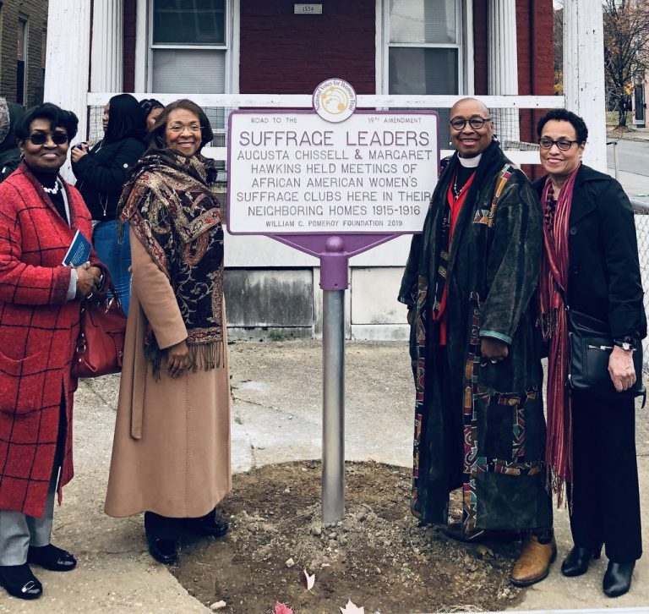

Left to right: The DuBois Circle members Evelyn McClarry, Dr. Judith Smith (Vice President), Rev. Canon Dr. Sandye A. Wilson (President), and Beverly Carter (Historian) celebrate the unveiling of a marker honoring Baltimore suffragists on Druid Hill Avenue. (Photo by Jean Thompson)

Both Chissell and Hawkins were members of the DuBois Circle. Founded in 1906 as an auxiliary of the Niagara Movement’s chapter in Baltimore, and still active today, The DuBois Circle promoted African-American suffrage, civic uplift, and educational enlightenment. Hawkins was its first president.
“That the ladies should have the right to vote was the consensus of opinion at the first monthly meeting this fall of The DuBois Circle,” reported The Afro-American on November 25, 1911. In 1915, The DuBois Circle member Estelle Hall Young founded the Women’s Suffrage Club. Chissell was the club’s secretary. Hawkins became its vice president. Chissell and Hawkins were next-door neighbors at 1532 and 1534 Druid Hill Avenue. Young lived a few blocks north (that building no longer exists). Their parlors buzzed with civic and women’s suffrage club meetings.
“I was honored to work with the Maryland Women’s Heritage Center on the planning and implementation of this event,” said Beverly Carter, The DuBois Circle Historian. “It is important for us to work together to make sure that we tell the whole story.”
African American women in Baltimore helped mobilize voters to defeat legislation that would have disenfranchised their husbands, fathers, brothers, and sons. The African American men had gained the vote with the passage of the 15th Amendment in 1870, but through the early 20th century Maryland proposed laws crafted to strip them of their rights.
After the 19th Amendment was ratified in August 1920, the Women’s Suffrage Club began teaching African-American women how to register to vote and use the ballot.
“According to Mrs. Young, the honor of the women is at stake, especially since the state of Maryland has taken such an active part in trying to keep the ballot away from women because colored women would be eligible to vote,” The Afro reported in September 1920. “We women,” she said, “are especially against the type of White politicians who said we would not know a ballot if we saw one coming up the street. We must register to vote, and we must vote in order to rebuke these politicians.” Chissell began writing A Primer for Women Voters, a recurring column in The Afro, to inform women “in regard to their newly acquired duties and privileges as voters and citizens.”
The marker dedication program was held on Nov. 23, at the historic Union Baptist Church. The colors were posted by the Girl Scouts Beyond Bars troops. Rev. Dr. Alvin C. Hathaway Sr. welcomed the visitors to Marble Hill, and Ida Jones, Ph.D., university archivist at Morgan State University, presented the suffragists’ biographies. Presentations were also made by Geri R. Byrd, the Mayor’s Deputy Chief of Staff for Administration and External Affairs; The DuBois Circle leaders; women’s commission and 19th Amendment centennial commission representatives, and marker sponsors MWHC and William G. Pomeroy Foundation.
“We are extremely proud of our members being honored today,” said The DuBois Circle President Rev. Canon Dr. Sandye A. Wilson. “At a time when women did not enjoy the full benefits of citizenship such as the right to vote, the honorees, along with the more than 10 other members of The DuBois Circle who were actively involved on many levels in the suffrage movement, diligently advocated for women’s right to vote and for racial equality.”
Jean Thompson is a freelance writer who volunteers with the Maryland Women’s Heritage Center project documenting local suffragists for the 2020 centennial of the 19th Amendment.

