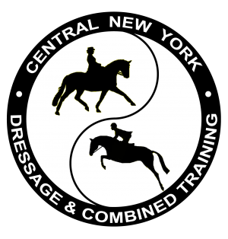
CENTRAL NY DRESSAGE & COMBINED TRAINING
Welcomes OLYMPIC MEDALIST
GINA SMITH
For a Year-End Symposium and Evening Discussion
November 18 and 19, 2023
at Canterbury Stables 4786 Roberts Rd Cazenovia, NY
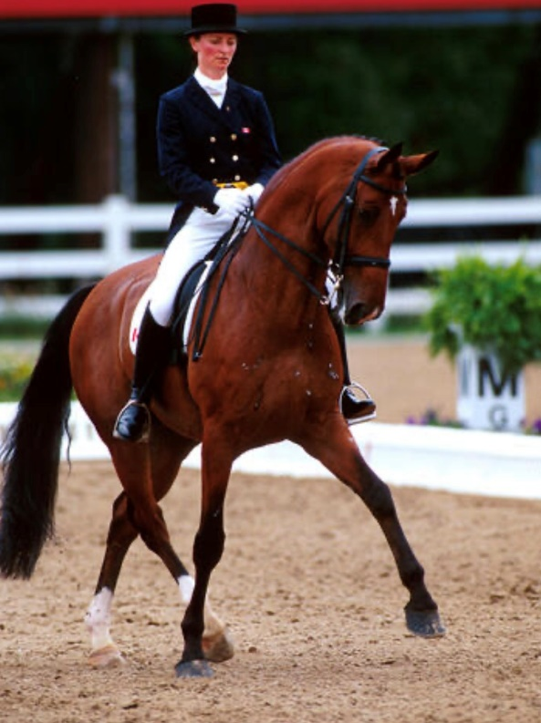

This symposium will be held in conjunction with CNYDCTA’s Year End Award dinner at the Lincklaen House, at which Gina will discuss her dressage background including her time spent in Germany, her Olympic experience, the ups and downs of a long career with horses, her horses and her future goals.
More info and to sign up is on our social media and at CNYDCTA.ORG
Gina Smith started riding with the Saskatoon Pony Club in 1969 at the age of 12, achieving her “A” level in 1976. She seriously began riding dressage in Vancouver as working student for Dietrich von Hopfgarten after taking several clinics that Dietrich gave in Saskatoon.
Gina and her friend Nancy MacLachlan traveled east with their horses in 1981 and Gina started working for Cindy Neale (now Ishoy). Gina groomed for Cindy at the World Championships in 1982, which were held in Lausanne, Switzerland. Gina decided to stay in Germany and continue training with the Canadian Team coach, Johann Hinnemann. It was at this time that, in lieu of a university education, Smith’s parents purchased the seven-year-old Westfalen gelding, Malte. Gina continued to spend the next 8 years training in Germany.
Smith was named to the Canadian Equestrian Team in 1984, the same year she was named reserve rider for the 1984 Olympic Team in Los Angeles. In 1986, when the World Championships were held in Cedar Valley, Ontario, Smith was a member of the fifth place home team with Malte. Gina was now training in Germany with Siegfried (Bimbo) Peilicke, and in 1988 she and Malte were members of the Olympic Team in Seoul, Korea that brought home the team Bronze Medal. Gina and Malte also finished 12th individually.
Gina returned from Germany in the summer of 1990 and has trained at Franklands Farm in Brockville, Ontario ever since.
At the 1991 Pan American Games in Havana, Cuba, she was a member of the gold medal winning team riding Franklands Farm owned Dutch Treat. One of Canada’s most accomplished dressage riders, Smith had the highest score in the 1996 Olympic Selection Trials, a 66.93%, partnered with Faust, owned by The Dressage Collection Inc. Faust and Gina represented Canada at the Olympics in Atlanta as part of the 10th placed team. In 1997, she was named Grand Prix champion at every show she entered with Faust, including the Canadian National Dressage Championships where she captured the title for the first time ever in her extensive career and also placed third with Fledermaus, who she began training as a 3 yr old.
At the 1997 North American Dressage Championships in Maryland, Gina was a member of the bronze medal team with Fledermaus, owned by Franklands Farm. The pair won the Swarovski Canadian League World Cup Final at the Royal Horse Show in 1999 and represented Canada at the World Cup Final in Holland in 2000.
Watch for Gina in future international competitions aboard her new partner, Bellaryn.

